DIVISION 02 – EXISTING CONDITIONS
SECTION 02 82 13 ASBESTOS ABATEMENT – ENCAPSULATION SFRM – INTERIOR EXPOSURE
(ENCAPSULATION OF ACM/RACM/PACM SPRAYED FIRE-RESISTIVE MATERIAL)

1.00 GENERAL REQUIREMENTS

1.01 WORK INCLUDED

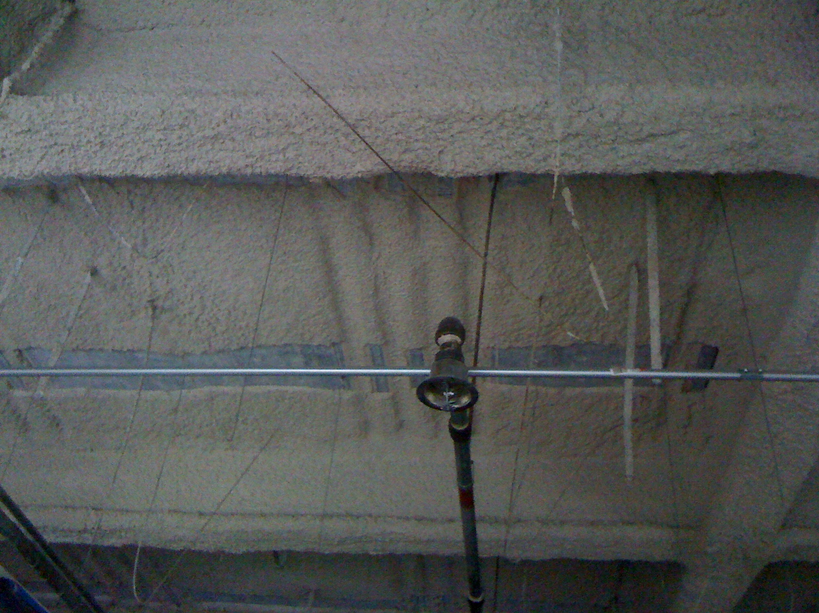
- Provide labor, equipment and materials to complete work involving long-term to permanent abatement of fireproofing (also SFRM – Sprayed Fire Resistive Materials) via encapsulation. The encapsulation process herein is described in work practices consistent with U.S. federal and state regulations and administrative rules, industry best practices, and the USEPA commissioned research and documents from approximately 1978-1986, and which remain current and in force today.
- Specification herein also requires encapsulation coatings which rated as acceptable in the 1981-1984 EPA-contracted Battelle research, and which can be used in both the penetrating encapsulation and bridging encapsulation stages outlined in this document.
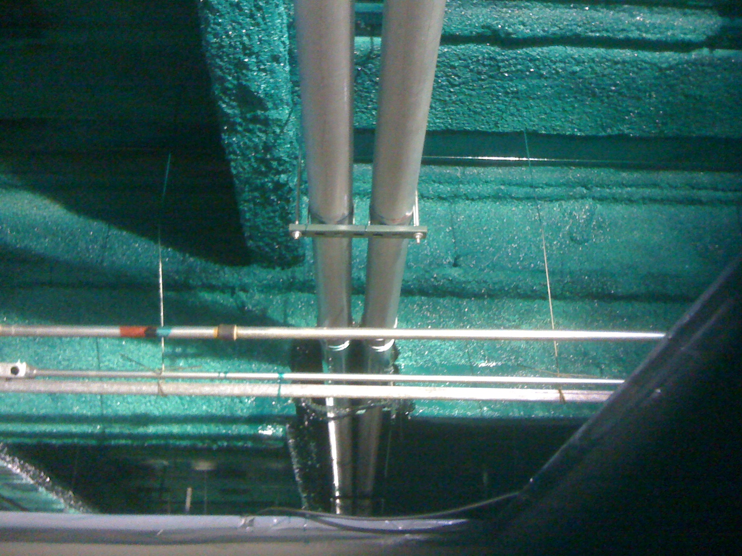
- Work included requires management of fiber and particulate release from potentially asbestos-containing materials, and fiber clean-up as necessary.
- The completed system will be an off-white, clear or green bridging encapsulation, preceded by a penetrating adhesive encapsulant that conditions the surface. The resulting encapsulation will be a laminar film of sufficient build and cohesion that fibers cannot become airborne, nor are fibers generated by incidental physical contact.
GSA Building, Los Angeles, 2010. ACM fireproofing after preparation; and after encapsulation with Fiberlock #6423 A-B-C Green

1.02 RELATED SECTIONS, DEFINITIONS,

- Specified elsewhere:

1. Section 00 26 00 – Hazardous Material Assessment
2. Section 00 26 23 – Asbestos Assessment
3. Section 02 82 00 – Asbestos Abatement
4. Section 02 82 33 – Removal and Disposal of Asbestos Containing Materials
5. Section 09 90 00 – Finishes
6. Section 09 91 00 – Painting & Coating
7. Section 07 81 00 – Applied Fire Protection

B: Definitions

- ABATEMENT: Lessening or permanently eliminating the hazard of asbestos (or lead). Accomplished through one or a combination of techniques including encapsulation, enclosure or removal. Often repair is necessary before encapsulation or enclosure. Removal of asbestos is required prior to demolition. Management in-place via encapsulation or enclosure are considered permanent solutions provided necessary oversight and, when necessary, maintenance is provided.
- ACM: Asbestos Containing Material
- ADEQUATELY WET: ASBESTOS is "adequately wet" when it is wet enough so that no particles are released. Surfactant is used to adequately wet asbestos. One indication of this (but not the only one) is no visible emissions.
- AHERA: The Asbestos Hazard Emergency Response Act. The EPA law covering ASBESTOS in schools.
- AMENDED WATER: Water plus a chemical called SURFACTANT. Amended water soaks into ASBESTOS faster than plain water.
- CONTROL METHODS: Ways of controlling ASBESTOS. Includes: ENCAPSULATE, ENCLOSE, REPAIR, remove, and O&M.
- DECON: Decontamination unit or area – A shower unit. The decon has three rooms: DIRTY ROOM, shower and CLEAN ROOM. Everyone must enter and leave the work room through the decon.
- ENCAPSULATION: Treatment of asbestos-containing materials (ACM) with a sealant material that surrounds or embeds asbestos fibers in an adhesive matrix to prevent the release of fibers. A bridging encapsulant creates a membrane over the surface. A penetrating encapsulant penetrates the material and binds its components together. Legitimate encapsulants in the US that can be considered abatement must be designed specifically for the purpose of asbestos encapsulation, and the manufacturer shall provide performance data supporting that the barrier between the living environment and the encapsulated ACM can be considered permanent. Ideally, the encapsulant used in the present was among the 34 deemed ACCEPTABLE by Battelle Laboratories (out of 117 tested) in testing conducted for the USEPA from 1981-1984.
- ENCASEMENT: a synonym for ENCAPSULATION. Sometimes considered a more robust variant of encapsulation, there is no grounding for this. This is an interchangeable word, albeit used far less frequently. Encasement products ideally should have been among the ENCAPSULATION products evaluated for the EPA by Battelle Laboratories, and a manufacturer of ENCASEMENT products should be able to supply that documentation.
- FRIABLE: Asbestos that can be crushed into powders and fiber fragments by hand pressure.
- LOCKDOWN (or Lockdown Encapsulant): A coating formulated as a finishing step after abatement by removal. Only a small amount of thin coating is needed to affix any residual fibers or fragments onto surfaces such that these particulates cannot become airborne and cannot thus be inhaled. These are low-solids (mostly water) products that cannot serve as either penetrating or bridging encapsulants. New replacement fireproofing or insulation often is installed after the original asbestos-containing materials are removed and after the abatement contractor has applied the lockdown encapsulant and cleared to tear down containment and exit the site. It is the collective responsibility of the abatement contractor, the fireproofing applicator, the general contractor and the abatement oversight (CIH or similar) party to ensure the lockdown encapsulant is compatible with the replacement fireproofing. Selection of a lockdown that has been classified by Underwriter’s Laboratories universally with common respray fireproofing products will often ensure compatibility, and thus satisfy code. Failure to do this can require removal and starting over, or mechanical attachment of the fireproofing throughout the building with metal pins and lath. A lockdown encapsulant marked with the UL logo, and listed in the category CBUI Encapsulants is the proper starting point to ensure compatibility and compliance with code.
- PACM: Presumed Asbestos Containing Material
- RACM: Regulated Asbestos Containing Material. Materials covered by the NESHAP regulations: 1) FRIABLE ASBESTOS material, 2) CATEGORY I NON-FRIABLE ACM that will or has become FRIABLE, or 3) CATEGORY II NON-FRIABLE ACM that has a high probability of becoming or has become FRIABLE during demolition or renovation.
- SPRAY APPLIED FIREPROOFING: The technical name for Spray Applied Fireproofing is Sprayed Fire-Resistive Material (SFRM). It is used as part of a building’s passive fireproofing strategy. Spray applied fireproofing has thermal and acoustical properties and controls condensation. However, its main use is in insulating steel and metal decking from the high temperatures found during a fire. Passive fire protection products, such as fireproofing, is used to delay (or even prevent) the failure of steel and concrete structures that are exposed to the high temperatures found during a fire. They do this by thermally insulating the structural members to keep them below the temperatures that cause failure. SFRM is composed of cement or gypsum and often contains other materials like mineral wool, quartz, perlite, or vermiculite. SFRM used to contain asbestos, and removal and replacement is not required. SFRM containing ACM continues to typically satisfy code and provide the intended passive protection. Encapsulation can eliminate the potential for release of friable (inhalable) fibers, removing that concern, and extending the service life of the fireproofing.

C. References:

- Evaluation of Asbestos Abatement Techniques. U.S. Environmental Protection Agency (USEPA, EPA), Office of Toxic Substances, EPA 560/5-86-016, July 1986, Washington, DC
- Evaluation of Encapsulants for Friable Asbestos-Containing Materials (1981-1984) by Battelle Laboratories, Columbus, Ohio
- Managing Asbestos In Place: A Building Owner’s Guide to Operations and Maintenance Programs for Asbestos-Containing Materials. EPA Office of Pesticides and Toxic Substances. 20T-2003, July 1990.
- Guidelines for the Use of Encapsulants on Asbestos-Containing Materials, Appendix A “A Test Which Indicates Whether Friable Asbestos-Containing Material Can Sustain the Weight of an Encapsulant”, by EPA Office of Toxic Substances, June 1981, Washington, DC
- Fire Resistance Directory (BXRH), Underwriter’s Laboratories, 2001. Fire-Resistance Ratings – ANSI/UL 263 (BXUV), II General, subsection 6 Exposed Interior Finishes
- Guidance for Controlling Asbestos-Containing Materials in Buildings. Office of Pesticides and Toxic Substances, EPA 560/5-85-024, June 1985, Washington, DC. (Commonly referred to as the EPA Purple Book).
- A Coatings Compendium: Asbestos Encapsulation, by Cole Stanton. Restoration & Remediation, August 2014
- The Applicability of TAHPR and NESHAP to Painting Asbestos-Containing Materials (ACM). Texas Department of Health (TDH), Toxic Substances Control Division. ARC010, November 2001.
- Commandant Instruction 6260.1.A: Subject: Asbestos, Lead and Radon in Coast Guard Housing. United States Coast Guard (USCG), 2004, Washington, DC.
- Model Asbestos Abatement Guide Specification. National Institute of Building Sciences, July 1986. Section 15254

C. Notes to Users of this Document (e.g., Architects, Engineers, Designers and Consultants):
- This specification is supplied in an exhaustive format with the intent of achieving as comprehensive inclusion of project factors as possible.
- The specifier is not obligated to utilize this specification in entirety, but instead is encouraged to adopt/adapt/apply those provisions which are applicable to specific projects.
- This compendium specification is focused on compliance issues satisfied by encapsulation in the United States. ICP has substantial experience with ACM encapsulation projects in Canada, Australia, New Zealand and in the United Kingdom. If the proposed encapsulation project is located in one of these nations, or any other nation, please contact ICP via MasterWorks (below) to consult with a subject matter expert from the Fiberlock team within the Environmental Restoration Group (ERG).
- This specification may be substituted as an “or equal” methodology with encasement protocols. From the regulatory perspective, encasement is an alternate term usable as a synonym for encapsulation, and encapsulation is the primary/dominant term of both compliance and best practice.
- The MASTERWORKS DESIGN+SPECIFICATION team of the ICP Building Solutions Group has prepared this overall specification.:
  - Web: www.icpmasterworkscommunity.com
  - Email: specifications@icpgroup.com
  - Phone: 800-342-3755 or 978-623-9980
- Metric Conversions: Metric conversion, where used, is soft metric conversion

1.03 QUALITY ASSURANCE

A. Cited Standards are incorporated herein by reference and govern the work:

- See other cited documents also to be considered incorporated byreference, as listed at REFERENCES at 1.02, B of this specification.
- Occupational Safety & Health Administration (OSHA) Regulations – Safety and Health Regulations for Construction, Subpart Toxic and Hazardous Substances. Title Asbestos. Standard Number 1926.1011
- South Coast Air Quality Management District (SCAQMD): Rule 1113 - Architectural Coatings.
- E 1494 - Standard Practice for Encapsulation Testing of Friable Asbestos-Containing Surfacing Materials. American Society for Testing and Materials (ASTM)
- ASTM E 84 - 20 Standard Test Method for Surface Burning Characteristics, ASTM
- Overview of the Asbestos National Emission Standards for Hazardous Air Pollutants (NESHAP).

- Single Source Responsibility:
  - Obtain asbestos encapsulation coating system (encapsulant to be used diluted as a penetrating encapsulant, and then full-strength as a bridging encapsulant) from a single manufacturer with not less than 25 years of successful experience in manufacturing and specifying installation of the principal materials described in this section.
  - Products shall be of first quality only.
  - Coating systems comprised of multiple brands, when those brands all are owned and manufactured by the same entity, are permitted.
  - Coatings systems comprised of multiple brands manufactured by different entities are not permitted as a rule of this specification, but may be permitted by approved exception as an “or equal” in writing by architect, prime contractor or owner/owner’s designee.

C. Contractor Experience: The installer shall be a firm or individual experienced in applying coatings, similar in material, design, and extent to those indicated for this Project.

- Letter or Certificate provided directly by Approved Encapsulant manufacturer stating that contractor (including project dedicated supervisor(s) and any subcontractors involved in application) have/has completed and satisfactorily demonstrated competent understanding of instructional training in asbestos encapsulation, and specific use of the Approved Encapsulant.
  - Training and documentation of satisfactory completion can proceed with the bid winner once work is awarded.
  - Failure to abide by the terms of this section, such as unapproved substitution of untrained for trained applicators, shall void any and all warranties and support.
D. [RESERVED]
- Cited Standards [see SECTIONS 1.02 and 1.03 of this Specification] are incorporated herein by reference and govern the quality of work. Apply encapsulants consistent with workmanship that exceeds industry standard-of-care, and the following inadequate defects will not be tolerated:
  - Runs, and/or "ropiness";
  - Areas where coating film of bridging encapsulant is not contiguous and consistent in film-build (Thickness);
  - Less than 100% hide of underlying surface color (white & opaque colors only, does not apply to encapsulation with clear products);
  - A finish inconsistent such that a light at an angle cannot yield a consistent visual observation of reflection from gloss of encapsulant (especially important with clear encapsulation as primary visual means of quality assurance);
  - The generation of friable fibers from physical touch;
  - Post-application delamination or deterioration of the underlying fireproofing. Either loss of integrity of fireproofing from within itself, or detachment of the fireproofing from the substrate on which it is situated(e.g., steel beam, concrete deck, etc.). This indicates that the evaluation process (outlined in 1.03,G below) was insufficient; and/or the Penetrating Encapsulation step was lacking in execution;
  - or other defects in final finish will not be accepted.
- Sampling of Material:
  - When directed by Architect/Engineer, obtain test samples from material stored at distributor or manufacturer.
  - When deemed preferable by the oversight party, select samples at random from sealed containers.
- Pilot Application/Mock-Up:
  - Upon request (By Owner, Client, Enforcement Authority, Architect or Engineer), it may be determined necessary to provide a mock-up for evaluation of surface preparation techniques, validation of performance expectations, and anticipated application workmanship.
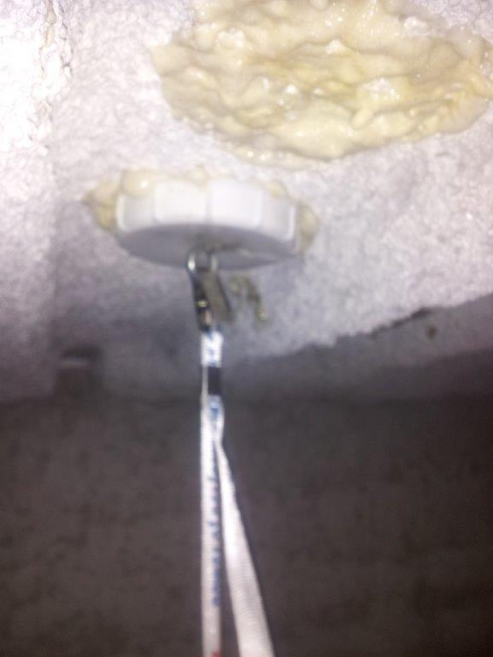
  - For the encapsulation of fireproofing, pre-testing representative areas in advance (and ideally during project design) has greater importance because although the methodology is proven, and ACM fireproofing may appear visually in pristine condition, subsurface developments over time can compromise adhesion. The hardest, most dense SFRM materials are the least likely to need pre-testing as these products resemble cement in some cases. However, much of the extant ACM fireproofing is less dense, and some is so comparatively lightweight that in the abatement trade the fireproofing is described as “cotton candy”. These types of SFRM can often be encapsulated after proof of viability via a Pull Test. This assessment method is outlined in the document cited at REFERENCES 1.02,C,4 Guidelines for the Use of Encapsulants on Asbestos-Containing Materials, Appendix A “A Test Which Indicates Whether Friable Asbestos-Containing Material Can Sustain the Weight of an Encapsulant”. This method has reliably stood the test of time. It can be found at the web address listed in the End Notes to this specification. Pictures of pull tests can be found in the Knowledge section at www.icpmasterworkscommunity.com. Execution of the Pull Test can be generalized as follows:
Successful Pull Test on ACM Fireproofing at McCormick Place, Chicago, IL 2013
    - Prepare surfaces designated for verification of suitability of proposed surface preparation procedures. Attach the hooks from which weights for the pull test will be suspended. Ensure test areas are representative in both fireproofing conditions and number of test locations.
    - Whenever possible, involve company representation on-site from Approved Encapsulant manufacturer. If on-site support is not possible, arrange for remote consulation with the manfuacturer’s Subject-Matter-Expert (SME) to verify satisfactory conduct of the evaluation. Document that the encapsulant manufacturer’s representation participated fully.
    - Encapsulate area designated by applying proposed encapsulant strictly in accord with coverage rate and dry film thickness proposed for project, including both penetrating and bridging steps. However, setting up airless spray for small test areas can be impractical, so substitution with compression or trigger spray of penetrating encapsulant and bridging encapsulant is acceptable. Note however more passes while wet with either manual spray or brush will be needed to simulate product delivered by an airless sprayer in full-scale application.
    - Apply bridging encapsulant ideally when penetrating encapsulation is between wet and has developed a tack to the touch by fingertip.
    - Do not proceed with remaining work until pertinent project authority (By Owner, Client, Enforcement Authority, Architect or Engineer), executes suspension of the weights for the proper duration, and based on successful performance, approves the mock-up.
- Standard for Accepting Work: Encapsulated surfaces will be deemed acceptable if, in the sole opinion of the Engineer, Owner’s Designee, or Architect, there are no insufficient or excessive application irregularities when viewed overhead in normal lighting from the floor of the workspace, whether or not such irregularities existed prior to start of painting work. The party responsible for determining acceptance shall be determined in advance of coating application and notice given in writing to both General Contractor and Installer.
- Pre-Project Meeting (in accordance with Section [01 31 19 - Project Meetings]): Convene a pre-application meeting [2] [Two] weeks or more before start of pre-encapsulation cleaning. Require attendance of parties directly affecting work of this section, including Contractor, Asbestos Abatement Consultant/Workplan Author, Engineer &/or Architect (if different from creator of abatement encapsulation workplan), Installer/Abatement Subcontractor(s), and those pertinent manufacturer's representatives. Review surface preparation, priming of exposed steel where applicable, install of replacement fireproofing to areas where removal was necessary, application, curing, protection/sequencing, and other coordination with this workspace and the overall project.
- Responsibility for Surface Preparation: If substrate preparation is the responsibility of another contractor, Installer shall notify Owner’s agent of unsatisfactory preparation before proceeding.

1.04 SUBMITTALS: Submit the following electronically on company letterhead:

- URL for product literature including technical data and label. Product literature shall include the Approved Encapsulant product, and the same documentation for all supplementary system components (reference end notes of this specification for system components potentially employed).

- URL for documentation that encapsulant was evaluated and deemed acceptable for the encapsulation of asbestos containing materials during the testing protocol conducted by Battelle Laboratories under EPA Contract #68-03-2552-T2005 (Contracted testing program was conducted from 1981-1984).

- Contact information for pertinent local representative Approved Encapsulant manufacturer. Manufacturer must have representation sufficiently local and knowledgeable that assistance is available and informative in order to resolve project and material-specific questions.

- URL for documentation that the encapsulant has been tested to the flame spread and smoke development protocols of ASTM E 84, and found to satisfy the criteria for Class A.

- URL for manufacturer’s Safety Data Sheets (SDS). Encapsulant content of VOCs shall not exceed 100 g/l. (calculated per 40 CFR 59.406). Only submit complying products based on project requirements (e.g., LEED). Compliance is also required with other pertinent regulations regarding VOCs (CARB, OTC, SCAQMD, LADCO). To ensure compliance with district regulations and other rules, businesses that perform coating activities should contact the local district in each area where the coating will be used.
- URL for documentation that encapsulant has been manufactured, specified and performed successfully for no less than 25 years in the U.S. A manufacturer’s statement attesting to previous success accompanied by a credible reference list should be considered acceptable. This will satisfy the requirement listed at QUALITY ASSURANCE Section 1.03,B of this specification.
Notes:
- Bidders are encouraged to submit materials that meet the Basis of Design. In order to have a material accepted as an Approved Encapsulant for the work outlined herein the items listed in this section 1.04 must be received by the engineer/consultant/architect for evaluation and approval no less than 4 days prior to the original published bid date. Approved alternative Encapsulants will be by Addendum only. Submittals circumventing this process will not be approved and will not be acceptable for inclusion in this project. Alternative/substitution products considered in accordance with provisions of Section 01 60 00 specifications attached by consulting architects and engineers to the overall scope of this project.
- Only submit complying products based on project requirements including regulations regarding VOCs (CARB, OTC, SCAQMD, LADCO). To ensure compliance with district regulations and other rules, businesses that perform coating activities should contact the local district in each area where the coating will be used.
- Substitutions will only be considered for products manufactured by companies of primarily U.S. ownership, and when the proposed substitute product is “all or virtually” all manufactured in the United States (in accord with the Made in USA Standard of the Federal Trade Commission (FTC)).

1.05 PRODUCT DELIVERY, STORAGE AND HANDLING (see Section 01 60 00 - Product Requirements)

- Deliver manufacturer's unopened containers to the work site. Packaging shall bear the manufacturer's name, label, and product number (as well as minimum information detailed at Section 2 of this specification).

- Storage of materials:
- Store only acceptable project materials on site.
- Store in suitable location convenient to progress of work.
- Comply with health and fire regulations.
- Storage temperature shall be between 40° F (4.5° C) and 90° F (32° C), or such other ambient temperature conditions as may be specifically recommended by product manufacturer.
- Encapsulants shall not be permitted to freeze on site, and delivery of encapsulant should be refused if freezing during transit is probable.
- Avoid storage directly in hot sun exposures.
- Keep containers tightly closed when not in use.
- Keep out of reach of children.

- Handling:
  - Dispose of water-based and solvent-based materials, encapsulant and supplemental products, in accordance with requirements of local authorities having jurisdiction.
  - Verify that encapsulant and supplemental products are within acceptable shelf life, and do not utilize any product that is older than the maximum shelf life stated by the manufacturer.
- Extra Materials:
  - Furnish extra encapsulant materials in the quantities described below. Package with protective covering for storage and identify with labels describing contents. Deliver extra materials to Owner.
  - Furnish Owner with an additional one percent of each material and color, but not less than 1 gal (3.8 l), pail (19 l),or 1 case, as appropriate and collectively agreed upon in advance of substantial completion.

1.06 JOB CONDITIONS

A. Environmental requirements

- Comply with manufacturer’s recommendations as to environmental conditions under which encapsulant coating systems can be applied.
  - Temperature:
    - At Application: Surfaces to be coated and ambient air temperature shall be between 45° F (7.2° C) and 100° F (38° C). Do not apply encapsulants at temperatures beyond those limits stated in the manufacturer’s technical data sheet unless given written permission by the manufacturer.
    - After Application: Site temperature shall remain within the manufacturer’s acceptable range for no less than ten (10) days post-application.
    - Fluctuating Conditions: Supply of air movement may be recommended to aid curing when site conditions are minimal for application.
  - Humidity:
    - Ideal humidity for encapsulant application is 40-50% Relative Humidity (%RH).
    - Humidity in excess of 70% RH will slow the drying and curing of encapsulant coatings. Supply of air movement may be recommended when site conditions are minimal for application.
    - Do not apply encapsulant when the Relative Humidity is above 85% or when the Dew Point is closer than 3 degrees to the ambient air temperature.

- Surface/Substrate Moisture:
  - Do not apply encapsulants to wet surfaces. Surfaces may be lightly damp to the touch. At no time should coatings be applied where significant topical moisture is present (such as droplets, “beading” water). Applicators are expected to account for slow-drying surface elements (such as shaded areas, hairline cracks, nail holes).
  - Review carefully and comply with manufacturer’s permissible maximum moisture content (MC%) for product and substrate combinations where entrained substrate moisture could influence curing and performance, especially when trapped substrate moisture will attempt to escape or balance in future, such as when influenced by radiant heating/cooling cycles (or other similar causes of “vapor drive”). Moisture content readings taken should be recorded in the applicator’s project log.
    - Fireproofing will not generally be a moisture content concern, but causes such as roof leaks or when building systems have been inoperable for extended periods of time can create unusual moisture conditions. When reasonable causes are known or suspected conduct a moisture content survey including both fireproofing and underlying substrates.
  - For all products, prevent wide temperature fluctuations that could cause moisture condensation on freshly coated surfaces

B. Surface Protection/Prevention of Cross-Contamination:

- Cover or otherwise protect finished work from activity of occupants and/or of other trades, and surfaces not being coated concurrently or not to be coated.
- Do not apply encapsulants in areas where dust or other airborne particulate matter is being generated.
- Avoid cross-contaminating encapsulation areas with airborne particulate from areas of surface preparation and demolition. Such particulate may contain asbestos, lead and other hazardous contaminants. These contaminants may bias clearance testing as well as introduce unwanted and potentially health-affecting substances.
- Worker Safeguards: Shall exceed activity-specific requirements as promulgated by OSHA and relevant local jurisdictions. To include but not limited to:
  - Provide adequate illumination (Maintain minimum 80 footcandles (861 lx) on surfaces to be coated) and ventilation during application.
  - Contractor is to ensure and document provision with and training for use of all necessary Personal Protective Equipment (PPE).
    - Manufacturer, Prime Contractor, and Owner shall bear no responsibility for failure of Installer to properly equip and train workers with PPE.
- Damage: Each Contractor and Subcontractor shall be held responsible for and shall pay for all damage to or soiling of other work caused by its work or operations.
  - Maintain adequate safeguards concerning the premises and the public from hazards associated with work of this Section.
  - Post "Wet Paint" signs at surfaces subject to contact.
  - Ensure that site and on-site supplies are secured, locked, chocked, powered down and protected against accident, intrusion, vandalism, and curiosity.
2.00 PRODUCTS

2.01 MATERIALS (Basis of Design)

- ENCAPSULANT FOR BOTH PENETRATING AND BRIDGING STEPS: A-B-C ASBESTOS BINDING COMPOUND, [or equal]
  - Product ID:
    - 6421-5 (OFF-WHITE), 6422 (CLEAR) or 6423(GREEN).
    - Manufactured by FIBERLOCK, a brand of ICP BUILDING SOLUTIONS GROUP; located at 150 Dascomb Road, Andover, MA. 01810. (800-342-3755) www.fiberlock.com
  - Key Performance Attributes of Encapsulant
    - Exposure: Interior
    - Finish: Gloss
    - Solids by Weight ± 2%: 51.4%
    - Weight: 10.8 lb/gal) [1.3 Kg/L]
    - Solids by Volume ± 2%: 44.0%
    - Viscosity at 70°F: 60-75 Kreb units
    - Specular Gloss: 82º ± 5 @ 60º
    - Vehicle: Water-based
    - Flash Point (tag, closed-cup): Non-combustible
    - Shelf Life: 24 Months Min. (Original Sealed Container)
    - Calculated VOC: 56-64* grams/liter *ABC Calculated VOC dependent on color
    - Odor: Mild Elmer’s Glue (completely dissipates when coating is dry; zero post-cure off-gassing)
    - Hazardous Air Pollutants: Zero HAPs
    - HMIS Rating (Hazardous Material Indentification System) Rating: 0
    - Miscible: Yes (with clean, potable water)
    - Changes Acoustical-Sound Deadening Properties: No
    - Freeze-Thaw: 3 cycles – Good
    - Film Hardness (Sward Rocker): 2 (Excellent)
    - Water Resistance of Dry Film: Excellent
    - pH: 4.6
    - Heat Discoloration Effectiveness (45 minutes at 300°F): Excellent
    - Average Particle Size: 0.2 microns
  - Performance Testing
    - EPA Requirements
      - ABC has been tested at Battelle Laboratories, and met or surpassed the EPA requirements for effective asbestos encapsulation.
        - Battelle Columbus Laboratories under Government Contract. #68-03-2552-T2005
        - Judged to be acceptable June 9, 1981.
        - See SECTION 1.02 REFERENCES for endnote and reference hyperlink to Final Report on Evaluation of Encapsulants for Sprayed-on Asbestos Containing Materials in Buildings
        - The only government evaluation of bridging encapsulants available then and now. Of the eleven encapsulants (out of over 100 products tested) then judged by Battelle to be acceptable, ABC is one of the few (5) still manufactured today.
      - Battelle’s requirements for acceptable are/were as follows:
        - Class “A” fire Resistance (ASTM E 84)
        - Minimal smoke generation
        - Release of gases when burned well below any possible problem levels established by the National Academy of Sciences
        - Good surface integrity capable of either sealing the fibrous surface (as a bridging encapsulant) or of binding the fibers together by penetrating 0.5 inches or more into the test matrix (as a penetrating encapsulant).
        - Other criteria evaluated by Battelle for EPA
          - Viscosity
          - Solids Content by percentage
          - Minimum and Maximum Impact Resistance (Gardner Impact Tester; 60 and >60)
    - Additional Testing: A-B-C Asbestos Binding Compound
      - Southwest Research Institute, (May 1983), Project No. 01-7282-223))
        - Surface Burning Characteristics ASTM E 84: CLASS “A”
          - Flame Spread: 10
          - Fuel Contribution: 10
          - Smoke Density: 5
      - German Approval: iBMB-TU- Braunschweig
- ENCAPSULANT FOR BOTH PENETRATING AND BRIDGING STEPS: SERPIFLEX [or equal]
  - Product ID:
    - 2451-5 (WHITE)
    - Manufactured by FIBERLOCK, a brand of ICP BUILDING SOLUTIONS GROUP; located at 150 Dascomb Road, Andover, MA. 01810. (800-342-3755) www.fiberlock.com
  - Key Performance Attributes of Encapsulant
    - Exposure: Interior
    - Finish: Matte
    - Density: 1.20
    - Solids by Weight ± 2%: ____%
    - Weight: 10.8 lb/gal) [1.3 Kg/L]
    - Solids by Volume ± 2%: 40.0%
    - Viscosity at 70°F: 80-85 Kreb units
    - Specular Gloss: 82º ± 5 @ 60º
    - Vehicle: Water-based
    - Flash Point (tag, closed-cup): Non-combustible
    - Shelf Life: 36 Months Min. (Original Sealed Container)
    - Calculated VOC: 76* grams/liter
    - Odor: Negligible when wet (completely dissipates when coating is dry; zero post-cure off-gassing)
    - Hazardous Air Pollutants: Zero HAPs
    - Miscible: Yes (with clean, potable water)
    - Changes Acoustical-Sound Deadening Properties: No
    - Freeze-Thaw: 3 cycles – Good
    - Film Hardness (Sward Rocker): 2 (Excellent)
    - Water Resistance of Dry Film: Excellent
  - Performance Testing
    - EPA Requirements
      - Serpiflex has been tested at Battelle Laboratories, and met or surpassed the EPA requirements for effective asbestos encapsulation.
        - Battelle Columbus Laboratories under Government Contract. #68-03-2552-T2005
        - Judged to be acceptable June 9, 1981.
        - See SECTION 1.02 REFERENCES for endnote and reference hyperlink to Final Report on Evaluation of Encapsulants for Sprayed-on Asbestos Containing Materials in Buildings
        - The only government evaluation of bridging encapsulants available then and now. Of the eleven encapsulants (out of over 100 products tested) then judged by Battelle to be acceptable, Serpiflex is one of the few (5) still manufactured today.
      - Battelle’s requirements for acceptable are/were as follows:
        - Class “A” fire Resistance (ASTM E 84): [ 0 Flame Spread
        - Minimal smoke generation (ASTM E 84): 5 Smoke Development
        - Release of gases when burned well below any possible problem levels established by the National Academy of Sciences
        - Good surface integrity capable of either sealing the fibrous surface (as a bridging encapsulant) or of binding the fibers together by penetrating 0.5 inches or more into the test matrix (as a penetrating encapsulant).
        - Other criteria evaluated by Battelle for EPA
          - Viscosity
          - Solids Content by percentage
          - Minimum and Maximum Impact Resistance (Gardner Impact Tester; 60 and >60)
    - Additional Testing: Serpiflex
      - UL (Underwriter’s Laboratories): Tested to demonstrate conformance with ASTM E 119. U.L. 263, ASTM E119 Fire Test for Lock-Down Encapsulant.
      - See test report for File R14014 at https://www.fiberlock.com/wp-content/uploads/UL-Labs-Report-on-encapsulant-materials-E119-Sepiflex_Serpimastic.pdf

- Ensure inclusion on labels of containers of encapsulants (bridging and penetrating) and all supplementary products:

  - Product name, and type (description).
  - Batch Number
  - Manufacture date.
  - Product SKU
  - Color number/identification

2.02 COLORS
- 6421-5 (OFF-WHITE [ivory]), 6422 (CLEAR) or 6423(GREEN). All Gloss.
- 2451-5 (WHITE) Matte

2.03 MIXING

A. Accomplish job mixing and application only when acceptable to the Architect/Engineer.

B. Mix components only in containers furnished or approved in writing by the Manufacturer.

C. Mix encapsulant thoroughly, preferably with an electric drill mounted device designed for blending liquid coatings. When a clear liquid is present in the headspace when container is opened, installer is to consider that liquid an integral part of the product, and such liquid must be mixed in completely (unless the encapsulant manufacturer expressly instructs otherwise).

D. Thinning or diluting of the encapsulant, other than that for the penetrating encapsulation described ON-SITE in this specification and/or in writing by accredited manufacturer representation, is not permitted, unless expressly instructed in writing in advance by the manufacturer.

3. EXECUTION

3.01 EXAMINATION

- PRE-WORK VISUAL INSPECTION
  - Visually examine surfaces to be encapsulated. The purpose of the visual inspection is to evaluate existing surface conditions and determine how to properly encapsulate in accordance with this Specification. If the surface cannot be put into an acceptable condition, as described within this Specification (outlined in 1.03 above) for the particular substrate type and/or surface conditions, do not encapsulate.
  - Examine surfaces scheduled to receive encapsulant for conditions that will adversely affect execution, permanence or quality of work and which cannot be put into an acceptable condition through preparatory work as outlined herein.
CAUTION NOTICE: Dry sanding, scraping and other surface preparation procedures can create toxic dust and hazardous waste. A HEPA (High Efficiency Particulate Air) vacuum should be used on all surfaces to remove hazardous dust and particles. Use MSHA/NIOSH approved or equivalent respiratory protection suitable for concentrations and types of air contaminants encountered.
  - Notify Owner’s agent immediately upon determination that surfaces scheduled to receive encapsulant are unacceptable for proper adhesion or subsequent performance. If substrate preparation is the responsibility of another installer, notify Owner’s agent of unsatisfactory preparation before proceeding.
  - Do not proceed with surface preparation or encapsulant application until conditions are suitable. Work should commence only after conditions have been corrected and approved by all parties, otherwise application of coatings will be considered as an acceptance of surface conditions.
  - Do not proceed with surface preparation and application without first consulting with federal, state and local authorities for specific work practice guidelines and safety procedure information for that jurisdiction.
- PRE-WORK SURFACE ASSESSMENTS:
  - SUBSTRATE STABILITY (DEGREE OF DETERIORATION, SUITABILITY OF PURPOSE):
    - VISUAL INSPECTION: Perform a visual inspection. Inspector should present findings indicating stability or instability to a degree that involved parties agree encapsulation is practical or is impractical. Visual inspection is also the opportunity to verify that encapsulation and ACM composition and function are not incompatible.
    - ENCAPSULANT PILOT TEST/MOCKUP: Described at 1.03,G of this specification
  - PREPARATION OF SURFACES
- All surfaces to be encapsulated should be properly prepared so that all are clean and dry at the time of application. This specification does not cover surfaces of fireproofing that was previously encapsulated.
- Initial preparation is to HEPA-vacuum all surfaces. HEPA equipment should employ a bristle intake nozzle fixture or similar to agitate surface contaminants and encourage removal into the airstream suction of the vacuum. Fireproofing is often located above drop ceilings, and has therefore been protected from contamination during many years of service life. For this reason, the HEPA-vacuum may be the only preparatory step required for most areas of the project.
- The second step in preparation, if necessary, is a cleaning treatment by wiping. Because airborne asbestos fibers are a potential concern, all surfaces where very friable ACM fibers would be rendered airborne by ordinary encapsulation activity (airless spray of penetrating encapsulant), these areas should be wet wiped with clean rags/towels and minimal water. Wiping media should be discarded and replaced frequently to avoid moving contaminants from area to area, rather than removing contaminants from the substrate.
- Where extensive soot (industrial smoke, automobile-diesel residue) is present wiping media may be premoistened with a mild alkaline detergent solution or botanical equivalent degreaser. The degreaser/detergent is intended to reduce surface tension that inhibits cleaning. The alkalinity will reduce the naturally acid pH of soot residues. For extensive soot and/or soot-smoke odor, contact by FIBERLOCK, a brand of ICP BUILDING SOLUTIONS GROUP; located at 150 Dascomb Road, Andover, MA. 01810. (800-342-3755) www.fiberlock.com. Work practices more closely related to smoke and fire damage restoration may be applicable.
3.03 APPLICATION

- Apply encapsulant only after the surface has been examined, assessed, prepared, cleaned, and dried, as outlined in the surface assessment and preparation sections of this specification (sections 3.01 and 3.02). Application of encapsulant to surfaces that are not clean and dry as described will void all reasonable expectations of performance.
- PENETRANT-
  - Preparation of Penetrating Encapsulation: For most fibrous asbestos applications, such as cotton-candy style fireproofing or compressed acoustic material less than 2 inches thick, add 1 part water to 1 part encapsulant (manufacturer’s instructions may vary from product to product regarding water addition to achieve penetration).
  - Application of Penetrating Encapsulation:
    - Apply mixed penetrating encapsulant solution to the ACM by airless sprayer (or roller) until surface is visibly saturated.
      - Multiple passes may be required, allowing time between passes for dissipation of the solution into the ACM matrix.
      - Full saturation is achieved when the ACM will not absorb any more of the encapsulant into the matrix.
      - Typically, the penetration step of encapsulation can be deemed adequate when a visible glistening effect is observable.
  - Coverage, depending on thickness and porosity of the material, can vary between 50-75 sq. ft./gal.
- BRIDGING -
  - Dry-Film Thickness:
    - All parties should determine and agree to the necessary dry film thickness for any project during the bid solicitation process. Ideally, this determination is in consultation with the Approved Encapsulant Manufacturer
    - The necessary dry film thickness of a bridging encapsulant for asbestos containing materials (ACM) will vary from project to project as ACM can have a wide range of characteristics, including density, porosity, and surface profile. In the EPA’s Guidance for Controlling Asbestos-Containing Materials in Buildings, the primary instruction regarding dry film thickness states that when encapsulating ACM, the coating is to be applied “considerably thicker than recommended for painting” and at no more than 100 sq. ft./gallon.
  - Application of Bridging Encapsulation:
    - Apply bridging encapsulant at full strength to ACM by airless sprayer or roller.
    - Apply bridging encapsulant ideally when penetrating encapsulation is between wet and has developed a tack to the touch by fingertip. This can improve penetration of penetrating encapsulation already applied.
    - Successful encapsulation to reduce the probability of future friable fiber generation is contingent on careful application of a contiguous film across all areas of the surface.
    - Clear products may apply milky white when wet, permitting applicator to visually observe and address sufficient and insufficiently coated areas. Specifiers may mandate this product attribute as a contribution towards overall project quality control.
    - If the penetrating application was conducted correctly, the porosity of the ACM should have been reduced such that a single coat of the bridging encapsulant will yield a contiguous film.
  - Coverage and Dry film thickness applications for a continuous, unbroken laminar film of encapsulant, follow approved manufacturer’s instructions. See End Notes for coverage and dry film specifics for encapsulant listed in the Basis of Design section of this specification.
- Wet mil film thickness should be measured throughout any encapsulation project using a wet mil gauge or coupon panel.
  - Wet film thickness gauges are available upon request and at no charge from the manufacturer of the encapsulant.
  - Another method to assure that a minimum dry film thickness is achieved, is to tape a panel (“coupon”)(with a predetermined thickness), to the area being coated so that it receives the same treatment as the surrounding area. Once the film dries the panel should be measured again using a micrometer or dial caliper. Subtract overall thickness from the panel thickness to determine the dry film thickness.

  - METHODS OF APPLICATION
- Airless Spray: Encapsulants can be successfully applied with most major brands of airless spray equipment. Consult with manufacturer for spray instructions.
  - For best results with both Penetrating and Bridging Encapsulation, employ airless spray.
  - For very rough and irregular surface profiles, consider airless spray immediately followed with backrolling. For encapsulants to perform optimally, no voids should persist beneath the dry, cured film.
  - Techniques of spraying: A double cross-hatch is employed when encapsulating fireproofing to address the fireproofing surface from different angles (thus counteracting some of the irregular surface profile), and assisting with build-up of the contiguous dry film thickness required with minimized runs and drips. The installer shall choose whether to employ this technique for both the penetrating and bridging steps (although it is virtually always used for the latter bridging encapsulation):
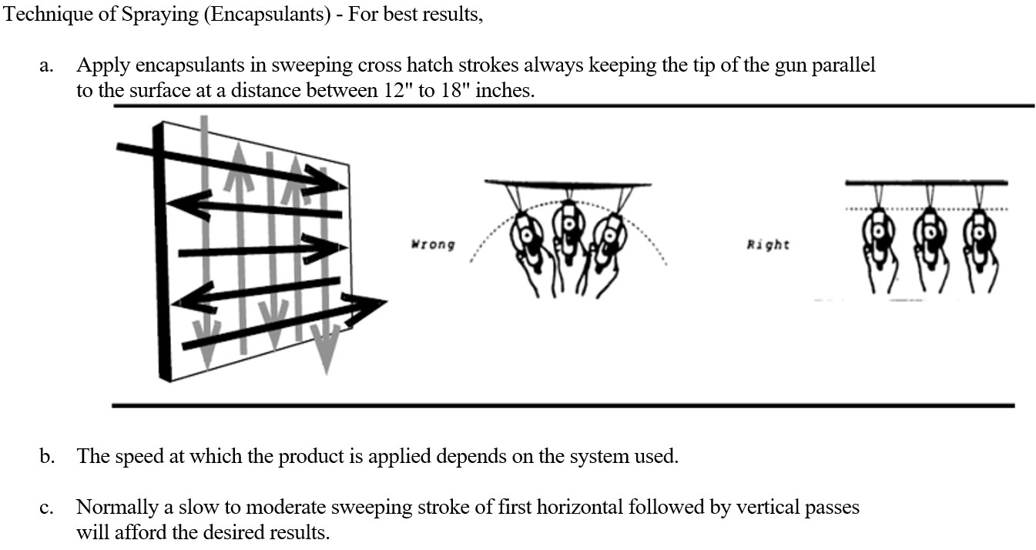

  - Spray Settings for Encapsulant listed in Section 2 Basis of Design (Using Titan 640 or larger):
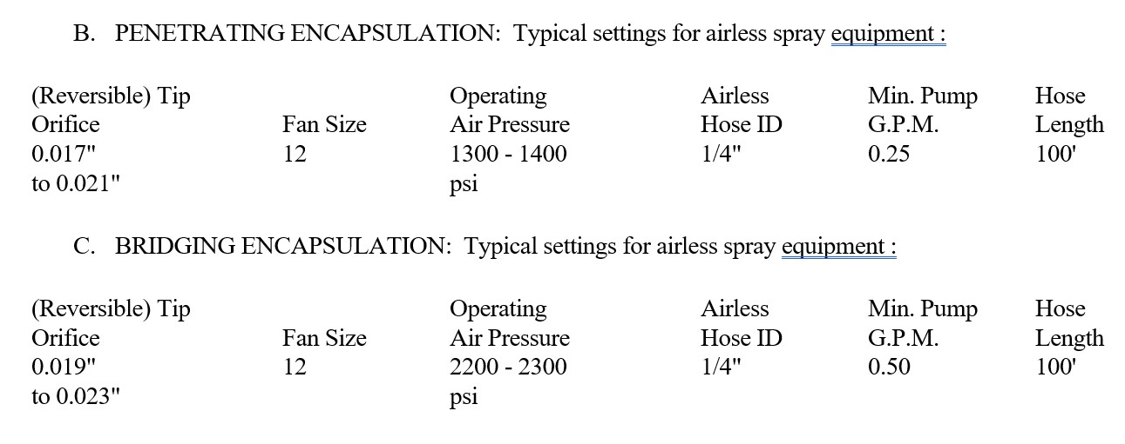
- Roller: For best results apply with a 1/2" nap roller (manufacturer recommendations may vary) due to the inherently rougher profile of a substrate.
- Brush: Consult manufacturer.
- Palm-Painter’s Mitt/Trowel: Consult manufacturer.

3.04 POST APPLICATION (SITE CLEANING, PROTECTION)

- All products in this specification are best cleaned up with a mixture of warm water and mild soap or detergent. For application tools, immerse into soap and water, soak if necessary, and work water-soap through and around all surfaces (such as brush bristles, roller nap).
- Protect work of other trades, whether to be painted or not, against damage by painting. Correct damage by cleaning, repairing or replacing, and repainting, as acceptable to Architect.
- Provide "Wet Paint" signs to protect newly painted finishes. Remove temporary protective wrappings provided by others for protection of their work after completion of painting operations.
- At completion of construction activities of other trades, touch up and restore damaged or defaced painted surfaces.
- Comply with other additional protective requirements specified in Division 1
- Remove debris promptly from work area and dispose of properly.
- Remove spilled, splashed, or splattered coating materials from all surfaces.
- Do not mar surface finish of items being cleaned.

3.05 FINISH SCHEDULE

A. [RESERVED FOR PROJECT SPECIFIER IN CONSULTATION WITH ENCAPSULANT MANUFACTURER]

  - WARRANTY

- Due to the variable nature of asbestos containing materials (ACM), any warranty must be determined on a project-specific basis, and owner should not have any expectation of warranty from installer or manufacturer without analysis and consensus prior to bid solicitation.
- If a warranty is negotiated in advance, issuance of manufacturer warranty shall be a condition precedent to receipt by Fiberlock Area Manager of completed and signed warranty documentation.
- Unpaid invoices void all warranties.
- SPECIFICALLY IN REGARDS TO THE [INSERT OFFICIAL DESIGNATION OF THE ASBESTOS ENCAPSULATION PORTION HERE], A PROJECT COMPONENT OF THE [ ] PROJECT], ICP has pre-determined that a ten (10) year product replacement limited performance warranty can be extended to this scope of work.
  - Provided ACM integrity and other conditions are as currently understood and are not altered by disturbance or other unforeseen causes
  - Provided designated ICP technical representative is given the opportunity to train applicators, and access to the project such as required to perform quality control functions and document execution of the work.
  - The full terms and conditions of the proposed ten year warranty will be enumerated in a separate but concurrent document.

END OF SECTION

END NOTES

This section is provided as a courtesy to the specifier or project designer/manager.

This section may be included or excluded in the project specific specification at discretion.

ICP BUILDING SOLUTIONS GROUP provides product training via Masterworks. The Fiberlock management team and field representation will designate on a project-by-project basis the Masterworks curriculum necessary to be qualified for a specific project, or accredit the approved applicator via onsite or remote instructor-led training. Hands-on instruction may be required at the discretion of the authorized Fiberlock representative. Note that training from manufacturer does not replace other training mandated by federal, state or local regulation. Concerning asbestos, mold and lead paint activities, the contractor is responsible for potential requirements such as EPA lead-safe remediator training (RRP), and/or state-issued lead abatement licensing for firms, supervisors and workers.

The MASTERWORKS DESIGN+SPECIFICATION team of the ICP Building Solutions Group has prepared this overall specification.:
  - Web: https://www.icpmasterworkscommunity.com
  - Email: specifications@icpgroup.com
  - Phone: 800-342-3755 or 978-623-9980

- The effective encapsulation of any abatement project is contingent upon the competence of the applicator.

- If encapsulated surfaces are damaged, repair and re-encapsulate immediately to prevent exposure to the potential hazard. HUD, EPA and state governments recommend periodic and/or annual examination of all encapsulated surfaces for damage.

- This specification does not fully describe all the limitations, warnings and precautions related to the products described herein.

- Reference should be made to the Technical Product Data Sheets for complete technical information on all products manufactured by Fiberlock, a brand division of the Environmental Restoration Group (ERG) of the ICP BUILDING SOLUTIONS GROUP.

- Safety Data Sheets (SDS) should be referred to for health and safety information. Copies of all SDS sheets can be obtained by visiting our website at www.fiberlock.com

Copyright © 2021 by ICP BUILDING SOLUTIONS GROUP, Inc.

This publication was produced specifically for the use of the [ ] Project, and their consulting engineering provider: [ ]
Phone: [ ]
address [ ]

and

[ ]

For other parties, this specification may not be reproduced or copied in whole or in part by any means without the express written permission of ICP BUILDING SOLUTIONS GROUP.

- To obtain a custom specification for your project or organization, contact the MastertWorks Design+Specification team at ICP BUILDING SOLUTIONS GROUP by email to specifications@icpgroup.com

MSW03192021
END NOTES FROM WITHIN SPECIFICATION TEXT:

Definitions are drawn from a variety of sources, but several are adopted from the glossary maintained online by the Center for Construction Research and Training https://www.cpwr.com/sites/default/files/training/asbestos/Glossary.pdf
Surfactant: Such as Fiberlock #6450 Penewet https://www.fiberlock.com/product/penewet/
Amended Water: Such as Fiberlock #6450 Penewet https://www.fiberlock.com/product/penewet/
DECON shower: Such as Fiberlock #6439 Klean-Pop Shower https://www.fiberlock.com/wp-content/uploads/Klean-Pop-Overview.pdf
Minnesota Department of Health: The first three sentences of this definition are borrowed from the Minnesota Department of Health website definition found at: https://www.health.state.mn.us/communities/environment/asbestos/workprac/awpencmainrep.html#:~:text=Encapsulation%20is%20defined%20by%20Minnesota,a%20membrane%20over%20the%20surface.
Lockdown Encapsulant such as Fiberset PM from Fiberlock. Fiberset PM is classified by UL (Underwriter’s Laboratories), and is UL-classified with all common respray fireproofing.
UL (Underwriter’s Laboratories ) Classification for Fiberset PM from Fiberlock in CBUI Encapsulants category: https://www.fiberlock.com/wp-content/uploads/UL-Classification-R13770-Fiberset-Firebond.pdf
Evaluation of Asbestos Abatement Techniques https://nepis.epa.gov/Exe/tiff2png.cgi/9100AMMM.PNG?-r+150+-g+3+D%3A%5CZYFILES%5CINDEX%20DATA%5C86THRU90%5CTIFF%5C00001945%5C9100AMMM.TIF
Battelle Columbus Laboratories Test for the Evaluation of Encapsulants for Friable Asbestos Containing Materials https://www.fiberlock.com/wp-content/uploads/EPA-Battelle-Testing-ACM-Encapsulants-1978-1981.pdf
EPA Managing Asbestos In Place. 1990: https://nepis.epa.gov/Exe/ZyNET.exe/20011E4D.txt?ZyActionD=ZyDocument&Client=EPA&Index=2016%20Thru%202020%7C1991%20Thru%201994%7C2011%20Thru%202015%7C1986%20Thru%201990%7C2006%20Thru%202010%7C1981%20Thru%201985%7C2000%20Thru%202005%7C1976%20Thru%201980%7C1995%20Thru%201999%7CPrior%20to%201976%7CHardcopy%20Publications&Docs=&Query=encasement&Time=&EndTime=&SearchMethod=2&TocRestrict=n&Toc=&TocEntry=&QField=&QFieldYear=&QFieldMonth=&QFieldDay=&UseQField=&IntQFieldOp=0&ExtQFieldOp=0&XmlQuery=&File=D%3A%5CZYFILES%5CINDEX%20DATA%5C86THRU90%5CTXT%5C00000014%5C20011E4D.txt&User=ANONYMOUS&Password=anonymous&SortMethod=h%7C-&MaximumDocuments=15&FuzzyDegree=0&ImageQuality=r85g16/r85g16/x150y150g16/i500&Display=hpfr&DefSeekPage=x&SearchBack=ZyActionL&Back=ZyActionS&BackDesc=Results%20page&MaximumPages=1&ZyEntry=1&SeekPage=x#
EPA 1981 Guidelines Appendix A for assessment test method: https://www.fiberlock.com/wp-content/uploads/EPA-1981-ACM-Pull-Test-for-Encapsulants.pdf
UL Fire Resistance Directory RE: Exposed Interior Finishes https://www.fiberlock.com/wp-content/uploads/UL-Fire-Resistance-Directory-Exposed-Interior-Finishes.pdf
Guidance for Controlling Asbestos-Containing Materials in Buildings https://www.fiberlock.com/wp-content/uploads/EPA-1985-Guidance-for-Controlling-ACM-Purple-Book.pdf
A Coatings Compendium: Asbestos Encapsulation, by Cole Stanton. Restoration & Remediation, https://www.fiberlock.com/wp-content/uploads/A-Coatings-Compendium-Asbestos-Encapsulation-RR-Article-1.pdf
Applicability of TAHPR to NESHAP https://www.fiberlock.com/wp-content/uploads/TX-Texas-DOH-Painting-Asbestos-FAQs.pdf
USCG Housing Directive 2004 re: Asbestos, Lead and Radon https://www.fiberlock.com/wp-content/uploads/US-Coast-Guard-Directive-on-ACM-and-LBP-2004.pdf
NIBS Model Asbestos Encapsulation Guide 1986 Sec 15254. https://www.fiberlock.com/wp-content/uploads/NIBS-Model-Asbestos-Encapsulation-Guide-1986-Sec-15254.pdf
ASTM E 1494 https://www.astm.org/DATABASE.CART/HISTORICAL/E1494-12.htm
ASTM E 84-20 Standard Test Method for Surface Burning Characteristics of Building Materials https://www.astm.org/Standards/E84.htm For testing on ABC to ASTM E 84 conducted by Southwest Research Institute, Project no. 01-7282-223, see https://www.fiberlock.com/wp-content/uploads/ABC-ASTM-E-84-Testing-SWRI-1983.pdf
EPA Overview of NESHAP EPA: https://www.epa.gov/asbestos/overview-asbestos-national-emission-standards-hazardous-air-pollutants-neshap
The product ICP will recommend in Basis of Design is A-B-C Asbestos Binding Compound. ABC has been an active and compliant product for abatement since before the incorporation of the Fiberlock brand since 1983. As for a successful specification and perfromance history, the A-B-C Select List of References can be viewed here: https://www.fiberlock.com/wp-content/uploads/ABC_Reference-8-24-15.pdf A summary of product testing is provided here as well.
The product ICP will recommend in Basis of Design is A-B-C Asbestos Binding Compound. ABC has been an active and compliant product for abatement since before the incorporation of the Fiberlock brand since 1983. As for a successful specification and perfromance history, the A-B-C Select List of References can be viewed here: https://www.fiberlock.com/wp-content/uploads/ABC_Reference-8-24-15.pdf A summary of product testing is provided here as well.
(ASTM E 84 (Similar to ANSI 2.5, NFPA 255, UL 723, UBC Method 42-1)
Clear products may apply milky white when wet, permitting applicator to visually observe and address sufficient and insufficiently coated areas. Specifiers may mandate this product attribute as a contribution towards overall project quality control.
Such as Benefect Atomic Degreaser https://benefect.com/us/products/atomic-degreaser/
Refer to A-B-C Technical Product Data sheet https://www.fiberlock.com/wp-content/uploads/ABC-642164226423-PDS.pdf
Note that a qualified asbestos professional may be required by law or regulation to assess or design for individual abatement projects.
Guidance for Controlling Asbestos-Containing Materials in Buildings. Office of Pesticides and Toxic Substances, EPA 560/5-85-024, June 1985, Washington, DC. (Commonly referred to as the EPA Purple Book) https://www.fiberlock.com/wp-content/uploads/EPA-1985-Guidance-for-Controlling-ACM-Purple-Book.pdf
Typical bridging applications of A-B-C are applied at a coverage rate of 75-100 sq. ft./gallon, which yields a dry film thickness between 6-10 mils on hard, cementitious ACM. The range of dry film thickness is due to the irregular surface profile of fireproofing surfaces to which A-B-C is most often applied as an encapsulant. Cotton candy and other more porous and “thirsty” types of fireproofing will require more product before film build is achieved, and thus reduce coverage per gallon. For fireproofing and other ACM that are very hard, dense and non-porous, a penetrating encapsulation may not be necessary. Moreover, the applicator should consider an ICP- Fiberlock encapsulant with a higher viscosity, as A-B-C may run and drip excessively on hard, dense and smooth surfaces. For these situations consider Serpimastic [https://www.fiberlock.com/product/serpimastic/], T-B-C Transite Barrier Compound [https://www.fiberlock.com/product/tbc-transite-barrier-compound/], or Lag-Kote II [https://www.fiberlock.com/product/lag-kote-ii/]. Contact your regional area manager for Fiberlock for project advice. Regional Managers can be found using the Find My Rep tool at the ICP MasterWorks community portal: www.icpmasterworkscommunity.com.
Both wet film thickness gauges and coupon panels are available from ICP-Fiberlock upon request. Quantities are limited.

