DIVISION 02 – EXISTING CONDITIONS
SECTION 02 82 13 ASBESTOS ABATEMENT – ENCAPSULATION
EXTERIOR EXPOSURE

1.00 GENERAL REQUIREMENTS

1.01 WORK INCLUDED

- Provide labor, equipment and materials to complete work involving long-term to permanent abatement of exterior asbestos-containing materials (ACM) in cementitious & fabric substrates present on south and west walls of a manufacturing building via encapsulation. The encapsulation process herein is described in work practices consistent with U.S. federal and state regulations and administrative rules, industry best practices, and the USEPA commissioned encapsulation research and documents from approximately 1978-1986, and which remain current and in force today.
- The completed system will be a gray-white,granular, impact-resistant bridging encapsulation, preceded by a penetrating adhesive encapsulant that conditions the surface. The resulting encapsulation will be a laminar film of sufficient build and cohesion that fibers cannot become airborne, nor are fibers generated by incidental physical contact provided owner maintains surfaces.
- Lead, whether or not it may be present in some areas, is not a concern of this project as occupational exposure is improbable and this is not target housing.

    - RESOURCES AND RELATED SECTIONS
- The MASTERWORKS DESIGN+SPECIFICATION team of the ICP Building Solutions Group has prepared this overall specification.
    - Web: www.icpmasterworkscommunity.com
    - Email: specifications@icpgroup.com
    - Phone: 800-342-3755 or 978-623-9980
- Specified elsewhere:
    - Section 002600 – Hazardous Material Assessment
    - Section 002623 – Asbestos Assessment
    - Section 028200 – Asbestos Abatement
    - Section 028233 – Removal and Disposal of Asbestos Containing Materials
    - Section 099000 – Finishes
    - Section 030000 – Concrete
    - Section 040000 – Masonry
- References
    - American Society for Testing and Materials (ASTM)
    - U.S. Environmental Protection Agency (USEPA, EPA)
    - U.S. Department of Housing and Urban Development (HUD)

1.03 QUALITY ASSURANCE
- Cited standards are incorporated herein by reference and govern the work:
  - Occupational Safety & Health Administration (OSHA) Regulations – Safety and Health Regulations for Construction, Subpart Toxic and Hazardous Substances. Title Asbestos. Standard Number 1926.1011
  - ASTM E 84 Standard Test Method for Surface Burning Characteristics of Building Materials
  - Battelle Columbus Laboratories Tests for the Evaluation of Encapsulants for Friable Asbestos Containing Materials. Protocol conducted by Battelle Laboratories under EPA Contract #68-03-2552-T2005 (Contracted testing program was conducted from 1981-1984)
  - South Coast Air Quality Management District (SCAQMD): Rule 1113 - Architectural Coatings.
  - [RESERVED]
- Single Source Responsibility:
  - Obtain asbestos encapsulation coating system from a single manufacturer with not less than 25 years of successful experience in manufacturing and specifying installation of the principal materials described in this section.
  - Key ancillary products directly associated with the performance of the encapsulant shall be:
    - Manufactured by the encapsulant manufacturer
    - Recommended by the encapsulant manufacturer
    - Sanctioned by the encapsulant manufacturer
- USEPA Government Directed Evaluation of Bridging Encapsulant
  - Bridging Encapsulant shall be tested and found to meet or surpass requirements of:
    - Battelle Columbus Laboratories Tests for the Evaluation of Encapsulants for Friable Asbestos Containing Materials. Protocol conducted by Battelle Laboratories under EPA Contract #68-03-2552-T2005
    - Or equivalent government performance evaluation that includes a minimum 50% same performance criteria, and documentation is provided by an independent, public or private, third party.
    - Ordinary paint may not be used in lieu of a Bridging Encapsulant.
- Independent Quality Assurance of Manufacturing Practices: Bridging Encapsulant shall bear in good-standing a quality assurance mark on the product label that represents regular facility and production inspections. The only quality assurance organizations considered acceptable are:
  - Underwriter’s Laboratories (UL): UL Classified
  - Factory Mutual (FM): FM Global
- Manufacturer Oversight of Applicator and Application Practices:
  - Installer Experience & Competence: The installer shall be a firm or individual experienced in applying coatings, specifically asbestos encapsulation products, similar in material, design, and extent to those indicated for this Project; and must provide:
    - Competence Documentation: Supervisors and Project Management for Installer: Certificate provided directly by Approved Encapsulant manufacturer stating that contractor (including project dedicated supervisor) has completed and satisfactorily demonstrated competent understanding of instructional training in asbestos encapsulation, and specific use of the Approved Encapsulant.
    - Documentation shall be issued by the manufacturer or a partner training provider. Documentation must have individual’s name, date of training, name of instructor, and certification shall not have expired.
  - Manufacturer Responsibility for Oversight: Whenever possible, involve company representation on-site from Approved Encapsulant manufacturer.
    - If on-site support is not possible, arrange for remote consultation with the manufacturer’s Subject-Matter-Expert (SME) to verify satisfactory conduct of the evaluation.
    - Document that the encapsulant manufacturer’s representation participated fully.
    - Note that manufacturer oversight does not constitute assumption by the manufacturer of responsibility for proper project execution. It is not possible for manufacturer representation to ever observe all simultaneous activity on a project site, nor examine every location of installed product. Encapsulant manufacturer shall document quality control activities insofar that if examined areas and activities are representative of the whole, then the Owner has reasonable added reassurance that performance will be reliable.
- SAMPLING AND PILOT AREAS:
  - Samples will be provided by the manufacturer at no charge to Owner, Architect sufficient for a test area(s) constituting no less than 50 sq. ft. (4.5 sq m), including all product types listed on the schedule in Section 2 of this specification.
  - All parties shall consent to and fully support a mock-up application. determined necessary to provide a mock-up for evaluation of surface preparation techniques, validation of performance expectations, and anticipated application workmanship.
  - Prepare surfaces designated for verification of suitability of proposed surface preparation procedures
  - Encapsulate area designated by applying proposed encapsulant strictly in accord with coverage rate and dry film thickness proposed for project.
    - Encapsulate area designated by applying specified encapsulant system strictly in accord with coverage rate and dry film thickness proposed for project, including both penetrating and bridging steps.
      - However, setting up airless spray for small test areas can be impractical, so substitution with compression or trigger spray of adhesive primer/penetrating encapsulant, followed by bridging encapsulant, is acceptable.
      - Due to viscosity, bridging encapsulant will not apply via manual spray; instead brush, painter’s mitt, or soft trowel/spatula may be employed.
      - Note however more passes while wet with either manual spray or brush will be needed to simulate product delivered by an airless sprayer in full-scale application [For full-scale application to a project with this geometry and scale, combined with the attributes of the bridging encapsulant, larger airless spray equipment will most efficiently build the specified thickness.].
      - Apply bridging encapsulant ideally when adhesive primer is still slightly wet and has developed a tack to the touch by fingertip.
  - Do not proceed with remaining work until pertinent project authority (By Owner, Client, Enforcement Authority, Architect or Engineer), approves the mock-up.
  - Mock-up is for performance evaluation. Custom color acceptance will be subject to a separate verification process after in situ performance testing.
Notes:
a) Bidders are encouraged to submit materials that meet the Basis of Design. In order to have a material accepted as an Approved Encapsulant for the work outlined herein the items listed in this section 1.04 must be received by the architect for evaluation and approval no less than 21 days prior to the original published bid date. Approved alternative Encapsulants will be by Addendum only. Submittals circumventing this process will not be approved and will not be acceptable for inclusion in this project. Alternative/substitution products considered in accordance with provisions of Section 01 60 00 specifications attached by consulting architects and engineers to the overall scope of this project.
b) Only submit complying products based on project requirements including regulations regarding VOCs (CARB, OTC, SCAQMD, LADCO). To ensure compliance with district regulations and other rules, businesses that perform coating activities should contact the local district in each area where the coating will be used.
c) Substitutions will only be considered for products manufactured by companies of primarily U.S. ownership, and when the proposed substitute product is “all or virtually” all manufactured in the United States (in accord with the Made in USA Standard of the Federal Trade Commission (FTC).

2.00 PRODUCTS

2.01 MATERIALS (Basis of Design)

- ADHESION PRIMER & PENETRATING ENCAPSULANT: GRIPTACK. Product ID: 6408-5 (CLEAR). Manufactured by FIBERLOCK, a brand of ICP BUILDING SOLUTIONS GROUP; located at 150 Dascomb Road, Andover, MA. 01810. (800-342-3755) www.fiberlock.com [or equal]
  - This product may also be used as a removal encapsulant, i.e., diluted as a wet dust and particulate control method during surface preparation.
  - Key Performance Attributes of Penetrating Adhesion Primer
    - Exposure: Interior/Exterior (Topcoat required within 60 days)
    - Finish: milky on application; cured - clear, tacky to touch
    - Specular Gloss: N/A
    - Coverage: 100-200 sq. ft./gal.
    - Volume Solids: 50.0% ± 2
    - Weight Solids: 50.0% ± 2
    - Viscosity @ 77°F: 50-60 ± 2 KU @ 77°F
    - Maximum VOC: 0 g/l
    - Odor: Pungent but brief
    - Flash Point: Non-combustible (water based)

- BRIDGING ENCAPSULANT: SERPIMASTIC SPRAYABLE. Product ID: 2419-5 (CUSTOM TAN TBD BY OWNER). Manufactured by FIBERLOCK, a brand of ICP BUILDING SOLUTIONS GROUP; located at 150 Dascomb Road, Andover, MA. 01810. (800-342-3755) www.fiberlock.com [or equal]
  - Key Performance Attributes of Encapsulant
    - Exposure: Interior/Exterior, including Severe Environments
    - Finish: Flat (Sandy, Cement)
    - USEPA Government Directed Evaluation: Surpassed (deemed acceptable as a Bridging Encapsulant) Battelle Study Protocols (only to-date EPA coordinated performance testing)
    - Acceptable Use Sites:
      - Permanent Isolation/Management-in-Place of ACM on exterior surfaces including:
        - Cement asbestos sheet used to form walls and sloped roofs
          - Millboard, AC, Fibro, Transite, Masonite.
        - Thermal Systems Insulation (TSI), Exterior HVAC Ducts
        - Galbestos, and similar felt, textile and canvas ACM pressed into structural elements
      - Lockdown of Residual Adhesive/Mastic residues common on floors after removal of tile or carpet. Must be subsequently protected with replacement carpet + pad, tile, linoleum, laminar floor, or resilient liquid applied flooring (Such as epoxy, polyurethane floor finish systems)
    - Volume Solids: 62% ± 2
    - Weight Solids: 71%± 2
    - Weight: 11 lbs/gal) [1.3 Kg/L]
    - Viscosity @ 77°F: 24,000-32,000 CPS
    - Calculated VOC: 23 g/l excluding water (can be stated as <50 g/l)
    - Odor: Very slight
    - pH: 6.5-7.5
    - Coverage and Film Thickness (Custom for this specified project):
      - Dry Film Thickness (DFT): 18 mils
      - Coverage, theoretical flat surface): 65 sq. ft./gal.
      - Adjusted Estimate for Specified Project with Corrugation: 30 sq. ft./ gal.
    - Flash Point: Non-combustible (water based)
    - Permeability: 9.78 perms (ASTM D 1653)
    - Impact Resistance: Up to 160 psi (ASTM D 2794)
    - Chemical Resistance: Excellent
    - Fire Resistance Testing Data: Conforms to Class “A” per ASTM E 84
      - Flame Spread: <10
      - Smoke Development: <30
    - Service in Industry: 30+ years successful encapsulation projects
    - Classified Fire Testing:
      - UL: ASTM E 119
      - UL Classified with SFRM (see Classification R13770 under Fire Resistance Directory Category CBUI Encapsulants for specifics)
    - Additional Performance Testing: ASTM D 968, D 3359.
    - Color: Gray is standard; [Custom ____ for this project]
    - London Underground Approved

- REPAIR ENCAPSULANT (BRIDGING ENCAPSULANT FOR FILLING SURFACE DEFECTS): SERPIMASTIC TROWELABLE. Product ID: 2418-5 (GRAY). Manufactured by FIBERLOCK, a brand of ICP BUILDING SOLUTIONS GROUP; located at 150 Dascomb Road, Andover, MA. 01810. (800-342-3755) www.fiberlock.com[or equal]
  - Key Performance Attributes of Encapsulant: All shared with Serpimastic Sprayable other than Trowelable having a significantly higher viscosity.
- BIO-BASED CLEANING FOR SURFACES: BOTANICAL CLEANER/DEGREASER, CONCENTRATE
  - ATOMIC BOTANICAL CLEANER & DEGREASER (ATOMIC) [or equal]
  - Product ID: 80475^{h}

  - Manufactured by BENEFECT, a brand of the ICP BUILDING SOLUTIONS GROUP; Administrative Offices: 150 Dascomb Road, Andover, MA 01810. 800-909-2813 www.benefect.com
- Ensure inclusion on labels of containers of encapsulants (bridging and penetrating) and all supplementary products:

- Product name, and type (description).
- Batch Number
- Manufacture date.
- Product SKU
- Color number/identification

2.02 COLORS
- STANDARD: Gray-white (also called cement white); OR,
- [AT TIME OF COMPILATION of this document, parties have been made aware the bridging encapsulant will be a custom color _________ to be selected by the Owner or their designee. The color will be selected, a sample will be produced and approved by the Owner or their designee. Then production of the custom product will commence. Custom color product are not re-saleable and therefore are not returnable. Once production starts, the Owner or their designee is committed to delivery of and payment for the quantity ordered ± 5%, as manufacturing quantity of custom color will fluctuate].

2.03 MIXING

A. Accomplish job mixing and application only when acceptable to the Architect/Engineer.

B. Mix components only in containers furnished or approved in writing by the Manufacturer.

C. Mix both adhesion primer and encapsulant thoroughly, preferably with an electric drill mounted device designed for blending liquid coatings. When a clear liquid is present in the headspace when container is opened, installer is to consider that liquid an integral part of the product, and such liquid must be mixed in completely (unless the encapsulant manufacturer expressly instructs otherwise).

D. Thinning or diluting of the adhesion primer or the encapsulant, other than that for the penetrating encapsulation described below and/or by accredited manufacturer representation, is not permitted, unless expressly instructed in writing in advance by the manufacturer.
3. EXECUTION

3.01 EXAMINATION

- PRE-WORK VISUAL INSPECTION
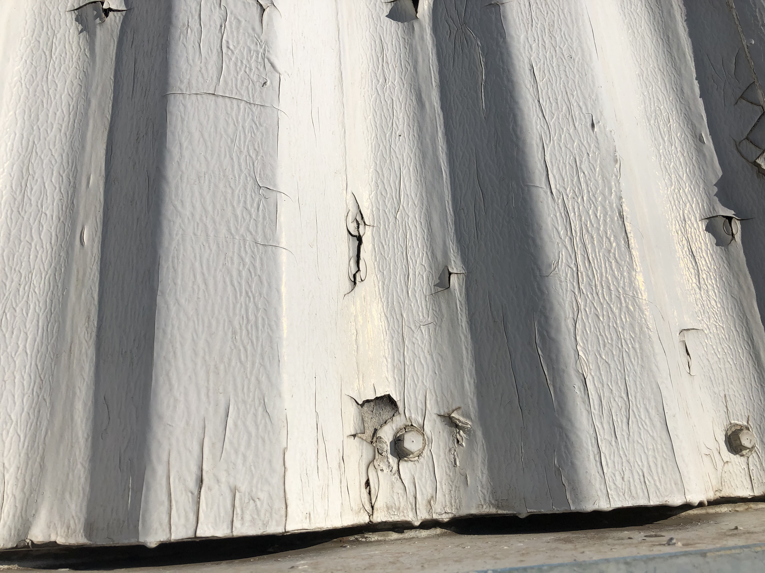
  - Visually examine surfaces to be encapsulated. The purpose of the visual inspection is to evaluate existing surface conditions and determine how to properly encapsulate in accordance with this Specification. If the surface cannot be put into an acceptable condition, as described within this Specification (outlined in earlier sections above) for the particular substrate typeand/or surface conditions, do not encapsulate.
Current conditions August 2021
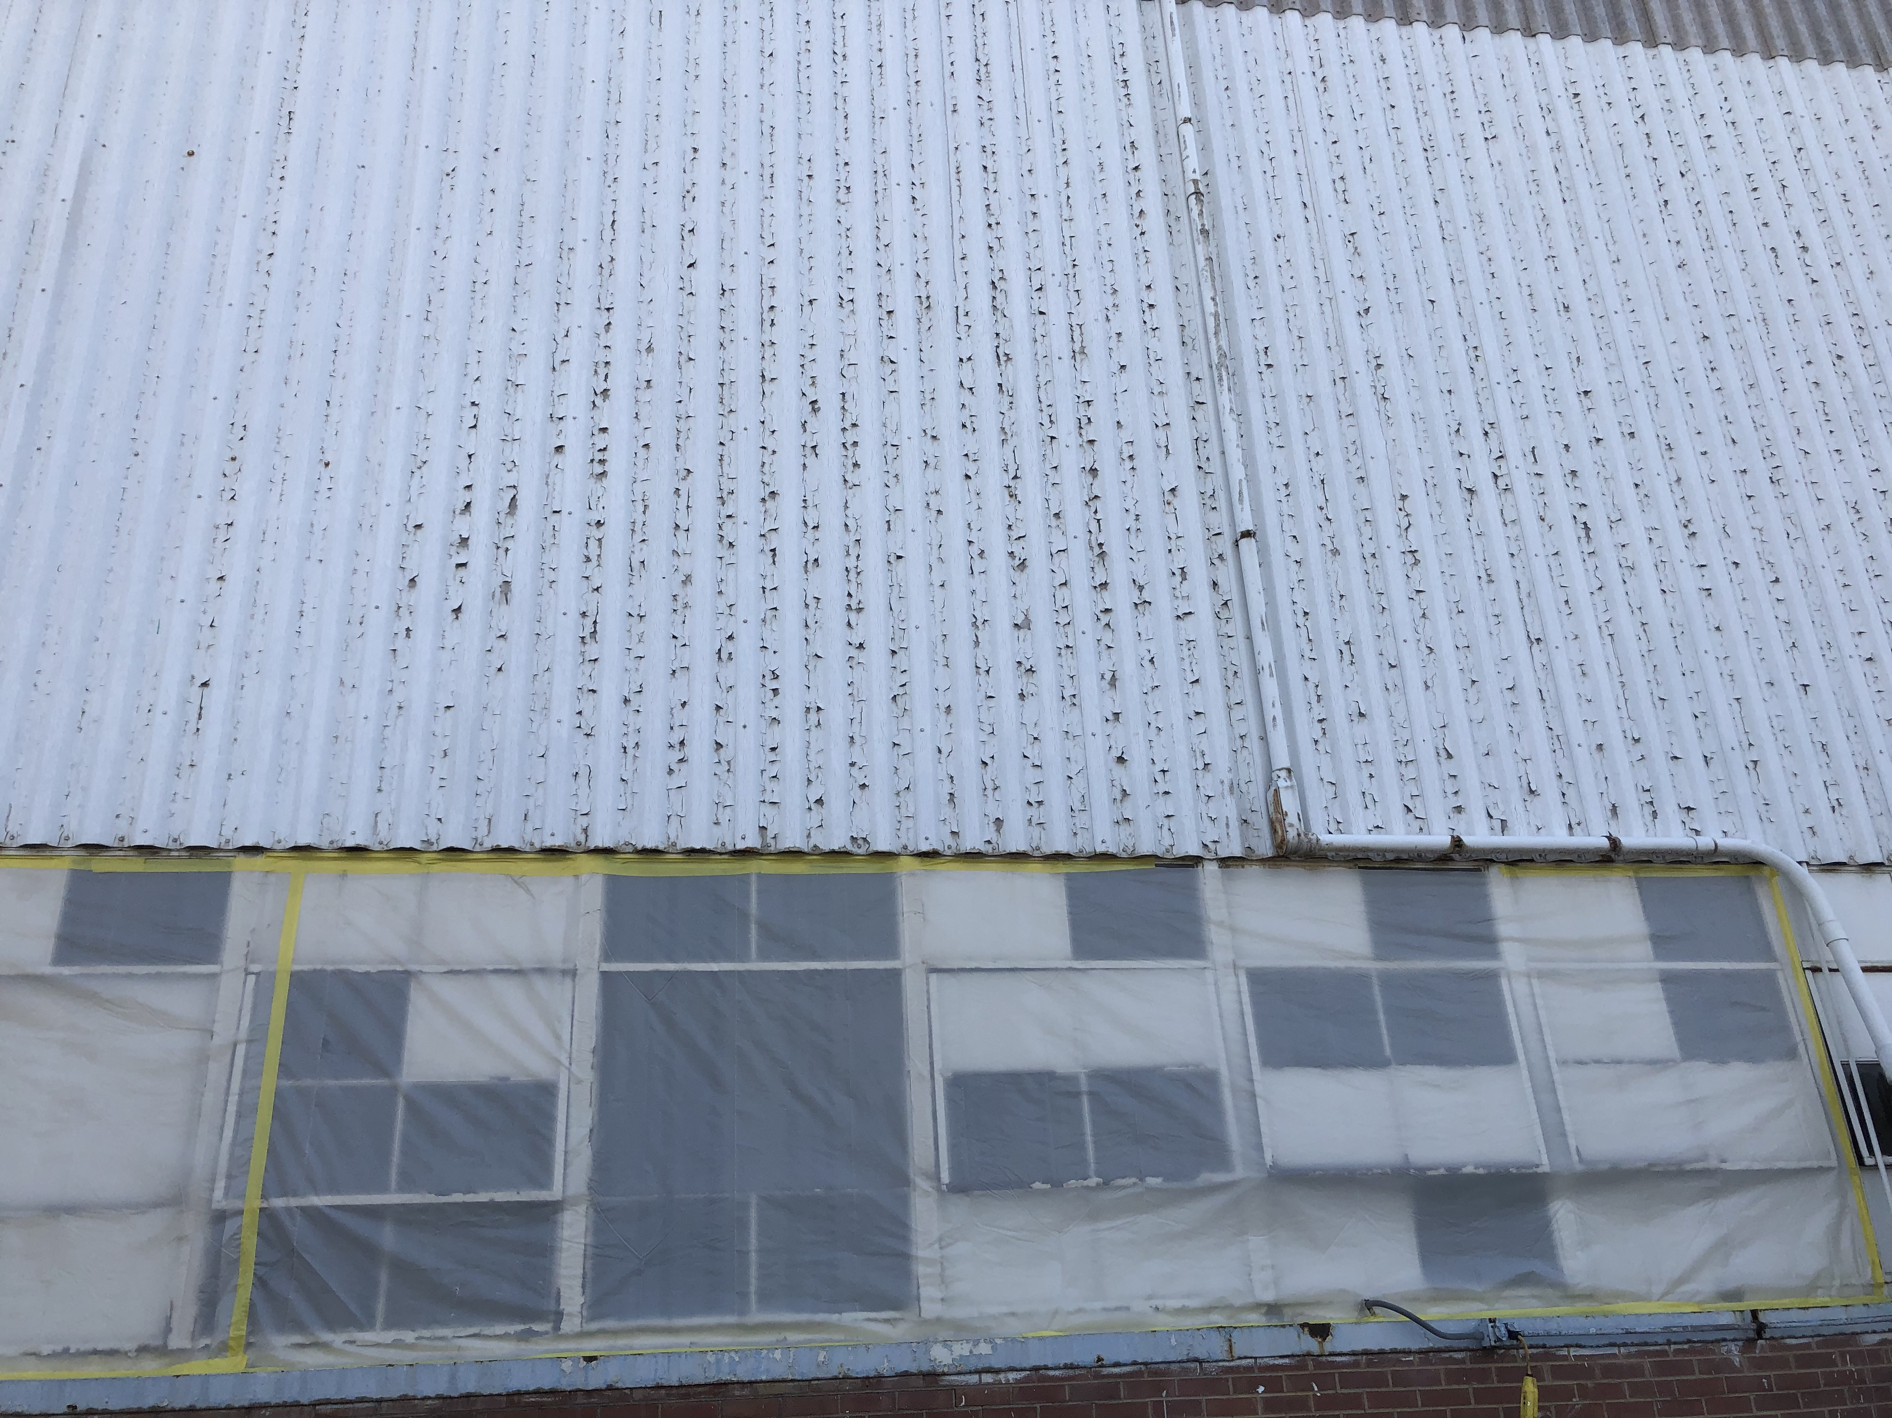
  - PREPARATION OF SURFACES
- All surfaces to be encapsulated should be properly prepared so that all are clean and dry at the time of application. This specification does not cover surfaces previously encapsulated.
- Existing paint is already delaminating freely to the textile (likely galbestos) layer. The coating or paint is not very thick. Initial preparation is to remove loose surface materials, paint and otherwise, to yield surface tight and free of gloss or other factors that would interfere with adhesion of a new coating.
- Cleaning:
  - Powerwashing is to be avoided, but a powerwasher may be used at very low pressure for cleaning. Pressurized spray can drive moisture deeply into substrates such that project timetables can be delayed to permit trapped moisture to gradually migrate outwards. Trapped moisture that is encapsulated can cause future failure as moisture, whether osmotic pressure or temperature differentials, can overwhelm the adhesion of the encapsulant causing delamination.
  - Wet clean all surfaces. Use a biobased, concentrated or RTU, butyl-free cleaning agent by foaming or soaping nozzle and settings (See Basis of Design, Section 2). Follow product instructions regarding mixing, dwell time, and then best methods for removing from substrate contaminants the detergency of the cleaner has emulsified and dislodged. Remember to consult relevant local ordinances and AHJs that likely govern such activities when ACM may be involved.
  - Consider agitation when cleaning wet to disturb existing surfaces that are unstable, but to the observer appear visually sound. For tall surfaces, such as those on this specified project, consider workers on lifts that use stiff-bristle brooms (such as corn brooms) on wet surfaces to disturb and reveal surface areas requiring preparation, as well as enhancing the overall quality of the cleaning process by helping the cleaning chemistry detach and lift contaminants. Guard against drying that would change particulate movement. All disturbed surfaces must be sufficiently wet during this process that particulates fall or flow directly down towards capture for disposal.
  - Review carefully whether rinsing is required, especially when most AHJs will require at least temporary capture of water (wash and rinsate, if any) for testing in order to categorize for disposal. Below each cleaning area, construct a plastic lined trough sloped towards cheesecloth or similar simple filtration that can capture solids, also for the purpose of categorization for proper disposal (as well as to prevent cross-contamination of the surrounding environment). Push with a squeegee or similar the captured solids in the trough into the filtration media.
  - Certain complex areas, such as over planters where it will be necessary to work off a boom, will require deviation from the guidance above. All parties involved shall agree in advance to how the installer will be expected to execute in such areas, and to involve the AHJs in such deviation, if there is consensus that such steps are prudent.
- Repair of Fasteners and similar after cleaning:
  - Check all screws, any that are loose, remove them and replace with a size larger screw
  - Use a dollop of mastic on each screw the size of a quarter (or larger depending on the screw) to fully encapsulate the screws.
  - Inspect for ferrous metal and other sources of corrosion. Rust must be addressed by priming by a DTM primer to arrest and seal in rust. Failure to address areas of corrosion can yield future bleeding stains. Creeping rust that can destabilize coatings is another possible consequence of unaddressed corrosion.
- Surface Defect Repair of Voids, Depressions, Divots and similar: It is preferred for installer to use a trowelable, thick compound that has a chemistry formulation as similar as possible to the Bridging Encapsulant. Ideally, trowelable repair product can be brushed, but is more commonly applied with mason’s trowel, soft spatula or painter’s mitt.
  - Polyurethane foam may be used to fill surface defects too large for a trowelable compound.
- Failure to confirm in advance that preparation products (cleaning or repair) or methods are compatible with the specified coating system is likely to void any warranty. Materials in the Basis of Design section of this specification are already prequalified towards a warranty consideration.
3.03 APPLICATION

- Apply encapsulant only after the surface has been examined, assessed, prepared, cleaned, and dried. Application of encapsulant to surfaces that are not clean and dry as described will void all reasonable expectations of performance. .
- ADHESIVE PRIMER (aka/serving as PENETRANT, PENETRATING ENCAPSULATION) -
  - Role & Purpose of Adhesive Primer (also serving as Penetrating Encapsulation): This specification is prepared for exterior substrates that are cementitious in nature, high density/low porosity, and dimensionally stable excepting common age/exposure related deterioration such as spalling, chalking and similar. Other types of ACM Encapsulation projects are typically more reliant on a penetrating encapsulation for enhancement of substrate stability. The specified project herein is better served with an adhesive primer formulated for cementitious surfaces, and that type of product is listed thereby in the Basis of Design (Section 2). A traditional penetrating encapsulation could be performed instead provided the approach was used in successful mockup.
    - Penetrating Encapsulants: For most fibrous asbestos applications, add 1 part water to 1 part bridging encapsulant (manufacturer’s instructions may vary from product to product regarding water addition to achieve penetration).
    - The product listed in the Basis for Design is more suited to hard cementitious substrates not requiring the penetration utilized as standard practice for indoor low density fireproofing for example. The adhesive primer formulation type as specified would be applied for this type of project at full-strength (but could be diluted for other aspects of a project such as a demolition adhesive, post-removal lockdown, or as a particulate control wetting agent during removal of unstable materials as part of surface preparation).
  - Application of Adhesive: Apply adhesive primer (or penetrating encapsulant) solution to the ACM by airless sprayer (or roller) until surface is visibly saturated.
  - Coverage, depending on thickness and porosity of the material, can vary between 50-75 sq. ft./gal.for a traditional penetrating encapsulant mixture, or as specified for this project, user can expect the adhesive primer to successfully condition the cementitious surfaces when applied at 100-200 sq. ft./gal.
- BRIDGING -
  - Dry-Film Thickness:
    - All parties should determine and agree during the bid solicitation process to the necessary dry film thickness for bridging encapsulant for any project. Ideally, this determination is in consultation with the Approved Encapsulant Manufacturer. As of the date of this specification, the thickness and coverage rate anticipated for this project is:
      - WFT: 30 mils
      - DFT: 18 mils
      - Estimated Coverage per gallon (corrugation included): 30 sq. ft. per gal.
    - The necessary dry film thickness of a bridging encapsulant for asbestos containing materials (ACM) will vary from project to project as ACM can have a wide range of characteristics, including density, porosity, and surface profile. In the EPA’s Guidance for Controlling Asbestos-Containing Materials in Buildings, the primary instruction regarding dry film thickness states that when encapsulating ACM, the coating is to be applied “considerably thicker than recommended for painting” and at no more than 100 sq. ft./gallon. AT 18 MILS DFT SPECIFIED, THIS PROJECT IS SATISFYING AND SURPASSING THIS EPA MINIMUM REQUIREMENT.
  - Application of Bridging Encapsulation:
    - Apply bridging encapsulant at full strength to ACM by airless sprayer or roller. Spray and backroll will likely yield the desired film thickness most efficiently.
      - Practicality and benefit of backroll be confirmed by mockup, and confirmation of owner’s preference.
      - Airless Spray Instructions: Review the airless spray instructions delineated on page 3 of the Serpimastic Product Data Sheet (PDS) located at: https://www.fiberlock.com/wp-content/uploads/SerpiMastic_PDS_v2.pdf
        - Installer and all parties are to review and understand descriptions in this document of dry time, aesthetic surface imperfections (orange peel, cracks) especially where project site temperatures are high, and/or day/night differentials are pronounced.
        - Note that elevated applications (I.e., a steep and significant rise from pump to nozzle and applicator) are typically fulfilled most efficiently by switching from electric airless to gas-powered airless (such as the Titan Speeflo equipment.
      - Roller: Use a ¾” synthetic nap.
      - Other handheld application methods: Brush application is not the same as painting. Use a stiff brush with short, synthetic (eg., nylon) bristles that can be work the SerpiMastic into the crevices and coarse profile of uneven surfaces.
    - Apply bridging encapsulant ideally when adhesive primer (penetrating encapsulation) is dry and has developed a tack to the touch by fingertip. Adhesive primer will have changed in appearance from milky white to clear, and some of the primer will have soaked into the paint-free areas (which will ne noticeably more solid to touch).
    - Successful encapsulation to reduce the probability of future friable fiber generation is contingent on careful application of a contiguous film across all areas of the surface. Physical performance attributes, including durability, will not be achieved to the Owner’s expectations if the specified DFT is not achieved.
    - If the adhesive primer application/penetrating application was conducted correctly, the porosity of the ACM should have been reduced such that a single coat of the bridging encapsulant will yield a contiguous film.
    - Applicators should be regularly checking the WFT by wet film thickness gauge, and results should be recorded and delivered to the provider of independent oversight and clearance responsibility at final inspection, or to Owner or Owner’s Agent upon substantial completion.
    - The Bridging Encapsulant shall provide complete hide of the prior surface color, but may not block stain migration from beneath, nor rusting of exposed ferrous metals. Shallow uneven surfaces are likely to be smoothed by the specified film thickness, but larger differential step-ups and step-downs will still be visible to the eye at nearer distances.
END OF SECTION

END NOTES

1. Any/all of these notes for specifiers may be retained in the final project specification, or reviewed and then discarded. This is entirely at the discretion of the specifier.
2. This is a specification prepared by MasterWorks, the education and specification entity of ICP (Innovative Chemical Products). The ICP Group specializes in manufacturing and distributing professional products for building applications and industrial coatings & adhesives. ICP manufactures products for approximately 20% of the divisions, sections and subsections of the MasterFormat system managed and utilized by AIA, CSI, CSC, SCIP and most other entities engaged in the design, construction and operation of the built environment in North America.
Users of this specification are strongly encouraged to engage MasterWorks’ resources and industry expertise in customizing this specification:ii
a. Web: www.icpmasterworkscommunity.com
b. Email: specifications@icpgroup.com
c. Phone: 800-342-3755 x 2241

All construction projects are unique. Ultimately, it is the responsibility of the involved parties (e.g., Installer/Applicator, Remediator/Restorer, General Contractor, Owner, Client, Enforcement Authority, Architect, Engineer or Consultant) to verify on a case-by-case basis that applications of this specification are appropriate.

3. The specifier is NOT obligated to utilize this specification in entirety, but instead is encouraged to adopt/adapt/apply those provisions which are applicable to specific projects.
4. It is understood that certain project dynamics preclude the use of product or manufacturers’ names. Section 2, Basis of Design, is intended to provide the specifier with performance criteria that can be utilized to establish minimum criteria, but without identifying any specific product by name, model number or manufacturer. For those specifiers, simply omit the product and manufacturer name, and utilize those performance criteria that are most project- applicable as the minimum requirements for submittals.

5. Deviation: Certain projects will involve unavoidable circumstances that prevent contamination removal in full accord with the professional standards of care, and the tenets of this specification. h A separate and specific specification should be developed in consultation with all parties, including product manufacturers, when deviation from the currently practiced standards of care is the only option for achievement of the objectives of the property owner.
6. Coordination: Coordinate with local and State health departments to ensure that current building codes, protocols and guidelines are followed.
7. Superiority: Where contraindicated by federal, state, or local laws and regulations, any of the preceding supplant the information in this document
8. The effective encapsulation of any abatement project is contingent upon the competence of the applicator
9. If encapsulated surfaces are damaged, repair and re-encapsulate immediately to prevent exposure to the potential hazard. HUD, EPA and state governments recommend periodic and/or annual examination of all encapsulated surfaces for damage.
10. This specification does not fully describe all the limitations, warnings and precautions related to the products described herein.

- Reference should be made to the Technical Product Data Sheets for complete technical information on all products manufactured by Fiberlock, a brand division of the Environmental Restoration Group (ERG) of the ICP BUILDING SOLUTIONS GROUP.

- Safety Data Sheets (SDS) should be referred to for health and safety information. Copies of all SDS sheets can be obtained by visiting our website at www.fiberlock.com

Copyright © 2022 by ICP BUILDING SOLUTIONS GROUP, Inc.

This publication was produced specifically for [_____________], for the use of the [__________] Project, and their consulting engineering provider: []

For other parties, this specification may not be reproduced or copied in whole or in part by any means without the express written permission of ICP BUILDING SOLUTIONS GROUP.

- To obtain a custom specification for your project or organization, contact the MasterWorks Design+Specification team at ICP BUILDING SOLUTIONS GROUP by email to specifications@icpgroup.com

MSW08162021

END NOTES FROM WITHIN SPECIFICATION TEXT:

Reference to the Battelle Report of ACM Encapsulants tested under US EPA contract from 1978-1984 will provide a listing of encapsulants with this longevity, although not all products remain available in the marketplace. The report can be found at https://www.fiberlock.com/resources/product-testing-documents/ , and it states Battelle judged 11 of the 100 encapsulants tested to be acceptable, and rated 23 others to be marginally acceptable. ICP’s understanding as of the date of this specification is that A-B-C Asbestos Binding Compound, Serpiflex, Serpimastic, and Lag-Kote are among the original products that passed the protocol and are still produced today by ICP. One other product from the Battelle testing made by another company also remains commercially viable in the marketplace.
Transite is a trademark of the JM Corp., and Masonite is a trademark of the Masonite Corp. This specification is not intended to conclude without qualification that either contain asbestos, and it is in fact highly unlikely that Masonite would contain asbestos when encountered in buildings in the field. However, in either case, properly applied Serpimastic would provide service as an encapsulant against unwanted release against a range of particulates, including silica.
May be used with, may require for degradation repair, the use in conjunction with Fiberlock’s Lag-Kloth, a rewettable repair lagging material. Often wrapped over replacement insulation and then the combination of Lag-Kloth and Serpimastic forms the long-term protective membrane around the restored surfaces.
According to the website https://trademark.trademarkia.com/galbestos-71374021.html: The trademark Galbestos was filed in 1936, and when expired in 1998 was owned. by H.H. ROBERTSON COMPANY.
Consult with the ICP Flooring and Cementitious Group at https://www.icpgroup.com/products/icp-building-solutions-group/flooring-cementitious/ . N.B., Encapsulants are not considered as nor adequate for abatement of friction and impact surfaces when used alone, but depending on AHJs, could be protected from wear via enclosure with sufficient protective elements.
https://www.fiberlock.com/wp-content/uploads/SERPIMASTIC-PERM-US-Testing-company-Permeability-testing.pdf
https://www.fiberlock.com/wp-content/uploads/SERPIMASTIC-PERM-US-Testing-company-Permeability-testing.pdf
https://www.fiberlock.com/wp-content/uploads/SERPIMASTIC-UL-Certificate-of-compliance-.-for-use-with-classified-sprayed-fiber-or-classified-cementitious-mixtures.pdf
https://www.fiberlock.com/wp-content/uploads/UL-Labs-Report-on-encapsulant-materials-E119-Sepiflex_Serpimastic.pdf
The problem with a lot of metal construction screws is that they often have a neoprene rubber or plastic gasket that is designed to waterproof the hole created by the screw. Unfortunately over time that gasket degrades and no longer creates a waterproof seal. And it becomes worse as the building moves and fasteners wiggle and start to loosen. That’s why we completely encase the fastener in mastic—to re-waterproof each of those holes.
Serpimastic is not miscible, i.e., cannot be diluted for use as a penetrating encapsulant. If desired, Serpiflex can be diluted and used for such purpose.
Note that a qualified asbestos professional may be required by law or regulation to assess or design for individual abatement projects.
When estimating corrugated, it is best to field verify using a soft measure tape to get an accurate stretch factor.
Guidance for Controlling Asbestos-Containing Materials in Buildings. Office of Pesticides and Toxic Substances, EPA 560/5-85-024, June 1985, Washington, DC. (Commonly referred to as the EPA Purple Book) https://www.fiberlock.com/wp-content/uploads/EPA-1985-Guidance-for-Controlling-ACM-Purple-Book.pdf

