DIVISION 2 – EXISTING CONDITIONS
02 51 29 SURFACE CLEANING DECONTAMINATION
(MOP [METHOD OF PROCEDURES SUMMARY] – SMOKE-IMPACTED CEMENTITIOUS FIREPROOFING [SFRM])

- Any/all of these notes for specifiers may be retained in the final project specification, or reviewed and then discarded. This is entirely at the discretion of the specifier.
- This is a specification prepared by MasterWorks, the education and specification entity of ICP (Innovative Chemical Products). The ICP Group specializes in manufacturing and distributing professional products for building applications and industrial coatings & adhesives. ICP manufactures products for approximately 20% of the divisions, sections and subsections of the MasterFormat system managed/utilized by AIA, CSI, CSC, SCIP and most other entities engaged in the design, construction and operation of the built environment in North America.
- This is an MOP Summary, i.e., a Method of Procedures, which is intended to provide an abbreviated description of steps to be performed.
- The specifier is NOT obligated to utilize this specification in entirety, but instead is encouraged to adopt/adapt/apply those into project documents governing this work.
- Optional text requiring a selection by the user is enclosed within brackets and as red text, e.g.: Color: [Red.] [Black.]"
- It is understood that certain project dynamics preclude the use of product or manufacturers’ names. Section 2, Basis of Design, is intended to provide the specifier with performance criteria that can be utilized to establish minimum criteria, but without identifying any specific product by name, model number or manufacturer. For those specifiers, simply omit the product and manufacturer name, and utilize those performance criteria that are most project-applicable to generate the minimum requirements for submittals.
- For assistance on the use of the products in this section, contact:
MASTERWORKS
Web: www.icpmasterworkscommunity.com
Email: specifications@icpgroup.com
Phone: 800-342-3755 or 978-623-9980 x 2241.
FIBERLOCK (a brand of ICP’s Environmental Restoration Group
Web: https://www.fiberlock.com
Email: sales@fiberlock.com (or cwds@fiberlock.com)
Phone: 800-342-3755

QUICK REFERENCE GUIDE TO THIS SPECIFICATION PACKAGE

GENERAL REQUIREMENTS (SECTION 1)

PRODUCTS (SECTION 2 - BASIS OF DESIGN)

EXECUTION (SECTION 3)

END NOTES (SUPPLEMENTARY INFORMATION & IMPORTANT LINKS)

COPYRIGHT, LEGAL NOTICES, AND DISCLAIMERS

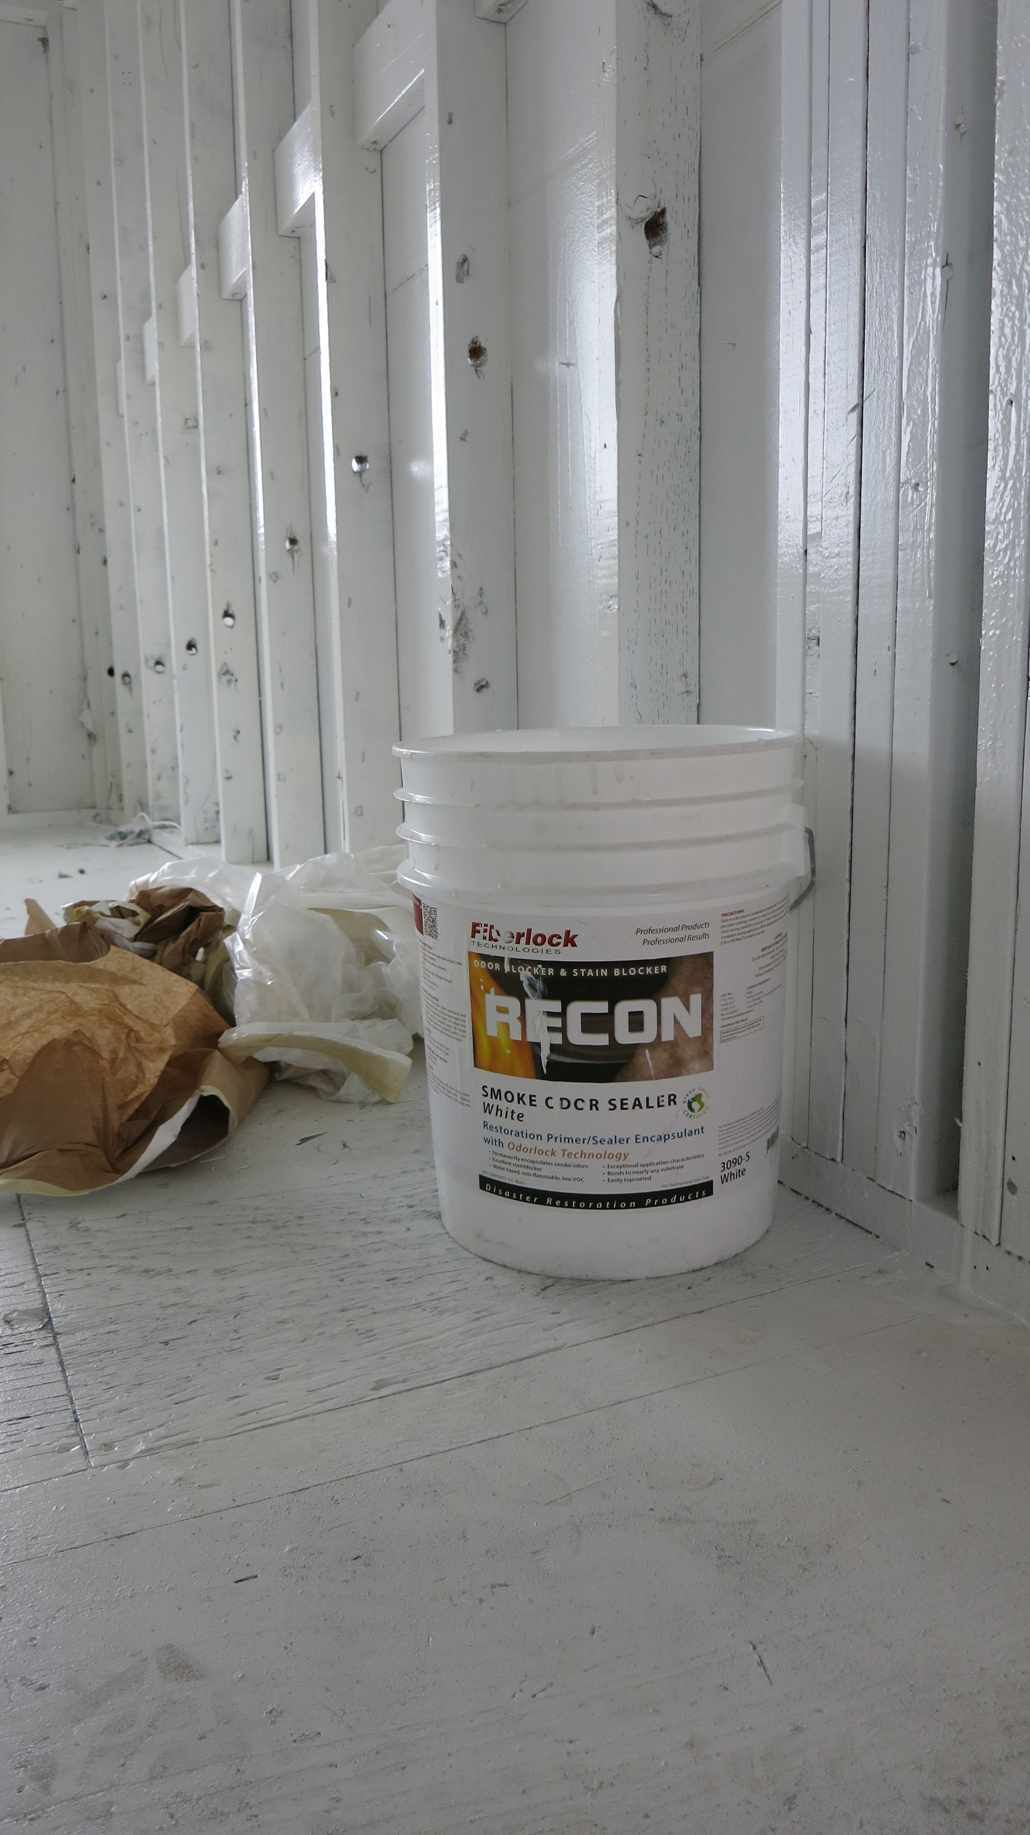
--------------- BEGIN SECTION --------------
DIVISION 2 – EXISTING CONDITIONS
02 51 29 SURFACE CLEANING DECONTAMINATION

- GENERAL REQUIREMENTS

ADMINISTRATIVE REQUIREMENTS

Retain the following for a pre-installation conference held prior to start of product installation.

Pre-Installation Conference:

Attendance: [Architect,] [Owner/Owner,] [Contractor,] [Construction Manager,] [Design/Builder] installer, and related trades.

Review: Project conditions, manufacturer requirements, delivery and storage, staging and sequencing, and protection of completed work.

GENERAL REQUIREMENTS

General: Drawings and general provisions of the Contract, including General Conditions, and other applicable specification sections in the Project Manual apply to the work specified in this Section

1.01 WORK INCLUDED

- Provide labor, equipment, materials, and related services to complete work involving field application of smoke odor sealer.
- See the EndNotes, as well as the Notes to Users below for limitations and guidance to improve use of this document.

1.02 RESOURCES, REFERENCES AND RELATED SECTIONS

- Related & Addressed-In-Part; and/or Specified elsewhere:
  - CSI (AIA MasterFormat Sections), CSC (US, Canada Respectively)
    - Section 099000 – Finishes
    - Section 099100 – Professional/Commercial Painting
  - NATSPEC (Australia)
    - Section 0671 Painting

1.03 QUALITY ASSURANCE
- REFERENCES/STANDARDS: Cited standards are incorporated herein by reference and govern the work:
  - American Society for Testing and Materials
    - E 84 Standard Test Method for Surface Burning Characteristics of Building Materials
  - Regulatory Compliance and Sustainable Design:
    - South Coast Air Quality Management District (SCAQMD): Rule 1113, effective February 5, 2016
- SINGLE SOURCE RESPONSIBILITY:
  - Obtain dry erase clear coating system, application equipment, and any ancillary products (e.g., preparation cleaner, primers, markers and marker cleaner) from a single manufacturer with not less than [5+] [_ _] years of successful experience in manufacturing and specifying installation of the principal materials described in this section.
- MANUFACTURER OVERSIGHT OF APPLICATOR AND APPLICATION PRACTICES:
  - Installer Experience & Competence: The installer(s) shall have IICRC SFRT/or RIA CR professionals on staff and associated with the project.
  - Installer’s certification shall not have expired.
  - Manufacturer Responsibility for Oversight: Whenever possible, involve company representation on-site from Approved coating system manufacturer.
    - If periodic on-site support is not possible, arrange for remote consultation with the manufacturer’s Subject-Matter-Expert (SME) to verify satisfactory conduct of the surface evaluation, preparation, and installation/application methods and techniques.
    - Document that the coating system manufacturer’s representation participated fully.
    - Note that manufacturer oversight does not constitute assumption by the manufacturer of responsibility for proper project execution. It is not possible for manufacturer representation to ever observe all simultaneous activity on a project site, nor examine every location of installed product. Manufacturer shall document quality control activities insofar that if examined areas and activities are representative of the whole, then the Owner has reasonable added reassurance that performance will be reliable.
  - GENERAL QUALITY OF WORKMANSHIP: Apply materials consistent with workmanship that exceeds pertinent industry standard-of-care, and the following inadequate defects will not be tolerated:
    - Runs,
    - drips,
    - "ropiness",
    - "orange peeling",
    - uneven gloss,
    - bleed through,
    - surface imperfections,
    - uneven cut-ins,
    - over-application,
    - excessive brush marks,
    - or other defects in final finish will not be accepted.
- MOCKUPS/PILOT AREAS; COORDINATION & SUPERIORITY:
  - MOCKUPS/PILOT AREAS:
    - All parties shall consent to and fully support a mock-up application if requested.
- COORDINATION: Notify Architect/Engineer in writing of concerns with surface treatment materials or primers installed by others and recommended remedies. Proceeding with installation indicates acceptance of surface conditions.
- SUPERIORITY: Where contradicted by federal, state, or local laws and regulations, any of the preceding supplant the information in this document.
1.05 SUBMITTALS: RESERVED.
- Comply with submittal instructions found in Division 1 for the project
Notes:
c) Substitutions will only be considered for products manufactured by companies of primarily U.S. ownership, and when the proposed substitute product is “all or virtually” all manufactured in the United States (in accord with the Made in USA Standard of the Federal Trade Commission (FTC). Statements such as Made in the USA with Globally Sourced Products, or equivalent statements, will be accepted.
1.05 PRODUCT DELIVERY, STORAGE AND HANDLING

- Deliver manufacturer's unopened containers to the work site. Packaging shall bear the manufacturer's name, label, and product number.

- Storage of materials:
- Store only acceptable project materials on site.
- Store in suitable and secured location convenient to progress of work.
- Comply with health and fire regulations. No products listed in the Basis of Design are flammable or combustible.
- Storage temperature shall be between 40° F (4.5 C) and 90° F (32 C), or such other ambient temperature conditions as may be specifically recommended by product manufacturer.
- Products shall not be permitted to freeze on site, and delivery should be refused if freezing during transit is probable. Inspect with instant thermometer upon receipt when shipment occurs during below freezing temperatures.
- Avoid storage directly in hot sun exposures or excessive temperatures.
- Keep containers tightly closed when not in use.
- Store securely closed and upright in original container.
- Keep out of reach of children.

- Handling:
  - Dispose of materials in accordance with requirements of local authorities having jurisdiction.
  - Verify that products are within acceptable shelf life, and do not utilize any product that is older than the maximum shelf life stated by the manufacturer.
- Extra Materials:
  - Furnish extra coating materials in the quantities described below. Package with protective covering for storage and identify with labels describing contents. Deliver extra materials to Owner.
  - Furnish Owner with sufficient additional mold-resistant or fungicidal coating to address an additional one percent of overall surface area, but not less than 1 gal (3.8 l), pail (19 l),or 1 case, as appropriate and collectively agreed upon in advance of substantial completion.

  - JOBSITE CONDITIONS

- Environmental requirements: Comply with manufacturer’s recommendations as to environmental conditions under which all chemicals and coatings can be applied.
  - Temperature:
    - Maintain ambient temperature not less than 50°F/
    - Do not install coatings unless substrate temperature is above 60 degrees F.
  - Controlled Construction Conditions
    - Provide adequate illumination and ventilation.
  - Surface/Substrate Moisture:
    - Moisture in excess is to be corrected
    - Consult manufacturer regarding whether topical dampness (latent moisture tangible by touch) after wet cleaning is acceptable at time of application. Applicators are expected to account for slow-drying surface elements (such as shaded areas, hairline cracks, nail holes).
  - Humidity: [RESERVED]
  - Surface Protection/Prevention of Cross-Contamination: Cover or otherwise protect adjacent areas. Identify adjacent areas which could be cross-contaminated by all site activity.
    - Careful attention should be paid to any occupied areas in the vicinity of the work area.
    - Utilize adequate engineering controls to ensure worker and occupant safety and health, and prevent cross-contamination. Engineering controls may include, but are not limited to, source containment, isolation barriers, pressure differentials, dust suppression, and high efficiency particulate air (HEPA) vacuuming and filtration.

2.00 PRODUCTS

2.01 MATERIALS (Basis of Design)

- Smoke and Odor Sealer: FIBERLOCK SMOKE ODOR SEALER. Product ID: 3090 White and/or 3091 Clear. Manufactured by Fiberlock, a brand of ICP BUILDING SOLUTIONS GROUP; located at 150 Dascomb Road, Andover, MA. 01810. (800-342-3755) www.fiberlock.com / [or equal]
  - Intended for use as a topically applied sealer after cleaning to restrict future release of smoke odor from the preceding combustion event
  - Key Performance Attributes of smoke odor sealer Coating System:
  - Product Specifications
    - Solids by Weight ± 2%: 51.4%
    - Solids by Volume ± 2%: 44.0%
    - Viscosity at 70°F: 75 Kreb Units
    - Specular Gloss: 82º ± 5 @ 60º
    - Flash Point: Non-combustible
    - Shelf Life: 36 Months Min. (Original Sealed Container)
    - Calculated VOC: White: 68 grams/liter Clear: 60 grams/liter
    - Coverage Smooth Surfaces: 200-300 ft2 /gal Porous Surfaces: 100-200 ft2 /gal
    - Drying Times (@ 70 - 77°F , 50% R.H.)
      - To Touch: 30 Min.
      - To Recoat: 4 hours
      - To Topcoat: 24 hours
  - Minimum Application Temp: 55º F (12.7º C) In areas with high humidity, apply when surface temperature is 60º F or higher.
  - This product is acceptable for use inside HVAC systems. For information on proper use of chemicals and coatings inside of HVAC systems, consult the manufacturer and review the most recent guidance from the National Association of Duct Cleaners of America (NADCA).

- CLEANING FOR COMBUSTION PARTICULATES: BOTANICAL CLEANER/DEGREASER, CONCENTRATE
  - ATOMIC BOTANICAL CLEANER & DEGREASER (ATOMIC) [or equal]
  - Product ID: 80475
    - Available:
      - Case of 1 Gallons: (Case Total - 4G; 3.78 liter per jug)
      - Five Gallon Pail (18.9 Liters)
      - Fifty-Five Gallon Drum (208 Liters)
  - Manufactured by BENEFECT, a brand of the ICP BUILDING SOLUTIONS GROUP; Administrative Offices: 150 Dascomb Road, Andover, MA 01810. 800-909-2813 www.benefect.com
  - Document Server Links for product: OVW TDS SDS LBL VID
  - Key Attributes of Cleaner
      - Exposure: Interior/Exterior
      - Active Ingredient: Plant derived surfactants and essential oils, solvent-free
      - Bio-Based Content: 100%
      - Color: Clear (Amber, Hazy)
      - Odor: Slight Detergent
      - Dyes/Pigments: None
      - Reodorants: None
      - Foaming: High Foaming
      - Flash Point: Non-combustible
      - pH: 10.9-11.0
      - Maximum VOC: 0 g/l
      - Biodegradable: Complete
      - Shelf Life: 3 years minimum
      - Coverage: 200-500 sq.ft./gallon
      - Miscible/Dilution: For mold & biofilms, mix from 16 oz/gallon to using full strength

- 2.02 COLORS
- WHITE OR CLEAR

2.03 MIXING

A. Accomplish job mixing and application only when acceptable to the Architect/Engineer.

B. Mix components only in containers furnished or approved in writing by the Manufacturer.

C. (RESERVED)

D. Thinning or diluting, is not permitted, unless expressly instructed in writing in advance by the manufacturer.

3. EXECUTION

  - EXAMINATION

- PRE-WORK VISUAL INSPECTION: Examine areas and conditions in which dry erase coatings will be installed.
  - Do not proceed with installations until unsatisfactory conditions have been corrected (ALSO see COORDINATION above in Section 1.
  - SURFACE PREPARATION
- Dry clean surfaces to remove gross amounts of combustion particulate. Permitting excess combustion particulate to remain on the surface can compromise performance of the smoke and odor sealer.
- Combustion particulate for low temperature fires, or when more than one floor or other significant distance from the seat of the fire, will result typically in PICs (products of incomplete combustion) that require a wet cleaning step:
  - Use botanical degreaser specified in Section 2 of this specification or equal
    - This product may be used for residues from structural fire or wildfire.
  - Remove combustion particulate from surfaces of SFRM. Clean outermost surfaces only. Take care not to saturate SFRM.
- Remove hardware, accessories, plates and similar items that cannot be coated, or protect inplace. Such surfaces will need to be cleaned off-site or in place to remove combustion residues.
- Gaps and junctions of surfaces and structural elements may be too large for a coating too bridge once dry. These micro-cavities can contain PICs and emit smoke odor indefinitely. Similar to best practice in painting, it is advisable to seal such areas with foam (appropriate SPF can foam such as HandiFoam) or caulk. Note that foam is typically more permanent and less vulnerable to future shrinkage than caulk.
- Rusted metal will need to be primed. The specified sealer is an excellent stain blocker for water and general combustion discoloration, but spot priming of metal will be needed when rust is present.

  - APPLICATION

- Permit surfaces that have been wet cleaned to dry until damp but not wet to the touch
- Apply smoke odor sealer in crosshatch pattern taking care to deliver a consistent and contiguous wet film to all surfaces. Note that any uncoated surface can provide a significant opportunity for residual smoke odor to release in the future.
- Methods of Application
  - Brush: Apply liberally and uniformly with a polyester or nylon brush
  - Roller: Not recommended
  - Airless Spray: Smoke Odor Sealer Coatings can be successfully applied with most major brands of airless spray equipment. Protect all surfaces not to be coated with any method of application, but provide additional attention when spraying as the atomized mist of coating can spread unpredictably.
    - Typical settings for airless spray equipment: [Recommended Airless Spray Equipment: Titan 740ix or Impact 1140 for high-volume projects/users.]
(Reversible) Tip Tip Operating Airless Min. Pump Hose
Orifice Size Air Pressure Hose ID G.P.M. Length
0.017" to 0.023" 2000 - 3000 psi 1/4" 0.50 50' -100'

    - Technique of Spraying - For best results, apply smoke odor sealer coating in sweeping strokes always keeping the tip of the gun parallel to the surface at a distance between 12" to 18" inches. 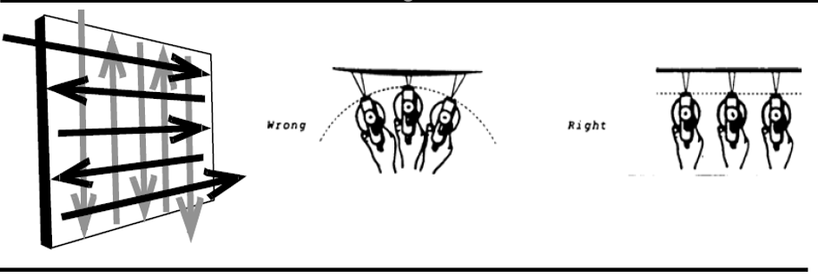
      - The speed at which the product is applied depends on the system used.
      - Normally a slow to moderate sweeping stroke of first horizontal followed by vertical passes in a ‘crosshatch’ pattern will afford the desired results.
      - If necessary, an angular mist coat may be applied to even out irregularities.
      - Best results are achieved when the filter in the spray gun handle is removed. For production work, a front feed gun produces best results. For finish quality application, a coarse filter in a standard gun is ideal.
- Coverage rate via airless spray will be lower (less square feet per gallon) compared to brush or roller application. While this difference can be as much as 50% less than other methods, adjustment of spray equipment and proper training of applicators can reduce this differential substantially.
- Application Rate: Smooth Surfaces: 200-300 ft2/gal; Porous Surfaces: 100-200 ft2/gal
- Following application, allow coating to dry until tacky to the touch then inspect for areas where application was insufficient.
  - This may be due too not enough product being delivered to the surface, or a porous “thirsty” surface has drawn in the wet coating product.
  - In either case, the results will be a membrane that is not 100% continuous over the high points and low points of the fireproofing (SFRM) surfaces. This is the opportunity to remedy with additional application.
  - Additional product can be applied while the first application is still tacky to touch or when completely dry
  - To inspect applications of clear sealer, use a high powered light at an angle to inspect for sheen, gloss. The specified product has a high gloss readily visible at an angle if application is sufficient.

3.06 POST APPLICATION CLEANING

A. Remove remaining debris promptly from work area and dispose of properly.

B. Remove spilled, splashed, or splattered coating materials from all surfaces.

D. Do not mar surface finish of items being cleaned.

E. In areas of older buildings where significant paint was disturbed by remediation operations, wipe any occupant-accessible surfaces with manufacturer approved lead-specific surface cleaner.

F. Cleanup tools and other equipment with warm, soapy water before coating dries.

G. Review product labels for proper disposal of unused product and empty containers.

END OF SECTION

END NOTES (INCLUDES SUPPLEMENTARY SYSTEM PRODUCTS BY NAME)

This section is provided as a courtesy to the specifier or project designer/manager.
This section may be included or excluded in the project specific specification at their discretion.

SITE PHOTO-taken by Fiberlock personnel and property of ICP]
Section and Subsections designated at 1.02 and elsewhere in this specification are derived from the MasterFormat system. MasterFormat®, a publication of CSI and CSC, is a master list of numbers and titles classified by work results of architectural, design, construction, and operations processes. It is primarily used to organize project manuals and detailed cost information, and to relate drawing notations to specifications. CSI is the Construction Specifications Institute. CSC is Construction Specifications Canada. The U.S. and Canadian formats were merged into a single format in 1972 (as the Uniform Construction Index, or UCI). For specification information for other nations, such as BSI in the UK, or NATSPEC/AUS-SPEC in Australia, contact ICP’s MasterWorks team for more information: specifications@icpgroup.com. Note that content of specification systems is typically protected by copyright, certain instances of use may require permission of the ownership organization.
RECON SOS was introduced in 2014
Moisture content in different types of structural materials are measured on different scales, and the measurement scales of moisture detection instruments (e.g., moisture meters meters can vary among manufacturers of these devices. Consult the manual from the moisture meter manufacturer for instructions concerning substrate type and scale of measurement for that material.
Recommended Airless Spray Equipment: Titan Impact™ 640 or 740ix or 1140 for high-volume projects/users. See: https://www.titantool.com/industry/commercial/heavy-over-4-stories/impacttm-series-electric-airless/
Example: LeadSafe lead dust cleaner manufactured by FIBERLOCK, a brand of ICP CONSTRUCTION; located at 150 Dascomb Road, Andover, MA. 01810. (800-342-3755) www.fiberlock.com (Product ID: 5496-1-C4 (Gallons) or 5496-Q-C12 (Quarts)). PLEASE REMEMBER: - The effective performance of any coating installation project is contingent upon the competence of the applicator. - If surfaces of smoke and odor sealer coatings are damaged, repair immediately. - This specification does not fully describe all the limitations, warnings and precautions related to the products described herein. - Reference should be made to the Technical Product Data Sheets for complete technical information on all products manufactured by Fiberlock, a brand division of the ICP BUILDING SOLUTIONS GROUP. - Safety Data Sheets (SDS) should be referred to for health and safety information. Copies of all SDS sheets can be obtained by visiting www.fiberlock.com. Copyright © 2022 by ICP BUILDING SOLUTIONS GROUP, Inc. This publication was produced specifically for the use of [FACILITY &/OR SERVICE PROVIDER] (___[CITY]_, ___[STATE]__) . For other parties, this specification may not be reproduced or copied in whole or in part by any means without the express written permission of the ICP BUILDING SOLUTIONS GROUP (formerly ICP Construction). To obtain a custom specification for your project or organization, contact the Design Services Team (DST) at ICP Construction by email to specifications@icpgroup.com. MSW042122

