DIVISION 2 – EXISTING CONDITIONS
SECTION 02 83 19.13 LEAD-BASED PAINT ABATEMENT – ENCAPSULATION
LEAD PAINT CONTROL & ABATEMENT FOR HISTORIC ORNAMENTAL PLASTER BOUNDARY CEILINGS

1.00 GENERAL REQUIREMENTS

1.01 WORK INCLUDED - SUMMARY

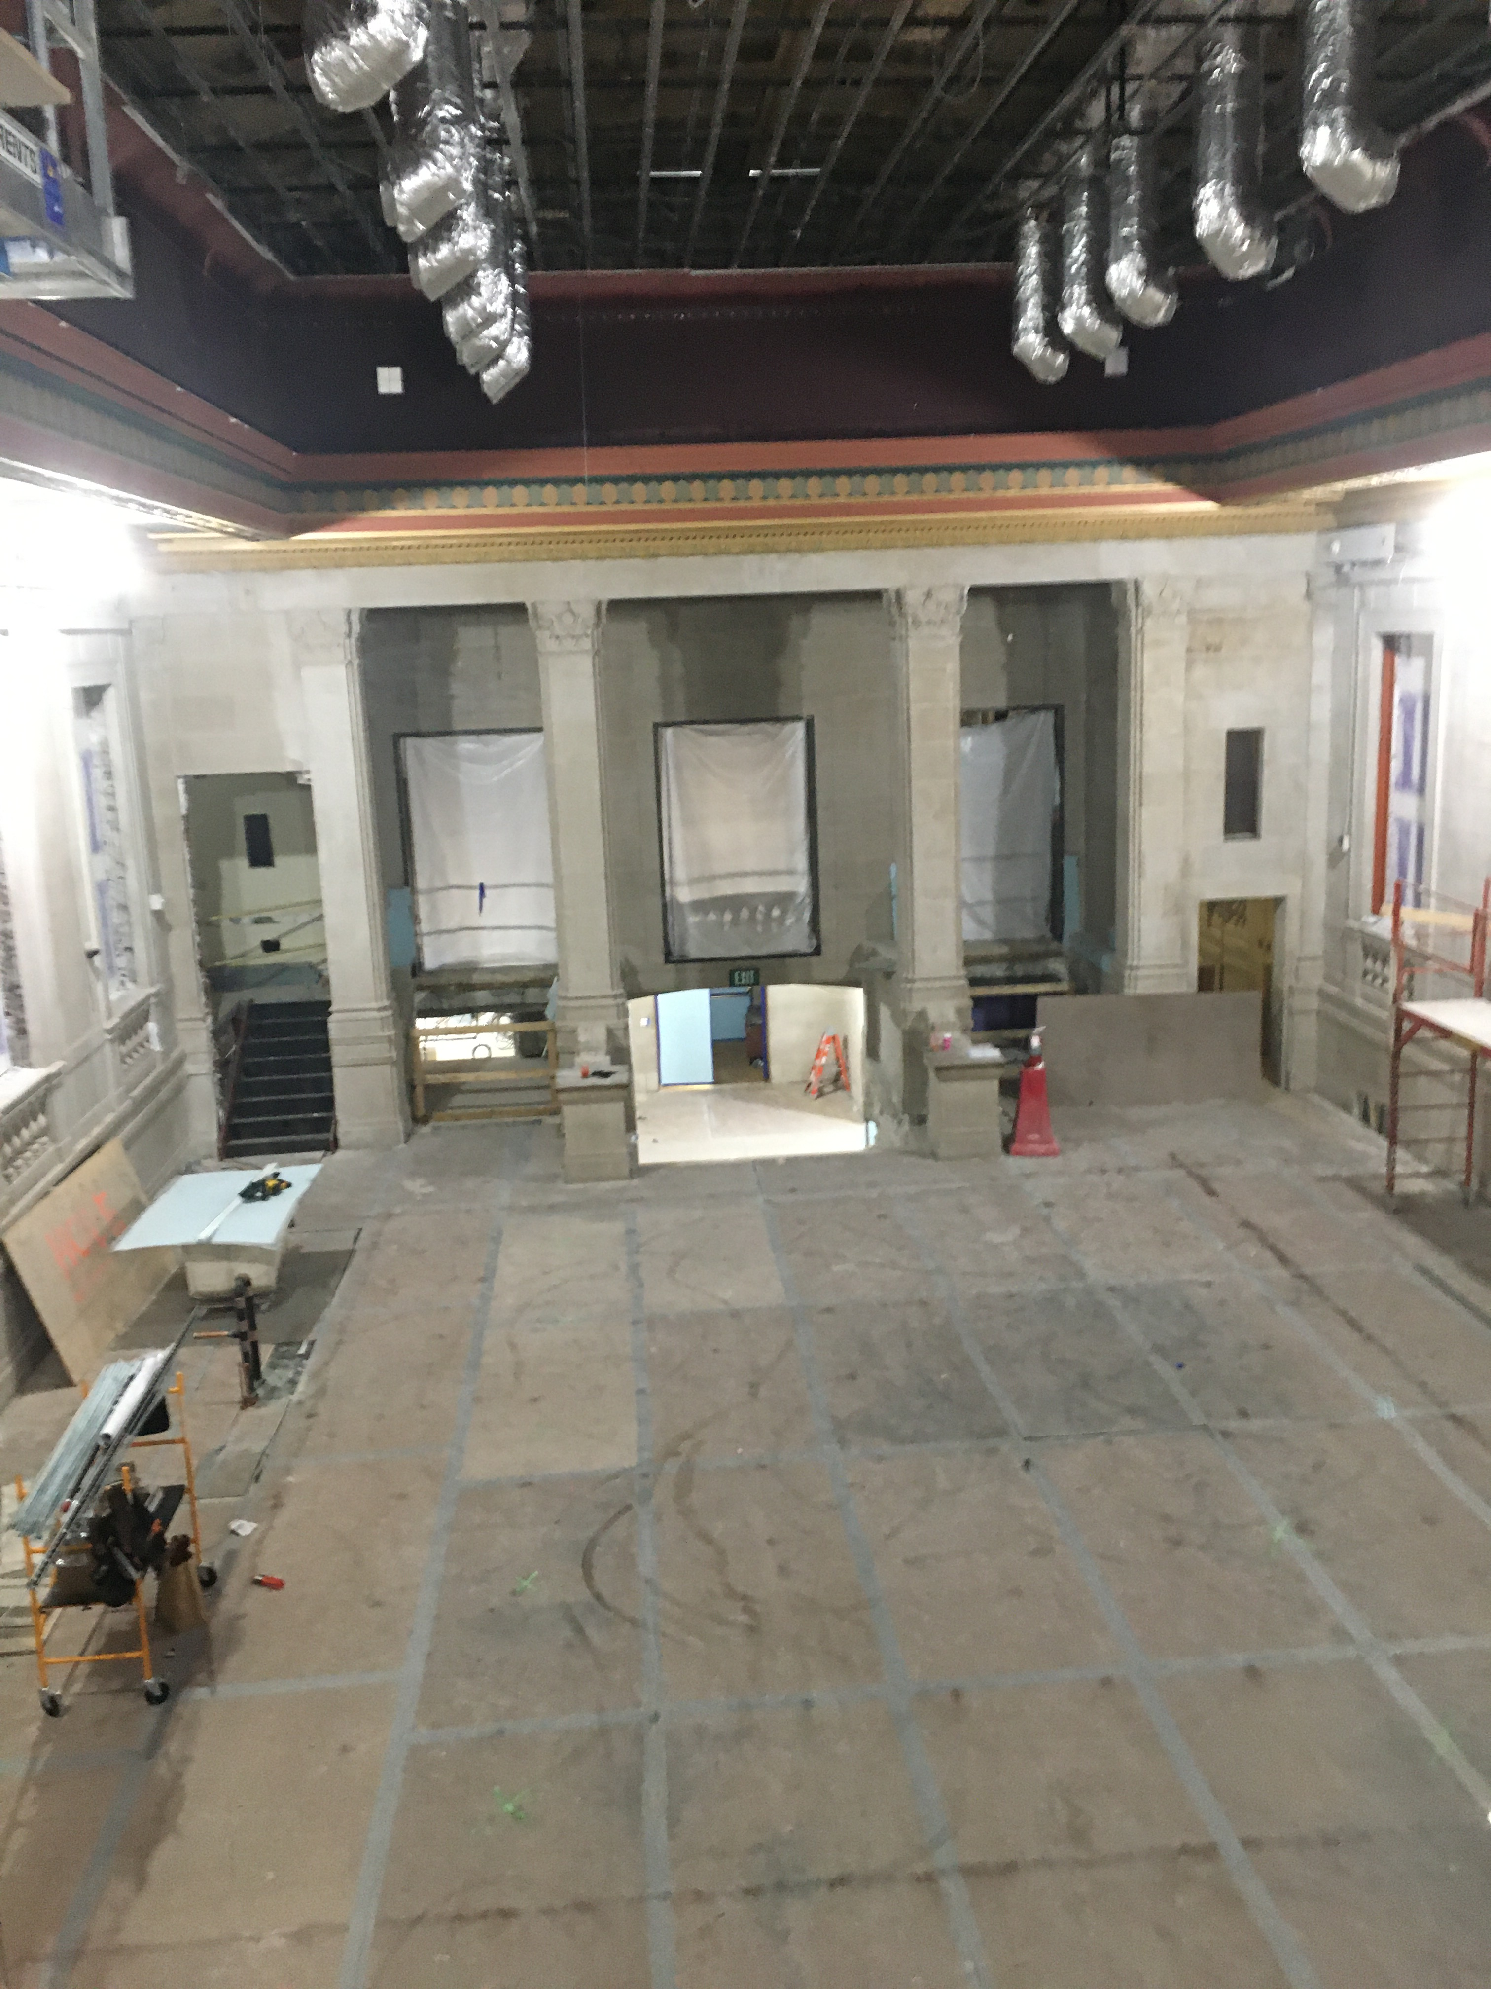
- Provide labor, equipment and materials to complete lead-specific cleaning, encapsulation of lead-based paint, and historically correct color restoration to ornamental plaster surfaces of a boundary skirt ceiling which is painted with lead paint..
- Relevant to project, environmental activities are structured around and designed to contain lead containing dust and particulates resulting from disturbances necessitated by installation of updated audio and lighting recessed into the ceiling.

1.02 RELATED SECTIONS

- Drawings and general provisions of the Contract, including General and Supplementary Conditions and Division 01 Specification Sections, apply to this Section.

- Related Sections generally Specified elsewhere:

  - Section 09 03 90 CONSERVATION TREATMENT FOR PERIOD PAINTING AND COATING
  - Section 09 03 91.23 CONSERVATION TREATMENT FOR PERIOD INTERIOR PAINTING
  - Section 09 03 56 CONSERVATION TREATMENT FOR TEXTURED CEILINGS
  - Section 02 83 13 LEAD HAZARD CONTROL ACTIVITIES
  - Section 09 01 20.91 PLASTER RESTORATION
  - Section 09 21 13 PLASTER ASSEMBLIES
  - Section 09 25 00 OTHER PLASTERING
  - Section 09 90 00 – FINISHES
- References: Cited Standards, Guidance Documents and Guidelines are incorporated herein by reference and govern the work:
  - ASTM E 1795-04 Standard Specification for Non-Reinforced Liquid Coating Encapsulation Products for Leaded Paint in Buildings, 2004
  - ASTM E 1796-03(2011) Standard Guide for Selection and Use of Liquid Coating Encapsulation Products for Leaded Paint in Buildings
  - ASTM E 84 Standard Test Method for Surface Burning Characteristics of Building Materials
  - ASTM D 2486, "Standard Test Method for Scrub Resistance of Interior Latex Flat Wall Paints."
  - Painting and Decorating Contractors of America (PDCA): PDCA P5, "Benchmark Sample Procedures for Paint and Other Decorative Coating Systems."

  - Lead Standard: 29 CFR 1910.1025 and 29 CFR 1926.62, U.S. Occupational Safety and Health Administration (OSHA) (1993)
  - How Much Cleaning is Enough, National Center for Lead-Safe Housing.
  - South Coast Air Quality Management District (SCAQMD): Rule 1113 - Architectural Coatings
- Notes to Users of this Document (e.g., Architects, Engineers, Designers and Consulting Professionals that prepare scopes of work, project specifications):
  - This specification is supplied in an exhaustive format with the intent of achieving as comprehensive inclusion of project factors as possible. Specifications for other special application/performance requirements may be produced upon request, or consultation can be provided by ICP and in-house specialists for both Fiberlock and ScuffMaster products.
  - The specifier is not obligated to utilize this specification in entirety, but instead is encouraged to adopt/adapt/apply those provisions which are applicable to specific projects.
  - The MASTERWORKS DESIGN+SPECIFICATION team of the ICP Building Solutions Group has prepared this overall specification. Users of this specification are strongly encouraged to engage the resources and industry expertise of Masterworks in customizing this specification:
    - Web: https://www.icpgroup.com/programs/masterworks
    - Email: masterworks@icpgroup.com
    - Phone: 800-342-3755 or 978-623-9980
- Metric Conversions: Metric conversion, where used, is soft metric conversion

1.03 QUALITY ASSURANCE

- Apply coatings (encapsulants and decorative finishes) consistent with workmanship that exceeds pertinent industry standard-of-care, and the following inadequate defects will not be tolerated:
  - Runs,
  - drips,
  - "ropiness",
  - uneven cut-ins,
  - over-application,
  - or other defects in final finish will not be accepted.
- Standard for Accepting Work: Painted surfaces will be deemed acceptable if, in the sole opinion of the Engineer, Owner’s Designee, or Architect, there are no insufficient or excessive application irregularities when viewed overhead in normal lighting from the floor of the workspace, whether or not such irregularities existed prior to start of painting work. The party responsible for determining acceptance shall be determined in advance of coating application and notice given in writing to both General Contractor and Installer.
- Pre-Project Meeting (in accordance with Section 01 31 19 - Project Meetings): Convene a pre-application meeting [2] [Two] weeks or more before start of cleaning. Require attendance of parties directly affecting work of this section, including Contractor, Architect, Installer, Electrical Subcontractor (audio/lighting upgrade install) and those pertinent manufacturer's representatives. Review surface preparation, priming, application, curing, protection/sequencing, and other coordination with this workspace and the overall project.

- Responsibility for Surface Preparation: If substrate preparation is the responsibility of another contractor, Installer shall notify Owner’s agent of unsatisfactory preparation before proceeding.

- Single Source Responsibility:
  - Obtain cleaning, encapsulating, and decorative (historic restoration) product system components from a single manufacturer with 5+ years successful experience in manufacturing and specifying installation of the principal materials described in this section.
  - Products shall be of first-quality only.
  - Coating systems comprised of multiple brands, when those brands all are owned and manufactured by the same entity, are permitted.
  - Coatings systems comprised of multiple brands manufactured by different entities are not permitted as a rule of this specification, but may be permitted by approved exception as an “or equal” in writing by architect, prime contractor or owner/owner’s designee.
- Contractor Experience: The installer(s) shall be experienced in use of products in circumstances similar in material, design, and extent to those indicated for this Project.
  - Letter or Certificate provided directly by approved lead-specific cleanser and lead encapsulant manufacturer stating that contractor (designating contracting firm, and/or dedicated project supervisor) has completed and satisfactorily demonstrated competent understanding of instructional training in painting, and specific use of the Approved manufacturer’s specified products.
  - Letter or Certificate provided directly by approved decorative finishes manufacturer stating that contractor (designating contracting firm, and/or dedicated project supervisor) has completed and satisfactorily demonstrated competent understanding of instructional training in painting, and specific use of the Approved manufacturer’s specified products.
  - The utilization of adequately trained workers is the sole responsibility of the Installer(s).
- Sampling of Material:
  - Provide samples of each color and material to be applied as directed by the Architect and/or general contractor.
  - If directed by Architect/Engineer, provide in-situ (field) samples on actual surfaces.
  - Pilot Application/Mock-Up: If directed by Architect/Engineer, it may be determined necessary to provide a mock-up to verify aesthetic effects of selected materials, as well as for evaluation of surface preparation techniques, validation of performance expectations, and anticipated application workmanship.

1.04 SUBMITTALS (.PDF or similar electronic file format to conserve resources)

- Submit all Product technical data, safety data sheet (SDS) and label. This is required for all products in this Specification including lead-specific cleaner, lead encapsulant, all components of selected decorative finishes, and ancillary products (such as PACM control spray, demolition adhesive, primers, efflorescence cleaners, foam, caulks and joint compounds).

- Submit contact information for local representatives of approved coatings manufacturer(s). Manufacturer must have representation sufficiently local and knowledgeable that assistance is available and informative in order to resolve project and material-specific questions.
- Enforcement Certification: Obtain and submit certification by authority having jurisdiction that encapsulation products are acceptable.
  - Test report shall indicate the minimum dry film thickness at which the encapsulant passes all requirements of ASTM E 1795, as application at a lower thickness (higher than recommended spread rate) is not considered lead abatement, and is therefore not fulfilling the project objectives.
  - In the following states, regulatory authorities have a state specific approval of encapsulant products by name and manufacturer: MA, CT, NH, NY, MI, MN and OH. When encapsulation project is located in any of these states, documentation of encapsulant acceptance in that state must be submitted.
  - For any of these encapsulation requirements: Manufacturer self-certification verbally, electronically or via written letter will not constitute an acceptable submittal.

- List of Samples, and coupons (if utilized) as delineated in Section 1.03 F
- Letter or Certificate of Applicator competency from Approved products manufacturer(s)
- Maintenance Instructions: Submit manufacturer's maintenance instructions, including maintenance procedures and materials, procedures for stain removal and surface repair, and recommended schedule for cleaning.
Notes Regarding Substitutions:

- Bidders are encouraged to submit materials that meet the Basis of Design.
- In order to have a material accepted as substantially equal for the work outlined herein, the submittal of alternatives must be received by the Architect/Engineer for evaluation and approval no less than 21 days prior to the original published bid date. Approved alternative coatings and coating systems will be by Addendum only.
- Submittals circumventing this process will not be approved and will not be acceptable for inclusion in this project. Alternative/substitution products considered in accordance with provisions of Section 01 60 00 specifications attached by consulting architects and engineers to the overall scope of this project.

- Substitutions will only be considered for products manufactured by companies of primarily U.S. ownership, and when the proposed substitute product is “all or virtually” all manufactured in the United States (in accord with the Made in USA Standard of the Federal Trade Commission (FTC).

1.05 PRODUCT DELIVERY, STORAGE AND HANDLING (see Section 01 60 00 - Product Requirements)

- Deliver manufacturer's unopened containers to the work site. Packaging shall bear the manufacturer's name, label, and product number.

- Storage of materials:
- Store only acceptable project materials on site.
- Store in suitable location convenient to progress of work.
- Comply with health and fire regulations.
- Storage temperature shall be between 40 F (4.5 C) and 90 F (32 C), or such other ambient temperature conditions as may be specifically recommended by product manufacturer.
- Products shall not be permitted to freeze on site, and delivery of product without documented freeze-thaw stability shall be refused if freezing during transit is probable.
- Avoid storage directly in hot sun exposures.
- Keep containers tightly closed when not in use.
- Keep out of reach of children.

- Handling:
  - Dispose of water-based and solvent-based materials, as well as lead contamination removed in cleaning, in accordance with requirements of local authorities having jurisdiction.
  - Verify all products are within acceptable shelf life, and do not utilize any product that is older than the maximum shelf life stated by the manufacturer.
- Extra Materials:
  - Furnish extra encapsulant materials in the quantities described below. Package with protective covering for storage and identify with labels describing contents. Deliver extra materials to Owner.
  - Furnish Owner with an additional one percent of each material and color, but not less than 1 gal (3.8 l), pail (19 l), or 1 case, as appropriate and collectively agreed upon in advance of substantial completion.

1.06 JOB CONDITIONS

A. Environmental requirements

- Comply with manufacturer’s recommendations as to environmental conditions under which coating systems can be applied (Lead specific cleaning can be conducted in any temperatures above freezing, and below such heat temperatures as would be unsafe for work).
  - Temperature:
    - At Application: Surfaces to be encapsulated and ambient air temperature shall be between 50° F (10° C) and 80° F (27° C). Do not apply any products at temperatures beyond those limits stated in the manufacturer’s technical published information unless given written permission by the manufacturer.
    - After Application: Site temperature shall remain post-application within the manufacturer’s acceptable range for no less than specified in technical product information.
  - Humidity:
    - Ideal humidity is 40-50% Relative Humidity (%RH).
    - Humidity in excess of 50% RH will slow the drying and curing of coatings.
    - Do not apply encapsulant when the Relative Humidity is above 85% or when the Dew Point is closer than 5° degrees to the ambient air temperature. For all products, prevent wide temperature fluctuations that could cause moisture condensation on freshly coated surfaces.
- Protective Procedures for People and Property
  - Surface Protection/Prevention of Cross-Contamination:
    - Cover or otherwise protect finished work from activity of occupants and/or of other trades; and surfaces not being coated concurrently or not to be coated.
    - Do not apply encapsulants, paints, and coatings in areas where dust or other airborne particulate matter is being generated.
    - Avoid cross-contaminating encapsulation finished areas with airborne particulate from areas of surface preparation and demolition. Such particulate may contain lead and other hazardous contaminants.
    - Do not begin application of intermediate or final painting coats until work is sufficiently advanced that coatings will not be damaged by later construction operations.
  - Worker Safeguards: Shall exceed activity-specific requirements as promulgated by OSHA and relevant local jurisdictions. To include but not limited to:
    - Provide adequate illumination (Maintain minimum 80 footcandles (861 lx) on surfaces to be coated) and ventilation during application.
    - Contractor is to ensure and document provision with and training for use of all necessary Personal Protective Equipment (PPE).
    - Manufacturer, Prime Contractor, and Owner shall bear no responsibility for failure of Installer to properly equip and train workers with PPE.
  - Damage: Each Contractor and Subcontractor shall be held responsible for and shall pay for all damage to or soiling of other work caused by its work or operations.
  - Maintain adequate safeguards concerning the premises and the public from hazards associated with work of this Section.
    - Post "Wet Paint" signs at surfaces subject to contact.
    - Ensure that site and on-site supplies are secured, locked, chocked, powered down and protected against accident, intrusion, vandalism, and curiosity.

- Surface/Substrate Moisture:
  - Consult manufacturer regarding whether topical dampness (latent moisture tangible by touch) after wet cleaning is acceptable at time of application, or if a completely dry (topical and internal) substrate’s surface is required. At no time should coatings be applied where significant topical moisture is present (such as droplets, “beading” water). Applicators are expected to account for slow-drying surface elements (such as shaded areas, hairline cracks, nail holes).
  - Review carefully and comply with manufacturer’s permissible maximum moisture content (MC%) for product and substrate combinations where entrained substrate moisture could influence curing and performance, especially when trapped substrate moisture will attempt to escape or balance in future, such as when influenced by radiant heating/cooling cycles (or other similar causes of “vapor drive”). Moisture content readings taken should be recorded in the applicator’s project log.
  - Maximum Moisture Content of Substrates: When measured with an electronic moisture meter as follows (unless specified otherwise on a per product basis):
    - Concrete: 12 percent.
    - Fiber-Cement Board: 12 percent.
    - Masonry (Clay and CMUs): 12 percent.
    - Wood: 15 percent.
    - Portland Cement Plaster: 12 percent.
    - Gypsum Board: 12 percent

2.00 PRODUCTS

2.01 MATERIALS (Basis of Design)

- LEAD-SPECIFIC CLEANING AGENT, CONCENTRATE: LEADSAFE™ LEAD DUST CLEANER: Product ID: 5496. Manufactured by FIBERLOCK, a brand of ICP Building Solutions Group; located at 150 Dascomb Road, Andover, MA. 01810. (800-342-3755) www.fiberlock.com [or equal]
  - Key Performance Attributes of Lead-Specific Cleaner:
    - Active Ingredients: Chelating Agents
      - Does not contain TSP Trisodium Phosphate or have high phosphate content
    - VOC Content: Zero.
    - Flash Point: Non-combustible
    - Vapor Pressure: 20 mm Hg at 20°C (68°F)
    - Specific Gravity: 1.069 grams/ml. at 20°C (68°F)
    - Density: 8.92 at 20°C (68°F)
    - Concentrate Formula Mixed 6-7 ounces per gallon water
    - pH as Concentrate: 5.0-6.2 Mildly Acidic
    - pH in Use Solution: 6.0-7.0 Neutral Range
- ENCAPSULANT FOR LEAD-BASED PAINT: L-B-C® LEAD BARRIER COMPOUND – (TYPE III INTERIOR/EXTERIOR), Product ID: 5800-5 (Antique Linen), 5801-5 (Tintable White), 5802-5 (Black). Manufactured by FIBERLOCK, a brand of ICP Building Solutions Group; located at 150 Dascomb Road, Andover, MA. 01810. (800-342-3755) www.fiberlock.com [or equal]
  - Key Performance Attributes of Encapsulant
    - Exposure: Interior/Exterior
    - Dry Film Thickness Compliance to ASTM E 1795 (Interior Use): 7 mils DFT
    - Dry Film Thickness Compliance to ASTM E 1795 (Exterior Use): 7 mils DFT
    - Finish: Matte
    - Specular Gloss: 5.5° ± 1 @ 60°
    - Volume Solids: 45.0% ± 2
    - Weight Solids: 59.0% ± 2
    - Viscosity @ 77°F: 95-120 KU @ 70°F
    - Maximum VOC: 88 g/l
    - Flame Spread (UL 723): 0
    - Smoke Development (UL 723): 0
    - Contains FDA-approved Anti-Ingestant: Yes (Bitrex®)
    - Underwriter’s Laboratories (UL®): Classified

- PACM CONTROL ENCAPSULANT FOR PATRICULATE CONTROL DURING ELECTRICAL COMPONENTS REPLACEMENT A-B-C FIBERSPRAY Product ID: 6410 by FIBERLOCK, a brand of ICP Building Solutions Group; located at 150 Dascomb Road, Andover, MA. 01810. (800-342-3755) www.fiberlock.com [or equal]
  - Key Performance Attributes of Encapsulant:
    - Solids by Weight ± 2%: 51.4%
    - Solids by Volume ± 2%: 44.0%
    - Viscosity at 70°F: 60-75 Kreb units
    - Specular Gloss: 82º ± 5 @ 60º
    - Flash Point: Non-combustible
    - Shelf Life: 36 Months Min.
    - (Original Sealed Containers)
    - Calculated VOC: 64 grams/liter
  - Special Warranty: The manufacturer shall warrant the work of this Section to be in accordance with the Contract Documents and free from faults and defects in materials for a period of twenty years from date of Substantial Completion. This special warranty shall extend the one year period of limitations contained in the General Conditions.
- SURFACE STABILIZING ADHESIVE/BONDING PRIMER FOR PATRICULATE CONTROL DURING ELECTRICAL COMPONENTS REPLACEMENT : GRIPTACK, , Product ID: 2419-5 (WHITE, dries CLEAR). Manufactured by FIBERLOCK, a brand of ICP BUILDING SOLUTIONS GROUP; located at 150 Dascomb Road, Andover, MA. 01810. (800-342-3755) www.fiberlock.com [or equal] – note GripTack and/or ABC Fiberspray could be used for particulate control on this project.
  - Key Performance Attributes of Penetrating Adhesion Primer
    - Exposure: Interior/Exterior (Topcoat required within 30 days)
    - Finish: clear, tacky to touch
    - Specular Gloss: N/A
    - Volume Solids: 50.0% ± 2
    - Weight Solids: 50.0% ± 2
    - Viscosity @ 77°F: 50-60 ± 2 KU @ 77°F
    - Maximum VOC: 0 g/l
    - Flash Point: Non-combustible (water based)
    - Decomposition Profile: Manufacturer must demonstrate that their product will pass the State of California Waste Extraction Testing for toxic metals content (See W.E.T. Test found at State of California Code of Regulations, Title 22, Section 66261.24 and Section 66261.126, Appendix II). Testing performed to demonstrate compliance with W.E.T. must be documented with test report data from an NVLAP (National Environmental Laboratory Accreditation Program) accredited laboratory. In addition, the dry film must be capable of gradual degradation in the presence of sunlight (UV).
- DECORATIVE FINISH FOR HISTORIC RESTORATION OF APPEARANCE TO NON-METALLIC ELEMENTS: SCUFFMASTER SCRUBTOUGH, A water-based two-component polyurethane-fortified and cross-linked coating designed for use as an alternative/upgrade to ordinary acrylic latex paint. Product ID: TBD based on selected historic color(s) determining base formula(s) [See Section 2.02 (a) below]. Manufactured by ICP BUILDING SOLUTIONS GROUP; located at Egan, MN. (800-898-0219) www.scuffmaster.com [or equal]
  - Key attributes of finish:
    - VOC: Coatings shall have less than 50 g/l of VOC’s.
    - Fire Rating: Coatings shall be Type I or Class A fire-rated, ASTM E 84.
    - Scrub Test: Greater than 8,000 cycles, ASTM D 2486.
    - Impact Resistance: Greater than 60 in/lbs, ASTM D 2794.
    - Chemical Resistance: 10 (test maximum) for all chemicals tested, ASTM D 1308.
    - Finish: 10-15% Gloss at 60°. Eggshell.
    - Stain Removal: 8 to 10 (test maximum) for all stains tested, four-hour Open Spot Test.
  - For previous projects, internal compatibility assessments have already been successfully conducted for ScrubTough applied over the L-B-C Lead Barrier Compound encapsulant. Successful application of the L-B-C encapsulant will constitute a previously painted surface not requiring a primer before the ScuffMaster ScrubTough.
  - Special Warranty: The manufacturer shall warrant the work of this Section to be in accordance with the Contract Documents and free from faults and defects in materials for a period of five years from date of Substantial Completion. This special warranty shall extend the one year period of limitations contained in the General Conditions.
- DECORATIVE FINISH FOR HISTORIC RESTORATION OF APPEARANCE TO METALLIC (GOLD) ELEMENTS: SCUFFMASTER ENVIROMETAL , Product ID: EM8011B (Brush Finish Gold). Manufactured by ICP BUILDING SOLUTIONS GROUP; located at Egan, MN. (800-898-0219) www.scuffmaster.com [or equal]
  - Key attributes of finish:
    - VOC: Coatings shall have less than 130 g/l of VOC’s.
    - Fire Rating: Coatings shall be Type I or Class A fire-rated, ASTM E 84
    - Scrub Test: Greater than 2,000 cycles, ASTM D 2486
  - Application will be by ScuffMaster’s EnviroMetal “brush technique”. ICP provides training on this technique via request to MasterWorks Field Services.
    - Training is highly recommended for every individual applicator handling/installing the EnviroMetal for this project. Additionally, the MasterWorks website offers instructional video content on this technique.
    - Natural variation (lighter or darker areas) in installed finish is a characteristic of the product. The degree of surface smoothness prior to product application, applicator technique, and the effects of artificial and natural light sources will also impact the uniformity of finish appearance.
  - A primer is not required as the EnviroMetal is compatible with both the ScuffMaster ScrubTough and the L-B-C lead encapsulant already previously applied for this project in accord with the sequencing within this specification.
  - Special Warranty: The manufacturer shall warrant the work of this Section to be in accordance with the Contract Documents and free from faults and defects in materials for a period of five years from date of Substantial Completion. This special warranty shall extend the one year period of limitations contained in the General Conditions.

D. Ensure the following information is present and legible on labels of containers of all products:

  - Product name, and type (description).
  - Batch Number
  - Manufacture date.
  - Product SKU
  - Color number/identification

2.02 COLORS
- Colors (non-metallic) shall be selected by the Architect/Engineer/Owner’s Agent from California Paint’s Historic Colors of America palette (More information can be found at: https://www.icpgroup.com/masterworks-capaints-historic-colors-america-may2019/)
- Metallic finishes shall be selected from the available palette for ScuffMaster EnviroMetal (more information can be found at (https://www.scuffmaster.com/explore-colors/#/?product=enviroMetal).
- Encapsulants
  - Clear encapsulants for lead-based paint are not acceptable. Current minimum performance standards (E.g., requirements of ASTM E 1795) preclude any viable clear lead encapsulants. For guidance on management of lead-containing substrates with minimal appearance alteration, contact the encapsulant manufacturer for alternatives to this specification.
  - Encapsulants - Pastel Colors: Some encapsulant manufacturers can provide products which may be ready-to-use as white, and which also may be tinted from white to pastel colors. When this capability is available:
    - Tinting to pastel colors shall be executed only by the manufacturer or a distributor authorized to tint the encapsulant.
    - No more than 2 ounces of tint per gallon may be added to the encapsulant, unless expressly instructed in writing in advance by the manufacturer.
    - Tints added must be specifically recommended by the manufacturer (generic type, pigment strength, and tint manufacturer’s brand).
    - Field tinting is never permitted, unless expressly instructed in writing in advance by the manufacturer.
    - Encapsulants - Deeper Than Pastel Colors: may only be supplied directly from the manufacturer.
    - The required performance warranty, as well as any performance expectation, suitability for use, or similar, will be invalidated by unauthorized tinting of the encapsulant or epoxy coatings, and results in the installer being in abrogation of responsibility for adherence to this specification.

    - MIXING

- Accomplish job mixing and application only when acceptable to the Architect/Engineer.
- Mix components only in containers furnished or approved in writing by the Manufacturer.
- Lead Dust cleaner solution preparation (Based on product listed in Basis of Design section above):
  - Contractor is expected to use a concentrated product, and either mix on site, or mix in shop and bring to the site ready-to-use.
    - Contractor may choose a ready-to-use product, but under the not to exceed provisions of this project, the additional cost will not be compensated.
    - Contractor will be provided with a source of clean water.
    - Contractor is expected to clearly label ALL containers of both concentrated and use-dilution solutions with secondary use labels provided by the manufacturer.
      - Handwriting (e.g., with marker) on trigger and compression/pump-up spray containers will not be acceptable.
      - When secondary use labels mar or otherwise become illegible, then replacements will be sourced from the cleaning solution manufacturer.
    - Dilute 6-7 oz. of concentrate per gallon of water.
    - Per basis of design specified product: (One 32 oz. bottle will make 5 gallons; One gallon will make 20 gallons).
    - One gallon of diluted product will clean approximately 600-700 square feet of painted plaster (i.e., hard, non-porous surfaces) and rough uncoated surfaces with low porosity.
  - To improve performance of cleaning chemistry, use warm water when mixing the solution and allow the product to sit for 10 minutes prior to cleaning.
- Lead Paint Encapsulant: Mix encapsulant thoroughly, preferably with an electric drill mounted device designed for blending liquid coatings.
  - When a clear liquid is present in the headspace when container is opened, installer is to consider that liquid an integral part of the product, and such liquid must be mixed in completely (unless the encapsulant manufacturer expressly instructs otherwise)/
  - Thinning or diluting of the encapsulant is not permitted more than two ounces of potable water per gallon, unless expressly instructed in writing in advance by the manufacturer.

- Decorative Finishes: Mix thoroughly.

3. EXECUTION

3.01 LEAD CONTAMINATION CLEANING AND PRE-APPLICATION EXAMINATIONS

- WORK AREA PREPARATION
  - WORK AREA PREPARATION FOR CLEANING & ENCAPSULATION
    - Lead-services subcontractor shall take possession of work area, and isolate work area within scope from adjacent areas. As may be required by pertinent ordinances and regulatory authority in effect, work area isolation may require multi-stage decontamination, ingress and egress incorporating pressure differentials, tack mats, and don/doff protocols for personal protective clothing & equipment control. However, low-risk activity involving particulate control and minimal generated emissions can mitigate whether certain containment precautions are necessary or prudent. These determinations shall be made, presented, and agreed upon at the Pre-Project Meeting [see Section 1.03 (C)].
    - Allowing for site-specific variations negotiated by all parties, contractor shall be responsible for securing a physical boundary that limits access to unauthorized personnel.
    - Warning signage shall be implemented as required by pertinent ordinances and regulatory authority in effect, but at a minimum:
      - Provide warning signs at approaches to lead control areas;
      - Locate signs at such a distance that personnel may read the sign and take the necessary precautions before entering the area; and,
      - Signs shall comply with the requirements of 29 CFR 1926.62.
    - If determined to be necessary at the Pre-Project Meeting, establish critical barriers with negative and positive pressure differentials.
      - Positive pressure may be used to protect addressed (cleaned, encapsulated) areas from still contaminated spaces.
      - Negative pressure containment shall be implemented as required by pertinent ordinances and regulatory authority in effect, but when employed, at a minimum negative pressure will be sufficient that small ruptures in critical barriers (such as 6 mil polyethylene sheeting) does not result in release of particulates, gases, liquids, or solids into adjacent or surrounding spaces.
      - Shut down, lock out, and isolate HVAC systems that supply, exhaust, or pass through the lead control areas. Seal intake and exhaust vents in the lead control area with 6 mil plastic sheet and tape. Seal seams in HVAC components that pass through the lead control area.
      - If applicable and previously agreed, provide temporary HVAC system for areas in which HVAC has been shut down outside the lead control area.
    - Provide Eye Wash Station: Where eyes may be exposed to injurious corrosive materials, suitable facilities for quick drenching or flushing of the eyes shall be provided within the work area.
    - Remove hardware and hardware accessories, plates, machined surfaces, lighting fixtures, and similar items in place that are not to be painted, or provide surface applied protection prior to surface preparation and painting. Remove these items if necessary for complete painting of the items and adjacent surfaces.
      - Following completion of painting operations in each space or area, have items reinstalled by workers skilled in the trades involved.

  - GENERAL BEST PRACTICES FOR CLEANING HAZARDOUS SUBSTANCE CONTAMINATION
    - As recommended by HUD in the HUD Guidelines, a three-phase, vacuum-wet cleaning-vacuum cycle is recommended for high-dust jobs with some rough or porous surfaces. This specification requires this three-phase approach to cleaning, and the wet cleaning phase will require the “three bucket” method described herein.
    - Unless noted otherwise, a best practice requirement of this Specification shall be that when cleaning a designated space (e.g., a room interior), start with the highest overhead surfaces and work down high-to-low cleaning vertical surfaces to the floor.
    - Unless noted otherwise, a best practice requirement is, when practical, to work from the cleanest areas to the dirtiest areas to minimize spreading lead-contaminated dust to clean areas.
    - Unless noted otherwise, a best practice requirement is when cleaning to follow what has been colloquially called the process of “ceiling to floor and out the door”, or restated: when practical, to work backwards from farthest point in a space towards the main entrance/egress to minimize spreading lead-contaminated dust and compromising cleaning efficacy.
    - Unless noted otherwise, a best practice requirement is to carefully dry clean easily removable particulate and soils, likely containing lead and/or other contaminants, prior to wet cleaning methods. At no time will dry cleaning in the spaces addressed by this specification be considered sufficient without the wet cleaning methods described herein with lead-specific cleaner chemistry and techniques.
    - Unless noted otherwise, carpets and other difficult to clean (porous, soft) surfaces will be removed and discarded as contaminated.
  - INITIAL PARTICULATE REMOVAL
    - Clean all vertical and overhead surfaces with a vacuum cleaner equipped with a High Efficiency Particulate Air Filter (HEPA) or an equivalent high efficiency filter.
    - In the course of vertical surface cleaning, horizontal surfaces above floor level (such as the top of HVAC ducts) will be given attention and scrutiny including brushing accumulated dust, particulates and soil down to the floors for proper cleanup and waste collection. Those pre-cleaned horizontal surfaces above floor level will then be HEPA vacuumed as all other surfaces.
    - Be sure to clean dust traps such as windows, radiators, air vents/registers and ceiling fans.
    - Address floors after vacuuming of vertical and overhead surfaces. Sweep floor of larger particulate, followed by HEPA-vacuum.
    - When practical, work from the cleanest areas to the dirtiest areas to minimize spreading lead-contaminated dust to clean areas.
    - Do not open or change the filters and bags inside the containment.
    - Always follow the manufacturer’s instructions for routine maintenance, cleaning and filter changing. Contractor shall verify that entire device is achieving HEPA filtration by evaluation methods recommended by equipment manufacturer (e.g., DOP test). HEPA filters in a device do not automatically ensure HEPA performance as unseated filters, internal damage, filters approaching collection capacity, and many causes can result in pressure drop, or filter blow-by, and similar unacceptable circumstances.
  - WET CLEANING
    - During wet cleaning:
      - Replace rags, wipes, sponges, microfiber cloths and mops frequently.
      - Replace cleaning solution and rinse water when dirty.
      - Do not use a high-phosphate detergent (such as TSP Trisodium Phosphate).
    - Pre-spray with prepared lead cleaner solution, but do not allow to dry. Only pre-spray as far ahead of physical cleaning activity as personnel resources and drying conditions together dictate.
      - Prespray with a pump-up, compression type sprayer to target cleaning solution activity in a controlled manner that minimizes runoff.
      - Use a foaming tip or similar to generate some foaming that extends contact time on vertical and overhead surfaces.
    - Use a “three-bucket” system for all lead-dust cleaning activity.
      - Fill one bucket with a cleaning solution.
      - Fill the second bucket with rinse water.
      - Leave the third bucket empty.
        - Or use a three-chamber bucket
      - Put cleaning implement (e.g., mop, rag, sponge) into the bucket of cleaning solution, then wring out excess into empty bucket.
      - Clean a small section and rinse in the rinse bucket. Wring out excess into empty bucket.
      - Repeat until entire surface is clean.
      - Rinse with clean water from pressure sprayer, and wipe/mop with a new clean implement
      - Dispose of wastewater and soiled implements properly.
      - Wet cleaning will identify areas of poorly adhered paint that must be removed prior to encapsulation. Supervisors of wet cleaning will ensure that each cleaning group will collect chips and fragments of the existing paint system for proper disposal. After cleaning and prior to encapsulation, the prepared substrate shall be clean, dry and sound. Performing minor surface preparation alongside cleaning is the most efficient course to achieve a suitable surface, but note that workers shall be trained, properly authorized (per local jurisdiction), and properly protected (including overhead tasks) for lead disturbance activities.
    - FINAL WET CLEANING: Because the projects covered by this specification are inherently “high-dust” (see HUD) Guidelines), at project conclusion (i.e., before turnover to subsequent trades ) another/FINAL wet cleaning is required for horizontal surfaces, but this is not required to use the three bucket method.
    - DEGREASING WHEN NECESSARY:
      - If necessary, oil, grease and similar surface hydrophobic surface contamination should be removed with any manufacturer-approved degreasing surface cleaner which is free-rinsing and does not require a neutralizer.
      - Rinse degreased surfaces with clean water. Avoid uncontrolled release of rinsate beyond the work area, as it may contain lead. Jurisdictional regulations for management of rinsate (collection and disposal of waste liquids) can vary, and project-specific requirements are the responsibility of the installer.
      - On representative surfaces, perform a "water-break" test to determine if traces of oil, grease and similar hydrophobic contaminants are still present.
        - Wet a portion of the surface with clean water by splashing to induce runoff in a sheeting action. If water "beads", oil and/or grease is still present, and the washing and/or rinsing procedure must be repeated.
        - Water-break tests can be difficult for architectural elements involving complex geometry, including acute angles, undercuts and overhangs. Examine such areas carefully by eye and touch to detect whether hydrophobic residues remain present.
  - POST WET-CLEANING HEPA VACUUM
    - Allow at least one hour prior to vacuuming after wet cleaning. Surfaces may be damp to the touch, but should not be visibly wet such as bead-like droplets.
    - HEPA-vacuum all surfaces before proceeding to encapsulation. Arrange for on-site representative to visually inspect and approve each space in the interim between lead dust cleaning and encapsulation.
  - POST-CLEANING VERIFICATION (FOR STRUCTURES INTENDED AS TARGET HOUSING AND CHILDCARE ONLY)
    - This specification adheres to HUD Guidelines which state concerning verification of lead-dust cleaning:
      - Repeat cleaning and clearance (or cleaning verification), if necessary. Continue cleaning verification until the work area passes. If the work area fails, repeat cleaning of all of the surfaces that failed and all other surfaces represented by the surfaces that failed.
      - The cost of repeated cleaning after failing to pass clearance or cleaning verification should be borne by the contractor, not the owner, as a matter of the job specification.
      - “Cleaning is the process of removing visible dust and debris and dust particles too small to be seen by the naked eye”. Restated: Cleaning shall not be limited to visual contamination, but must address invisible lead present, with a minimum goal of achieving no more than 200 micrograms per sq. ft.
        - In a final rule published on July 9, EPA lowered the DLHS for floors from 40 micrograms per square foot (µg/ft2) to 10 µg/ft2. In addition, the DLHS for window sills was lowered from 250 µg/ft2 to 100 µg/ft2. No change was made to the dust-lead clearance level or the definition of lead-based paint, which is defined as paint or other surface coating that contains lead in excess of 1.0 milligram per square centimeter (mg/cm2) or 0.5% by weight. The revised DLHS applies to pre-1978 homes, certain schools, child-occupied facilities and hospitals. It will become effective on January 6, 2020.
- PRE-ENCAPSULATION VISUAL INSPECTION
  - After cleaning and cleaning verification, visually examine vertical and overhead surfaces to be encapsulated. The purpose of the visual inspection is to evaluate existing surface conditions and determine how to properly encapsulate in accordance with this Specification. If the surface cannot be put into an acceptable condition, as described within this Specification for the particular substrate type and/or surface conditions, do not encapsulate.
  - Examine surfaces scheduled to receive encapsulant for conditions that will adversely affect execution, permanence or quality of work and which cannot be put into an acceptable condition through preparatory work as included in 3.02. PREPARATION OF SURFACES.
  - Notify Owner’s agent immediately upon determination that surfaces scheduled to receive encapsulant are unacceptable for proper adhesion or subsequent performance. If substrate preparation is the responsibility of another installer, notify Owner’s agent of unsatisfactory preparation before proceeding.
  - Do not proceed with surface preparation or encapsulant application until conditions are suitable. Work should commence only after conditions have been corrected and approved by all parties, otherwise application of coatings will be considered as an acceptance of surface conditions.
  - Do not proceed with surface preparation and application without first consulting with federal, state and local authorities for specific work practice guidelines and safety procedure information for that jurisdiction.
  - During the visual inspection of surfaces, direct special attention to surfaces that may receive repeated friction or wear from ordinary operation. Contact regional representative regarding such surfaces.
  - NOTE ON 3.01, B: The surface assessment procedures described herein may differ across states and provinces. Project sponsorship and funding may also trigger specific preferred surface assessment metrics, such as projects involving the U.S. Department of Housing and Urban Development (HUD). Requirements regarding who may conduct surface assessment such as described in 3.01 B (below), as well as documentation requirements, can also vary per jurisdiction. Always check with local authorities for specific surface assessment requirements.

- PRE-WORK SURFACE ASSESSMENTS: For this specification, at this stage of abatement, an extensive cleaning has just been completed which involved physical contact with presumably all surfaces. Typically, this will render the adhesion tape test and encapsulant patch test a formality. The Architect, Engineer or Owner may choose for this reason to waive one or both of these assessments. However, note that upon drying the cleaned paint systems can behave differently, so post-cleaning observation and evaluation of adequate thoroughness is recommended. The directions on conducting tape tests and other surface assessments are available from the manufacturer.
*Important: Severely deteriorated paint systems should not be encapsulated unless they can be rendered sound through proper surface preparation. It is frequently advisable (and is required in several states) to employ the services of a certified lead abatement contractor when extensive dust generating surface preparation procedures are necessary.

CAUTION NOTICE: Dry sanding, scraping and other surface preparation procedures can create toxic dust and hazardous waste. A HEPA (High Efficiency Particulate Air) vacuum should be used on all surfaces to remove hazardous dust and particles. Use MSHA/NIOSH approved or equivalent respiratory protection suitable for concentrations and types of air contaminants encountered.
  - PREPARATION OF SURFACES
- General Surface Preparation Instructions for PLASTER, CONCRETE AND MASONRY Substrates (For encapsulation, vertical and overhead surfaces): All surfaces to be encapsulated should be properly prepared so that all are clean, dry, sound and deglossed at the time of application. fOR OTHER SUBSTRATE TYPES, contact manufacturer.
  - Clean to the extent required to remove existing deteriorated coatings and any other foreign matter, paying particular attention to areas found under structural components such as eaves, beams, archways, etc.
  - Thick and sharp edges of paint build-ups, runs and sags should be wet sanded smooth to achieve a feathered edge.
    - Note that depressions or “cratering” where loose paint was removed will contrast with areas where existing paint continued to adhere. An encapsulant will only partially smooth such surfaces. Also referred to as “step-ups and step-downs”, these surface variations will not adversely affect performance of a lead provided the entire surface is coated with equal to or in excess of the required dry film thickness for the encapsulant used. Subsequent decorative finishes, as specified herein, will also mitigate “step downs” but are unlikely to visually eliminate completely.
    - Repair and wet sand smooth surface defects to the extent required by Owner, Client, Architect or Engineer.
    - Always avoid dry sanding any lead-containing surfaces as this may increase lead exposure. Even limited dry sanding should only take place with proper containment, engineering controls, and particulate cleanup.
  - Fill minor surface voids (e.g., isolated hairline cracks) with appropriate foam, caulk or patching compound and smooth off to match adjacent surfaces. Review foam, filler or caulk before use to ensure the product will accept a water-based coating.
    - Larger surface voids may require using spray foam to fill, and smooth off to match adjacent surfaces.
  - For water-damaged plaster:
    - Conduct lead specific surface cleaning per Section 3, parts c through e. Note that acidic pH of lead-specific cleaner (as recommended in Basis of Design) will aid in neutralizing elevated alkalinity typical of long-term water damage to plaster. Lead-specific cleaning activity should have removed the efflorescence (the cotton, hair or mold like residues accumulated from longterm water migration).
    - Use pH pen, pH indicator paper (with distilled water), pH probe or similar assessment techniques to verify that residual alkalinity has been reduced such that surface pH is within the neutral range (pH 6-9). Utilize controlled neutralizing applications of 1:1 white vinegar and water to reduce alkalinity. Measure surface pH after each neutralization cycle to verify neutral range pH has been achieved before encapsulant application.
  - High-Sheen/Gloss Surfaces: A good profile (roughened surface) must be developed on high gloss or smooth, sound surfaces in order for an encapsulant to sufficiently adhere to the substrate. To reduce sheen and provide a profile that permits encapsulant adhesion
    - Wet sand gloss surfaces, and/or;
    - Wet clean and scour with detergent;
    - Utilize a commercially available liquid deglosser formulated to etch high-sheen surfaces. Use deglossers strictly in accordance with the manufacturer’s instructions for that product.
    - An alternative is to use a bonding primer. Some surface preparation is still required, but such primers can be both effective and reduce dust generating activity when trying to scour a biting edge into high-gloss surfaces. In the Basis for Design section of this specification, an example of an acceptable product is listed at Section 2.01, D.
  - If cleaned and dry surfaces continue to exhibit loose particulate residues, such as chalking, dusting, attempt to remove post-cleaning residues with a HEPA vacuum. For incessant chalking or similar despite cleaning methods, use a bonding primer.
  - Surfaces can continue to be dimensionally unstable after removal of deteriorated paint and proper cleaning, but may still be eligible for encapsulation. Common conditions in such situations can include minor spalling, chalking and “running edges” (chronic peeling at paint edges after each cleansing and clean water rinse cycle) along otherwise adhered paint systems. It can be possible to stabilize these situations by applying a surface stabilizing adhesive/primer. To determine if a bonding agent is a viable solution, test applications must be conducted as part of an Encapsulant Patch Test. In the Basis for Design section of this specification, an example of an acceptable product is listed at Section 2.01, D.
  - Surface Drying After Cleaning:
    - Allow surface to dry before applying an encapsulant.
    - The extent of drying after cleaning may be product specific, and specific guidance will be available from the manufacturer.
    - Some encapsulants may be applied when surfaces are damp to the touch. Check with the manufacturer.

3.03 APPLICATION OF COATINGS (ENCAPSULANT (OVERHEAD, VERTICAL))

- ENCAPSULANT – WET FILM THICKNESS (wft) AND DRY FILM THICKNESS (dft)
  - Apply encapsulant only after the surface has been examined, assessed, prepared, cleaned, primed and dried, as outlined in the surface assessment and preparation sections of this specification (sections 3.01 and 3.02). Application of encapsulant to surfaces that are not clean, dry, sound, deglossed and properly primed as described will void all warranties.
  - Apply encapsulant at a wet mil film thickness that will yield the recommended minimum dry mil film thickness at which the submitted testing to ASTM E 1795 documents compliance with performance requirements mandated in regulations (see Submittals Section 1).
  - Wet mil film thickness should be measured throughout any encapsulation project using a wet mil gauge
    - Wet film thickness gauges are available upon request and at no charge from the manufacturer of the lead paint encapsulant.
    - Another method to assure that a minimum dry film thickness is achieved, is to tape a panel (Also called a “coupon) with a predetermined thickness, to the area being coated so that it receives the same treatment as the surrounding area. Once the film dries the panel should be measured again using a micrometer or dial caliper. Subtract overall thickness from the panel thickness to determine the dry film thickness. Coupons are ideal to retain for project documentation.
- METHODS OF ENCAPSULATION APPLICATION
(Reversible) Tip Orifice | Tip Fan Size | Operating Air Pressure | Airless Hose ID | Min. Pump G.P.M. | Hose Length
0.021" to 0.025" | 521 | 1800 - 2000 psi | 1/4" | 0.50 | 50' -100'`

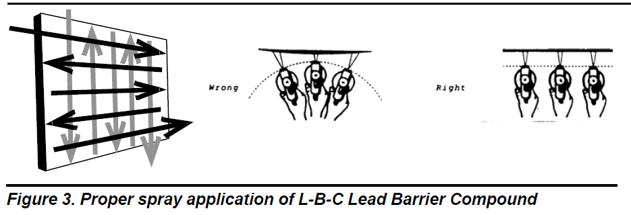
  - Airless Spray: Encapsulants can be successfully applied with most major brands of airless spray equipment.
    - Typical settings for airless spray equipment (for encapsulant):
    - Technique of Spraying - For best results, apply encapsulants in sweeping strokes always keeping the tip of the gun parallel to the surface at a distance between 12" to 18" inches.
      - The speed at which the product is applied depends on the system used.
      - Normally a slow to moderate sweeping stroke of first horizontal followed by vertical passes will afford the desired results.
      - If necessary, an angular mist coat may be applied to even out irregularities.
    - SPECIAL NOTE FOR SPRAY APPLICATION OF ENCAPSULANTS CONTAINING ANTI-INGESTANTS (DOES NOT PERTAIN TO BRUSH OR ROLLER APPLICATION)
      - Per this specification, the Architect/Engineer require that the encapsulant contain a non-toxic, bitter tasting anti-ingestion agent.
      - When sprayed, anti-ingestion agents have a strong bitter taste even in low concentrations.
      - There is no health hazard even if the temporarily airborne particulate is ingested or inhaled. It may cause slight irritation to the nose, mouth and/or throat and therefore as a result, will leave a bitter taste in the mouth. To avoid this discomfort, it is recommended that exposure to the airborne mist be avoided.
      - When areas to be sprayed abut inhabited spaces, rooms or offices should be closed off. The following procedures can be implemented to assure ventilation in the area to be sprayed and yet prevent airflow containing bitter-tasting mists from affecting adjoining rooms. Place an 18-24" fan (air flow pointed outward) turned on “high” in an open window of the room to be sprayed. Open a door to an adjoining area by no less than 2 inches. This will allow adequate air flow away from inhabited areas and yet allow persons to walk back and forth from the application area to the adjoining rooms.
  - Roller: For best results apply with a 3/8" - 1/2" nap roller (manufacturer recommendations may vary).
  - Brush: Apply liberally and uniformly with a polyester or nylon brush.
3.04 LIQUID-APPLIED PARTICULATE CONTROLS
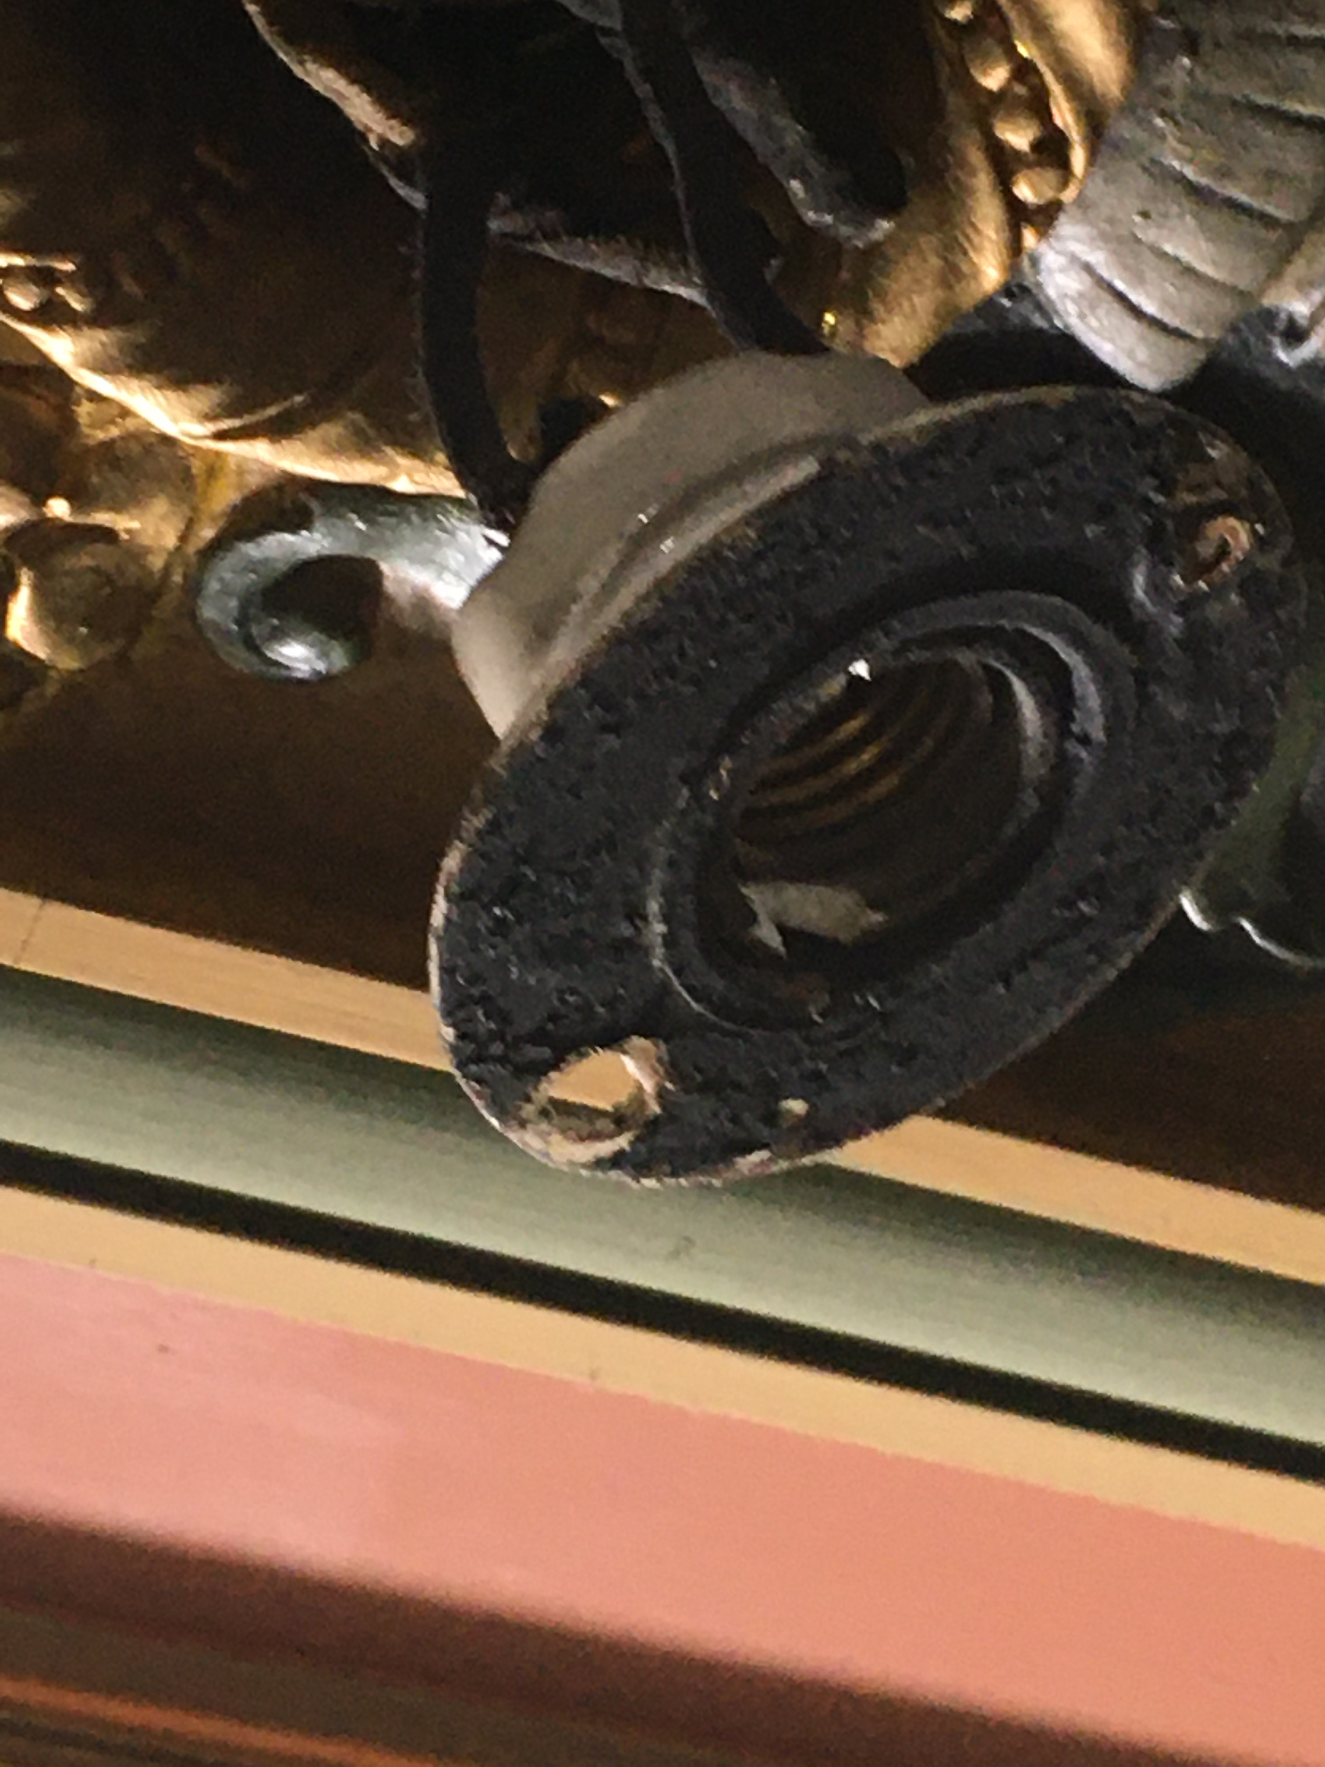
- After lead particulate removal via cleaning, and then encapsulation, the future functionality and design of the space involves installation of lighting and audio components wired within and recessed into the carefully prepared ornamental plasterworks. To stabilize the present conditions, and to mitigate against particulate generation caused by necessary electrical work, the current dust burden has been removed, and durability lent to the existing paint system via the tough dry film of the encapsulant.
- Electrical Tasks to be conducted will include, but are not entirely limited to:
  - Removal of existing recessed lights
    - This will involve cracking the existing rim to pull out the old fixture
      - Prior to cracking the rim, and immediately after fracturing the surface, and whenever dust is potentially generated, those involved surfaces are to be treated with either (see descriptions at 2.01 Materials (Basis for Design), subsections C & D) the PACM Control Encapsulant (Spray Can) or the Stabilizing Bonding Adhesive (brush or micro-roller), or both. Which product to use is at the responsible determination of the contractor removing the old lights.
      - When pulling through old wiring, the jacketed cabling may have PACM, lead or other contaminants, and therefore should be treated with a thorough spray can application of the jacketing and any associated components. This is considered a best practice to reduce particulate generation during removal, manipulation and proper placement into disposal bags (in accord with rules of local jurisdiction).
      - The encapsulant and the liquid applied particulate controls will likely withstand abrading from wire, but after removal affected areas should be inspected carefully and as necessary touched up with additional encapsulant by brush to restore a uniform appearance and a continuous encapsulant dry film.
  - Cuts and Penetrations Into Encapsulated Surfaces
    - Drill – daub drill hole target area with shaving cream or similar to absorb particulates pulled up by the drill bit. After penetration is made, wipe away shaving cream and disturbed material using a rag pre-soaked in lead-specific cleaner.
    - Cuts – Treat target area of cut with Stabilizing Bonding Adhesive. While tacky, perform cut with a HEPA-assisted power tool with dust capture capability.
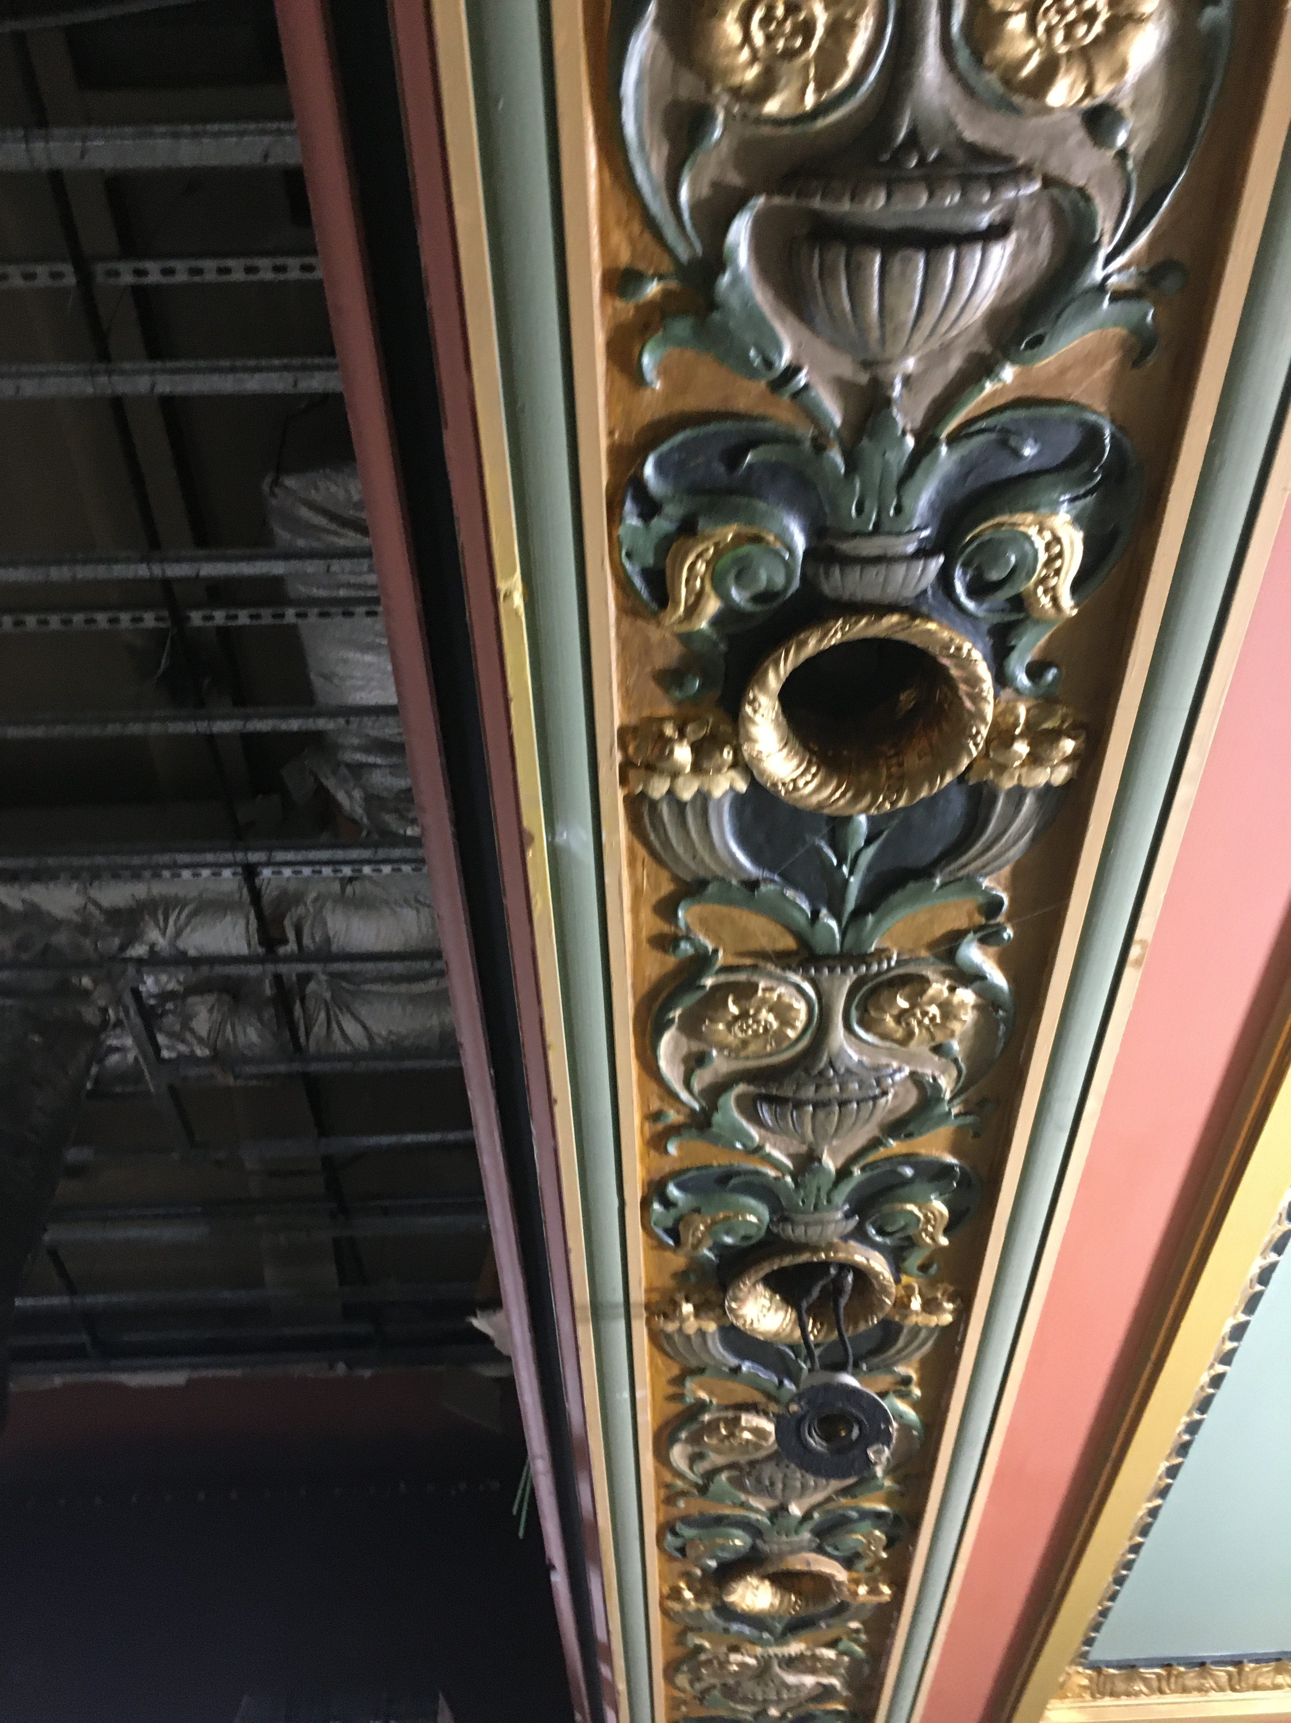
- The liquid particulate controls used in this section are compatible as primers with the lead paint encapsulant, so these products residuals do not need to be removed.
  - After lighting and audio tasks are complete, clean all affected areas with the FINAL WET CLEANING with lead-specific cleanser, as delineated at 3.01, A, d, D.
  - Repair damaged areas of the lead encapsulant, where found by visual inspection, by blending in replacement encapsulant via brush.
3.05 HISTORIC DECORATIVE FINISHES
- To restore the ornamental plaster details to a historically accurate appearance that will also be durable, this specification section describes the use of historic colors delivered by a polyurethane-fortified, water-based eggshell acrylic, with gold accents provided by a water-based metallic finish.
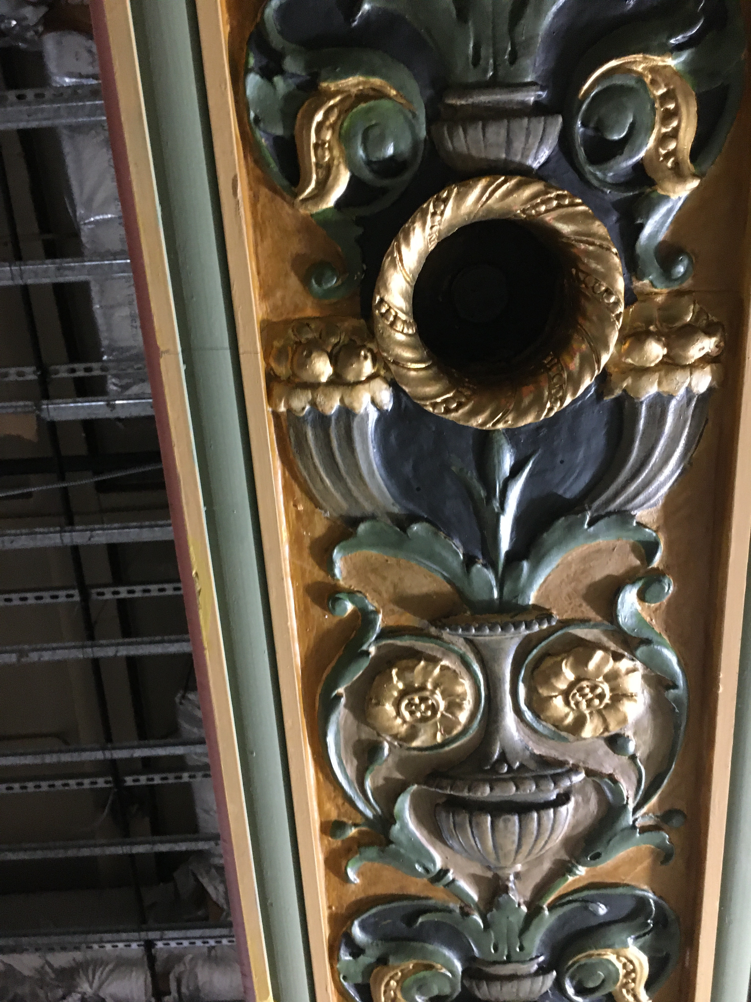
  - Specified system is water-based to ensure compatibility with the lead paint encapsulant previously installed. Manufacturer shall be same company and a letter of compatibility shall be provided to both owner’s agent and architect. Any incompatibility immediately after application of historic topcoats will be the responsibility of the manufacturer to repair (excepting intercoat issues due to improper installation practices).
  - Specified system is polyurethane-fortified to provide a durable system with extended years of performance realistically beyond service life from standard latex finishes. Intent of this specified system is to provide extended years of service, even with periodic dry brush, soft-bristle cleaning, as this common space will be difficult, disruptive and expensive to isolate for future frequent repainting.
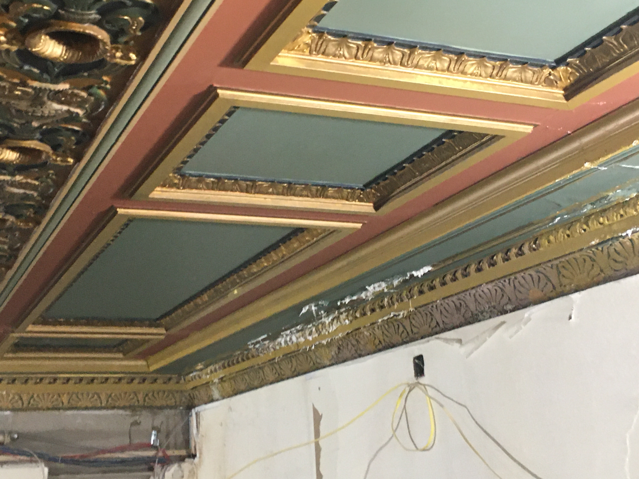
- Historic Color Palette: For this building constructed in 1922, with a 1953 addition, the colors selected for the restored ornamental plaster elements shall be selected by the architect and owner’s representatives from the 20th Century Colors of America historic palette from California Paints, based in Andover, MA (a brand division of ICP Building Solutions Group). This palette represents authenticity with colors drawn directly from 20th century museum properties and documented decorative color sources. Manufacturer of paints and ownership of color system shall be the same company, or equal as determined by the architect. Owner’s representative, architect, installation contractor and manufacturer shall draft and agree upon a selection and sample submittal process specific to the historic colors needed to execute this project.
- The pictures provided here are of existing conditions, but illustrate the complexity of the ornamental plaster features and colors that will be restored using the products listed at 2.01 Materials (Basis for Design), subsections E & F, (or equal):
- APPLICATION OF DECORATIVE HISTORIC FINISHES:
  - HISTORIC COLOR FINISHES:
    - Applicator shall apply coatings in accordance with manufacturer's written instructions.
      - Polyurethane-fortified finish in the specified system is a two-component product. Mixing of components immediately before application creates crosslinking integral to product performance. Follow instructions including:
        - Add two ounces of crosslinking catalyst per gallon
        - Mix well
        - Strain
        - Catalyzed Product Life: 36 hours or 8 hours under pressure
      - Fortified finish coat can be brushed, rolled or airless sprayed.
        - Brush: Synthetic fiber
        - Roller: Synthetic 3/8 – ½” nap
        - Airless Sprayer: 2000 psi and a .015 - .021 tip.
    - Do not exceed manufacturer’s recommended coverage rate.
    - Allow to dry prior to application of subsequent coats.
    - Spray or roll finish to completely cover encapsulant and according to manufacturer’s written instructions.
    - Apply in a continuous, even film at manufacturer’s specified coverage rate.
    - Apply each coat to a natural break point such as an edge or corner without stopping.
    - Finishes shall match approved benchmark samples and shall be free of runs, sags, holidays, and excessive irregularity/unevenness of pattern coat.
    - Transitions between colors and/or other materials shall be sharp, clean and without overlaps.
  - HISTORIC METAL FINISHES:
    - Applicator shall apply coatings in accordance with manufacturer's written instructions
      - TRAINING: Technique for success with this type of finish is of high importance. It is advisable to request training from MasterWorks Field Services.
      - BRUSHED: Tools required include
        - One roller set up with a 1/2 inch nap cover
        - One 3” high quality synthetic bristle brush
        - Painter’s tape
- Do not exceed manufacturer’s recommended coverage rate.
- Allow to dry prior to application of subsequent coats.
- Spray or roll finish to completely cover encapsulant and according to manufacturer’s written instructions.
  - N.B., Highly reflective finishes will telegraph any substrate flaws. The substrate must be very smooth. Fill in all visible dings and scratches.
  - Mask off the surface to be painted, this will reduce any “picture framing” caused by variations between brushing and rolling
- Apply in a continuous, even film at manufacturer’s specified coverage rate.
- Apply each coat to a natural break point such as an edge or corner without stopping
3.06 CLEANING
- Remove debris promptly from work area and dispose of properly.
- Remove spilled, splashed, or splattered coating materials from all surfaces
- Do not mar surface finish of items being cleaned
- Remove masking, draping, and other protection from adjacent surfaces

3.07 FINISH SCHEDULE/PROTECTION

A. Apply encapsulant and encapsulant/epoxy systems to all areas shown on the drawings or specified in the Room Finish Schedule.

    - WARRANTY

- Installer shall provide Owner, through Architect/Engineer, with an acceptable form of warranty against defects in workmanship for a period of one (1) year from date of substantial completion.
- Issuance of manufacturer warranty shall be a condition precedent to receipt by ICP Area Managers of completed and signed warranty documentation.
- Extent of ENCAPSULANT warranty shall be limited to the repair or replacement of defective surfaces at no additional cost of materials to the Owner during the warranty period of 20 years. Manufacturer may choose instead of replacing product to reimburse for current product value for quantity necessary to effect repairs. The warranty shall not include any remedy for defects caused by abuse, improper maintenance or operation, or by normal wear, tear and usage

END OF SECTION

AVAILABLE TRAINING AND CONTINUING EDUCATION:

ICP BUILDING SOLUTIONS GROUP provides product training via Masterworks. The management teams and field representation for each brand will designate on a project-by-project basis the Masterworks curriculum necessary to be qualified for a specific project, or accredit the approved applicator via onsite or remote instructor-lead training. Hands-on instruction may be required at the discretion of the authorized ICP-brand representative. Note that training from manufacturer does not replace other training mandated by federal, state or local regulation. Concerning lead paint activities, the contractor is responsible for potential requirements such as EPA lead-safe remediator training (RRP), and/or state-issued lead abatement licensing for firms, supervisors and workers.

The MASTERWORKS DESIGN+SPECIFICATION team of the ICP Building Solutions Group has prepared this overall specification.:
  - Web: https://www.icpgroup.com/programs/masterworks
  - Email: masterworks@icpgroup.com
  - Phone: 800-342-3755 or 978-623-9980

- The effective encapsulation of any abatement project is contingent upon the competence of the applicator.
- The effective success of any project is contingent upon the competence of the applicator.

- If encapsulated surfaces are damaged, repair and re-encapsulate immediately to prevent exposure to the lead hazard. HUD, EPA and several state governments recommend periodic and/or annual examination of all encapsulated surfaces for damage.

- This specification does not fully describe all the limitations, warnings and precautions related to the products described herein.

- Reference should be made to the Technical Product Data Sheets for complete technical information on all products manufactured by Fiberlock and ScuffMaster, both brand divisions of ICP BUILDING SOLUTIONS GROUP (BSG).

- Safety Data Sheets (SDS) should be referred to for health and safety information. Copies of all SDS sheets can be obtained by visiting our websites at www.leadsafe.com or https://www.fiberlock.com/safety-technical-data-sheets/ Or https://www.scuffmaster.com/tech-docs/

Copyright © 2019 by ICP BUILDING SOLUTIONS GROUP (BSG), Inc.

This publication was produced specifically for the use of: DYER BROWN ARCHITECTS, SHAWMUT DESIGN & CONSTRUCTION, and the LANGHAM HOTEL

For other parties, this specification may not be reproduced or copied in whole or in part by any means without the express written permission of ICP BUILDING SOLUTIONS GROUP (BSG).

To obtain a custom specification for your project or organization, contact the Design+Specification Team at ICP BUILDING SOLUTIONS GROUP (BSG) by email to masterworks@icpgroup.com

MSW111319

See https://nchh.org/resource-library/Vermont_Cleaning_Paper.pdf. HOW MUCH CLEANING IS ENOUGH? AN EVALUATION OF ALTERNATIVE POST-LEAD HAZARD INTERVENTION CLEANING PROCEDURES By: Sherry DixonA, Ellen TohnB, Ron RuppC, Scott ClarkDA, National Center For Lead-Safe Housing.
For additional information and guidance regarding Handi-Foam products available for encapsulation projects, contact ICP ADHESIVES located at 2775 Barber Road, Norton, OH. (330) 753-4585 https://www.icpgroup.com/icp-adhesives/
Historic Colors of America is a joint venture of Historic New England and the California Paints brand of ICP Group. For more information see https://www.icpgroup.com/masterworks-capaints-historic-colors-america-may2019/ and https://www.californiapaints.com/find-my-color/ See
Examples:
Example:

